Draft
AGENDA
of the trade mission to the Republic of Moldova
organized within the project “SUPPORTING EU SMES IN THE FIELD OF CIRCULAR ECONOMY TO PARTICIPATE IN PUBLIC PROCUREMENT IN EASTERN EUROPE COUNTRIES”
P2GreenEST
January 31st – February 2nd 2024
Wednesday, January 31st 2024

11:00 – 13:00 | Participation of the European Union SMEs in the official opening of the exhibition “Made in Moldova”  Visit of the exhibition (optional)  Address: “MOLDEXPO”, Chisinau, 1, Ghioceilor Street
13:00 – 14:00 | Lunch
15:00 -17:00 | Visit to TERMOELECTRICA or  ABS Recycling company (tbc)  Other visits may be organized depending on the profile of EU participating SMEs
Thursday, February 1st 2024

Conference in the field of Circular Economy - Turning Challenges into Opportunities for Small and Medium Sized Enterprises (SMEs)
9:00 – 9:30 | Registration of participants  Venue- to be confirmed
9:30 – 10:00 | Welcoming remarks
Welcome speech of the event host – Chamber of Commerce and Industry of the Republic of Moldova
Mr. Sergiu HAREA – President of the Chamber of Commerce and Industry of the Republic of Moldova

Mrs. Iordanca – Rodica IORDANOV
Ministry of Environment, Minister
National Focal Point, EU4Environment

Mrs. Veronica ARPINTIN
Ministry of Economic Development and Digitalization, State Secretary
National Focal Point, EU4Environment

Mr. Victor PARLICOV
Ministry of Energy of the Republic of Moldova, Minister (tbc)

Représentative frome Ukraine – Chambers of Commerce and Industrie of Ukraine (tbc)

Delegation of the European Union to the Republic of Moldova (tbc)

10:00 – 11:30 | Session 1: Sustainable Public Procurement in the Republic of Moldova
10:00 – 10:15 | Presentation of P2GreenEST Project, Mrs. Cristina CASIAN, Project Coordinator, Éa éco-enterprises Cluster, France  Presentation of Project partners  - Éa éco-enterprises, France  - Green Energy Cluster, Romania  - Asturian Federation of Enterprises, Spain  - Chamber of Commerce and Industry of the Republic of Moldova
10:15 – 10:30 | Presentation of the legal framework in the field of circular economy procurement in the Republic of Moldova,  Agency of Public Procurement of the Republic of Moldova, Ministry of Finance of the Republic of Moldova (tbc)
10:30-10:45 | Presentation of the current situation in the circular economy public procurement sector of the Republic of Moldova. - opportunities for energy efficiency waste and water management sectors,  Mrs. Diana ENACHI, Consultant in Public Procurement
10:45 – 11:00 | “Creating opportunities for SMEs participation in circular economy procurement in Ukraine”, Mr. Olexandr Shatkovskiy, expert in public procurement in Ukraine (tbc)
11:00 -11:15 | Questions and answers session
11:15 -11:30 | Coffee break
11:30 – 13:15 | Session 2: Presentation of public procurement opportunities on the framework of national and international programmes -investments and future actions in the Republic of Moldova
11:30 -11:45 | Ministry of Environment / National office for the implementation of Environmental Projects – projects presentation
11:45 -12:00 | City Hall of Chisinau – Chisinau Solid Waste Project /  /Apa-Canal Chisinau
12:00-12:15 | Agency for Energy Efficiency of the Republic of Moldova
12:15 -12:30 | Moldova Energy Projects Implementation Unit (MEPIU) / Moldelectrica
12:30- 12:45 | USAID Moldova Energy Security Activity (MESA)
12:45 -13:00 | Project presentation from the side of Ukraine (tbc)
13:00 -13:15 | Questions and answers session
13:15 – 14:00 | Lunch & Networking
14:00 - 16:00 | Bilateral business meeting and business to procurers’ meetings  For the matchmaking sessions will be used the project matchmaking b2match platform which will facilitate the registration of participants and the identification of needs in terms of business to business or business to procurers’ cooperation. It will be a practical tool for scheduling individual B2B meetings, gathering feedback from participants, promotion of the cooperation interest of the participants, etc. The meetings between SMEs and public buyers will be taken in advance on the platform, and they will meet physically during the event.
Friday, February 2nd 2023

10:00- 14:00 | Visit to companies/contracting authorities in accordance with the interest of cooperation of EU participating SMEs

Strategic Partners:
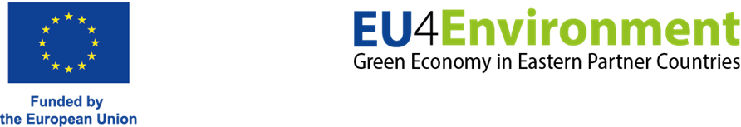
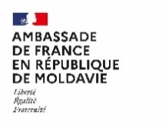
*The content of this agenda represents the views of the author only and is his/her sole responsibility; it cannot be considered to reflect the views of the Executive Agency for Small and Medium-sized Enterprises or any other body of the European Union. The European Commission and the Agency do not accept any responsibility for use that may be made of the information it contains

