European Neighbourhood Instrument Cross-Border Cooperation
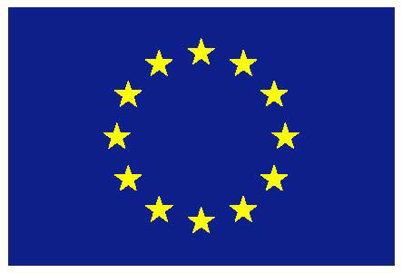

Black Sea Basin 2014-2020
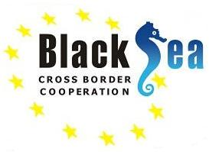
Joint Operational Programme - DRAFT 16 March 2015

Table of Contents
Black Sea Basin 2014-2020 1
◦ Executive summary 1
Introduction: Description of programme preparation steps 1
Summary of programme strategy 3
Summary of programme management and implementation 4
◦ Description of the Programme area 6
Participating countries and Programme area 6
Core regions 6
Map of the programme area 7
◦ Programme overall strategic framework 8
EU strategy for ENI CBC 8
EU strategic framework for the Black Sea Basin 10
Other relevant EU policies and initiatives 10
◦ Black Sea Basin socio-economic and SWOT analysis 13
Territory and demography 13
Economy 17
Education and employment, R&D, research 27
Environment 31
Health, safety and security 37
Energy, transport and communication networks 43
Culture, civil society and self-government 48
◦ Black Sea Basin strategic analysis and consultations 51
Past experience analysis 51
Stakeholder consultations 53
Consistency with other EU programmes 55
Summary of strategy identification 58
◦ Black Sea Basin ENI CBC programme strategy 59
Wider objective 59
Horizontal issues and modalities 59
Thematic objectives and priorities 59
Objectively verifiable indicators 65
Risk analysis and mitigating measures 67
Programme logical framework 69
Nature of projects and types of support 73
Mainstreaming of cross-cutting issues 74
Complementarities and synergies 76
◦ Programme structures and national bodies 79
Joint Monitoring Committee (JMC) 79
Managing Authority (MA) 80
Audit Authority (AA) and Group of Auditors (GoAs) 82
National Authorities (NAs) 84
Control Contact Points (CCPs) 85
Joint Technical Secretariat (JTS) 86
Other structures supporting national authorities 87
Selection Committee (SC) 88
◦ Project evaluation and selection procedures 89
Actors involved, roles and responsibilities 89
Description of the evaluation and selection process 89
◦ Programme implementation 92
Description of the management and control systems 92
Time-frame for programme implementation 92
Technical assistance (TA) 92
Monitoring and Evaluation 94
Communication 95
Strategic Environmental Assessment 95
Financial plan 98
Rules on eligibility of expenditure 99
Apportionment of liabilities among participating countries 99
Rules of transfer, use and monitoring of co-financing 100
Reporting and exchange of computerised data between the Managing Authority and the EC 100
Programme language 101
◦ ANNEXES 102
Annex 1 – Summary of mapping of projects awarded under the Black Sea Basin 2007-13 two calls for proposals and of the survey on current priorities and future needs 102
Annex 2 - Full SWOT and combined outcomes of SWOT and past experience analyses 102
Annex 2 - Outcomes from stakeholders consultations 102
Annex 3 – Monitoring and evaluation system and plan 102
Annex 4 – Communication strategy and annual information and communication plan 2016 102
Annex 5 – Report on strategic environmental assessment 102
Notes and Sources 103

Black Sea Basin 2014-2020

Executive summary

Introduction: Description of programme preparation steps
The Black Sea Basin Programme 2014-2020 is part of European Union’s Cross-Border Cooperation (CBC) under its European Neighbourhood Instrument (ENI). CBC under ENI extends the principles of CBC among EU Member States via the European Territorial Co-operation programmes. ENI CBC receives funding from ENI as well as from the European Regional Development Fund and the Instrument for Pre-Accession. All sources of funding may be used on either side of the EU external border for actions of common benefit. The ENI Regulation sets out the basis for CBC, further defined in the ENI CBC Implementing Regulation and the ENI CBC Programming Document.
While the overall strategic objectives for the programme were defined at EU level, detailed programming, including the priorities of the Black Sea Basin ENI CBC programme 2014-2020, were developed by the programme partners themselves working together accross borders. To this end, a Joint Programming Committee comprised of representatives from actively participating countries was established and met seven times between April 2013 and February 2015.
Nine countries actively participated in the programming process, Armenia, Azerbaijan, Bulgaria, Georgia, Greece, Republic of Moldova, Romania, Turkey and Ukraine. The development of the Black Sea Basin ENI CBC Programme 2014-2020 was facilitated by the Ministry of Regional Development and Public Administration of Romania, which was appointed as the Managing Authority allowing for continuity with its role as Joint Managing Authority for the Black Sea Basin ENPI CBC programme 2007-2013.
The Black Sea Basin ENI CBC programme 2014-2020 builds upon the previous cooperation framework, the Black Sea Basin ENPI CBC programme 2007-2013 programme, under which 62 projects were awarded and implemented in 8 countries surrounding the Black Sea Basin. Relevant lessons learned from this past experience have been integrated in the Black Sea Basin ENI CBC 2014-2020 programme strategy along with a mapping of projects awarded and a survey on current priorities and future needs carried out in 2013.
In addition to the past experience analysis, the methodology to identify the most relevant strategy for the Black Sea Basin ENI CBC 2014-2020 programme included a socio economic analysis of the programme area and an analysis of its key strengths, weaknesses, opportunities and threats (SWOT) which was developed from June to November 2013.
The outcomes of the past experience analysis combined with the results of the socio economic and SWOT analysis resulted in the reduction of the 10 thematic objectives given in the ENI CBC Programming Document to 8 objectives, focused on a limited number of priorities, that presented the most interesting potential for cooperation within the Black Sea Basin. The proposed list of possible thematic objectives and related priorites were agreed for consultation in the 3rd Joint Programming Committee meeting held in Kavala, Greece on 15 November 2013.
Programme stakeholders were widely consulted in order to validate the SWOT and give input on the possible programme priorities. Consultations included:
- An international regional level consultation during the Black Sea Basin ENPI CBC programme 2007-2013 annual conference held in Istanbul, Turkey on 5 December 2013 (including representatives of national, regional and local authorities and NGOs, researchers and academics, and other stakeholders active in the Black Sea Basin area).
- National stakeholder consultations (events and/or written consultations) in participating countries from November 2013 to March 2014. Consultations were held at both national and regional levels to allow consistency with national/regional strategies as well as to include the views of the actors on the ground.
- Open public consultations via the website of the current programme (initiated in December 2013) and some national websites.
The Black Sea Basin programme strategy also takes into account relevant EU strategies and policies (including the Blue Growth strategy, etc.) to ensure the coherence of programme support with existing EU strategic frameworks. A consistency analysis with relevant EU programmes was carried out so that the defined Black Sea Basin objectives and priorities would deliver real cross-border added value and would not cover elements already funded, or which could be more suitably funded, from other ENI or EU programmes.
The outcomes of the stakeholders’ consultations and the coherence analysis with other EU programmes were presented to the 4th Joint Programming Committee meeting held in Şile, Turkey on 28 April 2014.
After due consideration of:
- the wide geographical coverage and limited budget of the programme, and therefore the need for the Black Sea Basin strategy to concentrate on a limited number of themes in which concrete results can be obtained, and
- the stronger relevance of some priorities under ENI CBC thematic objectives “Business and development” (TO1) and “Environmental protection, and climate change mitigation and adaptation” (TO6) indicated throughout the analytical and consultation process,
these two objectives were selected for the strategy. Internal national and regional consultations, as well as online public consultations on the programme website (in June 2014), followed on the proposed set of priorities and indicative actions and these were finally agreed at the 5th Meeting of the Joint Programming Committee in Brussels, Belgium on 17 July 2014.
The strategic environmental assessement (SEA) process started in October 2014 and involved the relevant environmental authorities in the participating countries. The draft conclusions of the process were presented at the 7th meeting of the Joint Programming Committee in Chisinau, Moldova on 26 February 2015.
Modalities for the implementation of the programme were developed throughout the period and agreed progressively at the Joint Programming Committee meetings.
The final public consultation of the whole Joint Operational Programme was held in March 2015.
The programming process, including drafting of the programme and organisation of consultations in partner countries, was supported by the EU technical assistance project ENI CBC Support to Preparation of Programmes (SPP). Comments from the EU technical assistance project INTERACT ENPI also have been incorporated.

Summary of programme strategy
As a result of the completed analytical and consultation process, the Black Sea Basin programme will focus on two ENI CBC thematic objectives, contributing to two overarching strategic objectives, as defined in ENI CBC Programming document 2014-2020:
- Thematic Objective 1. Business and SME development, contributing to ENI CBC overarching strategic objective A. Promote economic and social development in regions on both sides of common borders
- Thematic Objective 6. Environmental protection, and climate change mitigation and adaptation, contributing to ENI CBC overarching strategic objective B. Address common challenges in environment, public health, safety and security
Within these ENI CBC thematic objectives, participating countries have agreed a set of of objectives and priorities for the Black Sea Basin programme, reflecting their specific circumstances and requirements, as presented in the table below.
Black Sea Basin ENI Cross-Border Cooperation programme 2014-2020 - Objectives and Priorities:
Overall objective | Specific objectives | Priorities | ENI EU funding (provisional)
Improve the welfare of the people in the Black Sea basin regions through sustainable growth and joint environmental protection | 1. Promote business and entrepreneurship within the Black Sea basin | 1.1 Jointly promote business and entrepreneurship in the tourism and cultural sectors | €25.34 million
 |  | 1.2 Increase cross-border trade opportunities and modernisation in the agricultural and connected sectors
 | 2. Promote coordination of environmental protection and joint reduction of marine litter in the Black Sea basin | 2.1 Improve joint environmental monitoring | €18.80 million
 |  | 2.2 Promote common awareness-raising and joint actions to reduce river and marine litter

A number of important elements for successful, sustained and inclusive cross-border cooperation will also be supported as horizontal issues or modalities to be deployed across any of the priorities. They include:
- So-called ‘people-to-people’ actions
- Promotion of local and regional good governance
- Promotion of regional integration/coordination
- The use and development of relevant information and communication technologies
- Promotion of gender equality, and opportunities for youth.
To achieve its objectives, the programme will award grants to CBC projects selected through calls for proposals. Two calls for proposals are expected to be launched during the programme lifetime, in 2016 and 2018. The recommended financial size of projects will be further defined in the calls for proposals.
Projects will be submitted jointly by partners effectively established in the programme area, from at least one of the participating EU Member States and one of the participating partner countries or the Russian Federation. Participation of Turkish partners is only possible in projects with at least one partner from a participating EU Member State and one partner from a participating partner country or the Russian Federation.
In line with the ENI CBC Programming document, the partners implementing projects will primarily represent the regional and sub-national administrative levels, as well as civil society organisations based within the eligible programme area. Priority will be given to local and regional authorities, civil society, chambers of commerce, and the academic and educational community; as well as other eligible actors based within the geographical eligibility of the programme and important for the realisation of the objectives of the programme.
Projects shall always deliver clear cross-border cooperation impact and benefits. Each project shall aim at establishing:
- Enhanced cross-border contacts within the Black Sea Basin including e.g. networking, forums and the establishment of lasting partnerships;
- Enhanced knowledge and skills including e.g. the exchange of experience and good practice, innovation, capacity-building and joint research;
- Concrete and visible outputs including e.g. small-scale investments, pilot projects, information and communication technologies shared tools, online open-access resources.
Complementarity of support is essential to ensure the best use of resources and the greatest results for the eligible regions and stakeholders. Beyond ensuring further consistency with other initiatives supported by the EU or at regional/national level during programme implementation, the Black Sea Basin ENI CBC programme will also look for complementarities with other key cooperation frameworks within the Black Sea Basin region and by other donors.

Summary of programme management and implementation
The Black Sea Basin ENI-CBC Programme management and control system will be organised with the following authorities, structures and bodies:
- Joint Monitoring Committee (JMC): supervises and monitors programme implementation and is responsible for the approval of project proposals;
- Managing Authority (MA): responsible for the management and implementation of the programme;
- Audit Authority (AA): carries out audits on the programme management and control systems, on an appropriate sample of projects and on the annual accounts of the programme;
- National Authorities (NAs): national counterpart institution to the Managing Authority in each participating country and overall responsible for supporting the MA in the implementation of the programme in their own countries;
- Group of Auditors (GoA): assists the Audit Authority in carrying out its tasks;
- Control Contact Points (CCPs): support the Managing Authority in its control functions;
- Joint Technical Secretariat (JTS): assists the MA, JMC, AA and the SC in carrying out their respective duties;
- Selection Committee (SC): supervises the evaluation and selection of the project proposals received during calls and issues recommendations for award decisions to JMC.
The designation process of the Managing Authority is expected to be complete in the first half of 2016, allowing the launch of the first call for proposals in the second half of 2016.
The monitoring and evaluation activities will play an important role in the programme implementation cycle and will involve monitoring at project level, monitoring at programme level and evaluation. Achievements of the programme will be measured at result level by 4 indicators (one for each priority) and at activity level by 6 ENI CBC common output indicators and 3 programme-specific output indicators.
Communication activities will aim to improve participation, assist successful implementation, ensure transparency and increase awareness of the programme, EU and national support.

Description of the Programme area

Participating countries and Programme area
‘Participating countries’ to the ENI CBC Black Sea Basin (BSB) programme include the following:
- EU Member States: Bulgaria, Greece and Romania
- Partner countries: Armenia, Azerbaijan, Georgia, Republic of Moldova and Ukraine
- Candidate country: Turkey
- Russian Federation
The ‘Programme area’ for Black Sea Basin ENI CBC includes only core regions, as described below.

Core regions
The following countries or NUTS II (or equivalent) territorial units form the core eligible area of the Black Sea Basin Programme, as defined in the ENI CBC programming document:
- Romania: Sud-Est
- Bulgaria: Severoiztochen, Yugoiztochen
- Greece: Kentriki Makedonia, Anatoliki Makedonia Thraki
- Turkey: TR10 (İstanbul), TR21 (Tekirdağ, Edirne, Kırklareli), TR42 (Kocaeli, Sakarya, Düzce, Bolu, Yalova), TR81 (Zonguldak, Karabük, Bartın), TR82 (Kastamonu, Çankırı, Sinop), TR83 (Samsun, Tokat, Çorum, Amasya) and TR90 (Trabzon, Ordu, Giresun, Rize, Artvin, Gümüşhane)
- Russia: Rostov Oblast, Krasnodar Krai, Adygea republic
- Ukraine: Odessa, Mykolaiv, Kherson, Zaporosh’ye and Donetsk Oblasts, Crimea Republic, Sevastopol
- Moldova, Georgia, Armenia, Azerbaijan: the whole country

Map of the programme area
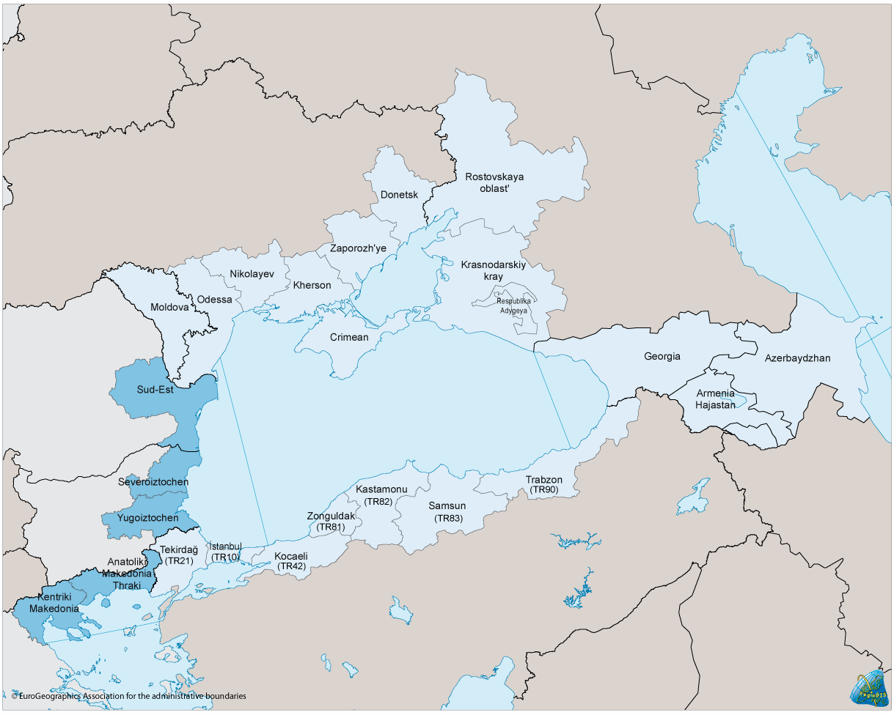Map of the programme: EU regions cooperation areas in dark blue, other cooperation areas in pale blue

Programme overall strategic framework

EU strategy for ENI CBC
Cross-border cooperation (CBC) on the external borders of the EU is a key priority both in the European Neighbourhood Policy and in the EU’s strategic partnership with Russia. CBC under the European Neighbourhood Instrument (ENI) will build on CBC under its predecessor, the European Neighbourhood and Partnership Instrument (ENPI).
ENI CBC receives funding from the European Regional Development Fund as well as the European Neighbourhood Instrument and the Instrument for Pre-Accession. All sources of funding may be used on either side of the EU external border, for actions of common benefit. The ENI Regulation sets out the basis for CBC, further defined in ENI CBC Implementing Regulation and ENI CBC programming document.
Overall objective and strategic objectives
ENI CBC aims to “promote co-operation across the borders between EU Member States and the countries on the European Neighbourhood and Russian Federation” and it should contribute to the overall ENI objective of progress towards “an area of shared prosperity and good neighbourliness” between EU Member States and their neighbours. Due to its geographical location, Turkey also participates in the Black Sea Basin ENI CBC as a candidate country.
CBC under the ENI has 3 overarching strategic objectives:
- Promote economic and social development in regions on both sides of common borders;
- Address common challenges in environment, public health, safety and security;
- Promotion of better conditions and modalities for ensuring the mobility of persons, goods and capital.
Each ENI CBC programme must contribute to at least one of the strategic objectives.
Thematic objectives
Taking the strategic objectives above into consideration, and based on the specific circumstances and requirements of the programme cooperation area, each programme shall focus on a maximum of 4 thematic objectives chosen within a list defined in ENI CBC programming document, that is:
- Business and SME development (Strategic objective: A)
- Support to education, research, technological development and innovation (Strategic objective: A)
- Promotion of local culture and preservation of historical heritage (Strategic objective: A)
- Promotion of social inclusion and fight against poverty (Strategic objectives: A, B, C)
- Support to local and regional good governance (Strategic objectives: A, B, C)
- Environmental protection, and climate change mitigation and adaptation (Strategic objective: B)
- Improvement of accessibility to the regions, development of sustainable and climate-proof transport and communication networks and systems (Strategic objective: C)
- Common challenges in the field of safety and security (Strategic objective: B)
- Promotion of and cooperation on sustainable energy and energy security (Strategic objective: B)
- Promotion of border management, border security and mobility (Strategic objective: C)

A list of indicative activities is provided under each Thematic Objective in the ENI CBC programming document.
Within this framework, it is the task of the local programme partners, working together across the borders, “to analyse the needs in the programme area, to identify the specific thematic objectives and priorities” which are most relevant to their own local circumstances.
The promotion of local cross-border “people-to-people actions is not considered as a thematic objective but as an important modality to be deployed in support of any of these objectives”. This could include support for enhanced cooperation among local and regional authorities, NGOs and other civil society groups, universities and schools, chambers of commerce etc.
Key programming orientations
- Coherence and complementarity between the ENI CBC programmes and other relevant EU instruments are to be ensured through the programming process. CBC programmes must deliver real cross-border added value and not cover elements which are already funded or could more suitably be funded from other ENI or EU programmes.
- Under sea-basin programmes, it will be possible to support activities involving a single partner on either side (EU-internal and –external) of the sea-basins, as well as activities involving more than one partner on either side of the sea-basin.
- The partners implementing projects under the sea-basin programmes will primarily represent the regional and sub-national administrative levels, as well as civil society organisations based within the eligible programme area. Eligibility is based on the ENI regulation, but priority should be given to local and regional authorities, civil society, chambers of commerce, and the academic and educational community; as well as other eligible actors based within the geographical eligibility of the programme and important for the realisation of the objectives of the individual programme. Involvement of national authorities will be necessary in all programme development stages and, when this is necessary, in project implementation.
- Participation of major social, economic or cultural centres in a programme may be considered where it can be demonstrated in the Joint Operational Programme that the involvement of such centres in the programme (i) would bring substantial added value for the core eligible border area, (ii) would strongly contribute to the achievement of the CBC impact in the core eligible border area, and (iii) is essential to achieving the programme objectives in a sustainable way. Consideration should be given to involving such centres only to address certain programme priorities or measures and to limit their eligibility to certain categories of project partners (e.g. eligibility of public entities and research centres and not of civil society organisations established in the selected centre).
- Efforts should be made to ensure the benefits of regional and local development supported by CBC can be sustained after CBC funding is complete. This issue should be reflected in the criteria for calls for proposals.

EU strategic framework for the Black Sea Basin
The EU communication on the Black Sea Synergy (2007) and the Parliament resolution on an EU Strategy for the Black Sea Region (2011) lay down strategic orientations for cooperation in the Black Sea Basin.
Black Sea Synergy
The EC communication on the Black Sea Synergy, adopted by the European Council in June 2007, was followed by a conference between EU and Black Sea Foreign Affairs Ministers in Kiev in 2008 that led to a joint statement initiating the Synergy. The initiative is designed as a flexible framework to ensure greater coherence and policy guidance, while also inviting a more integrated approach and closer regional ties in order to:
- Stimulate democratic and economic reforms
- Support stability and promote development
- Facilitate practical projects in areas of common concern
- Open up opportunities and challenges through coordinated action in a regional framework
- Encourage the peaceful resolution of conflicts in the region
A strategy for the Black Sea
The EU Parliament adopted a resolution on 20 January 2011 for an EU Strategy for the Black Sea Region to be launched. Parliament stressed that the main objective for the EU and the EU Member States in this strategy is to establish an area of peace, democracy, prosperity and stability founded on respect for human rights and fundamental freedoms and providing for EU energy security. It considered that good governance, the rule of law, promotion of respect for human rights, migration management, energy, transport, the environment and economic and social development should constitute priority actions.
The resolution encourages priority financing for small-scale development projects and stresses the need for a project-based approach with a view to including local authorities, business communities, NGOs or other civil society organisations.
It encourages the development of synergies between the various EU policies that come into play in the Strategy, particularly the Structural Funds, the Research and Development Framework Programme and the Trans-European Transport Networks in order to ensure the sustainability of the actions financed so that opportunities created by one economic development initiative can be taken up by another, complementary initiative.

Other relevant EU policies and initiatives
Other key EU strategies and policies to take into acccount in ENI CBC Black Sea Basin strategy development include the following.
Eastern Partnership
Representing the Eastern dimension of the European Neigbourhood Policy, this initiative was launched at the Prague summit in 2009 and was reaffirmed in 2011 and 2013. It aims to deepen and strengthen relations between the European Union and its six Eastern neighbours, Armenia, Azerbaijan, Belarus, Georgia, Moldova and Ukraine. The main objective is to support political and socio-economic reforms in partner countries to:
- Foster political association and further economic integration
- Support mobility of citizens and visa liberalisation as a long term goal
- Enhance sector cooperation
- Support civil society
It includes four multi-lateral platforms focusing on:
- Democracy, Good governance and Stability
- Economic Integration and Convergence with EU Policies
- Energy Security
- Contacts between people
Danube Strategy
A macro-regional strategy to boost the development of the Danube Region was proposed by the European Commission in 2010 and endorsed by the European Council on 13 April 2011. The Strategy seeks to create synergies and coordination between existing policies and initiatives taking place across the Danube Region, including 14 countries among which Bulgaria, Romania, Moldova and Ukraine are from the Black Sea Basin.
The Danube Region Strategy addresses a wide range of issues, divided among 11 priority areas within four pillars, connecting the region, protecting the environment, building prosperity and strenghtening the region.
Blue Growth Strategy
The Blue Growth communication adopted in September 2012 is the maritime strand of the Europe 2020 strategy (see below) and an update of the Integrated Maritime Policy.
This strategy consists of three components:
- Targeted effort towards specific activities (focus areas) identified as being the most promising sectors for growth development: coastal tourism, blue energy, aquaculture, blue biotechnology and marine minerals mining.
- Cross-cutting tools which are specific, policy integrated measures across sectors including Maritime Spatial Planning, Integrated Coastal Management, Marine Knowledge 2020 initiative and maritime surveillance.
- Sea-basin strategies
Other aspects that are crucial for a sustainable growth in the blue economy are the development of the appropriate skills, marine and maritime research and access to finance.
The EC extended the dialogue on sustainable development of the blue economy of the Black Sea to all Black Sea countries during a conference held in Bucharest, Romania on 30 January 2014.
Europe 2020
Europe 2020 is the EU’s ten-year growth and jobs strategy launched in 2010. It aims to create within the EU the conditions for economic growth:
- Smart, through more effective investments in education, research and innovation;
- Sustainable, thanks to a decisive move towards a low-carbon economy;
- Inclusive, with a strong emphasis on job creation and poverty reduction.

The Cohesion Policy is the EU's main investment tool for delivering the Europe 2020 goals within EU Member States.

Black Sea Basin socio-economic and SWOT analysis

The methodology to identify the relevant strategy for the Black Sea Basin ENI CBC programme included first an analysis of the programme area socio-economic environment and of its key strengths, weaknesses, opportunities and threats (SWOT).
The programme area socio-economic and SWOT analysis was developed in the summer-autumn 2013. It is based on information provided by participating countries, as well as data and reports from EU agencies and international organisations. As socio-economic figures at sub-national level are not always available or comparable, overviews of the Black Sea Basin area often rely on national-level statistics; however, the analysis focuses on ENI CBC eligible territories and relies on sub-regional data, whenever available, in the specific analysis of the territories and the selection of main issues covered.

Territory and demography
Overview of Black Sea Basin ENI CBC programme area
A statistical overview of the Black Sea Basin programme eligible area is provided in the table below.
COUNTRY | ELIGIBLE REGIONS | TERRITORY (km2) | POPULATION (thousands) | URBAN (%) | RURAL (%) | NB OF CITIES (> 20 000 inhabitants) | DENSITY (people/km2)
ARMENIA | (whole country) | 29 743 | 2 964 | 64% | 36% | n.a. | 104
AZERBAIJAN | (whole country) | 86 600 | 9 356 | 53% | 47% | 54 | 108
BULGARIA | Severoiztochen | 13 700 | 957 | 73% | 27% | 4 | 65
 | Yugoiztochen | 19 979 | 1 067 | 72% | 28% | 6 | 53
GEORGIA | (whole country) | 69 700 | 4 484 | 53% | 47% | 13 | 64
GREECE | Kentriki Makedonia | 19 146 | 1 876 | 78% | 32% | 10 | 100
 | Anatoliki Makedonia – Thraki | 14 157 | 608 | 61% | 39% | 7 | 43
MOLDOVA | (whole country) | 33 846 | 3 559 | 42% | 58% | 9 | 117
ROMANIA | South-East | 35 762 | 2 546 | 54% | 47% | 11 | 71
RUSSIA | Rostov Oblast | 100 800 | 4 404 | 68% | 32% | n.a. | 42
 | Krasnodar Krai | 76 000 | 5 125 | 53% | 47% | n.a. | 67
 | Adygea Republic | 7 800 | 450 | 53% | 47% | n.a. | 57
TURKEY | İstanbul (TR10) | 5 196 | 13 855 | 99% | 1% | 1 | 2666
 | Tekirdağ, Edirne, Kırklareli (TR21) | 18 665 | 1 593 | 66% | 34% | 3 | 85
 | Kocaeli, Sakarya, Düzce, Bolu, Yalova (TR42) | 20 184 | 3 376 | 76% | 24% | 5 | 167
 | Zonguldak, Karabük, Bartın (TR81) | 9 493 | 1 020 | 52% | 48% | 3 | 107
 | Kastamonu, Çankırı, Sinop (TR82) | 26 435 | 746 | 35% | 65% | 3 | 28
 | Samsun, Tokat, Çorum, Amasya (TR83) | 37 524 | 2 718 | 60% | 40% | 4 | 72
 | Trabzon, Ordu, Giresun, Rize, Artvin, Gümüşhane (TR90) | 35 174 | 2 545 | 38% | 62% | 6 | 72
UKRAINE | Odeska | 33 300 | 2 395 | 67% | 33% | 7 | 72
 | Mykolaiv | 24 585 | 1 174 | 68% | 32% | 4 | 48
 | Kherson | 28 500 | 1 078 | 61% | 39% | 5 | 38
 | Zaporosh'ye Oblast | 27 200 | 1 785 | 77% | 23% | 6 | 66
 | Donetsk Oblast | 26 517 | 4 375 | 91% | 9% | 27 | 165
 | Crimea Republic | 26 081 | 1 965 | 63% | 37% | 11 | 75
 | Sevastopol | 8 635 | 383 | 94% | 6% | 1 | 444
TOTAL |  | 834 722 | 76 404 | 64% | 36% | 200 | 91
Table 1. Overview of the Black Sea Basin eligible areas
Demographic trends
In 2012 the ENI CBC programme area had a population of 76.4 million people, that is an increase of 2 million since 2005 and the previous ENPI CBC programming period. This overall growth reveals nonetheless highly disparate demographic trends among participating countries (see figure 1 below). While on one hand in Azerbaijan and Turkey eligible area population grew steadily, respectively by 0.75 million and 2 million over the period, on the other Armenia, Bulgaria, Romania and Ukrainian eligible areas recorded significant population losses. Both the uneven fertility rates – from 2.1 births per woman on average in Turkey to 1.3 in Romania – and the migration trends explain these disparities.
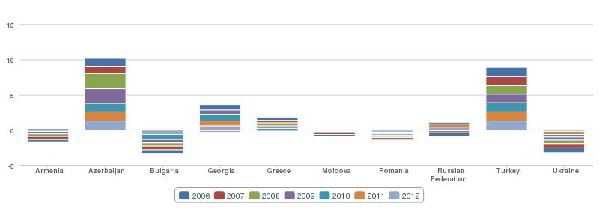
Figure 1. Population growth at country level (annual %), stacked per year over the period 2006-2012
Only Russia, Greece and Azerbaijan registered positive migration flows in 2010 (see figure 2 below), a constant since 2005. Though Greece is still perceived as a gateway towards the EU Schengen area for many legal and illegal migrants, its attractiveness has dropped in recent years (net migration reduced by half between 2000 and 2010). All the other participating countries, including EU members Bulgaria and Romania, are a source of migration, mostly labour migration, towards better economic opportunities in other EU member States, suggesting that local economic development on all sides of the Black Sea Basin remains a key issue for cooperation.
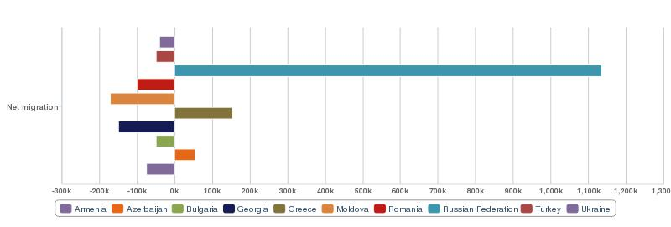
Figure 2. Net migration, 2010
Though all countries in the Black Sea region are sending and transit countries on the routes of migration flows towards Western Europe, migration within the region itself remains strong: in 2005 the top ten countries of origin of immigrants to the Black Sea region include Russia, Ukraine, Azerbaijan, Georgia, Bulgaria, Armenia and Moldova, while Russia, Ukraine, Turkey and Greece appear within the top ten destinations of emigrants from the Black Sea region.
A number of challenges and opportunities arise from these internal and external migration flows. ‘Brain and skill drain’ (as those with higher education and skills leave the country) is recognised as a serious problem in Moldova, Romania and Armenia, and affects notably doctors and the skilled medical workforce in Moldova and Bulgaria. An associated problem is skill waste, as high education migrants often end up working in low-skilled jobs (e.g. as construction, domestic workers). Brain drain is also an important issue for Turkey, with a high incidence of students graduating abroad not returning. However, labour migration can also help reduce unemployment and generate private remittances in the country of origin, which play an increasing role in regional economic development. Hence, effective migration management within the Black Sea region is a common issue of interest and there is potential notably for facilitating emigrant links with their home communities, including remittance transfer and the development of scientific, business and other types of networks.
Urban and rural development
In 2012, population density in the Black Sea Basin ENI CBC programme area was 91 people/km2, a slight increase since 2005 though below EU average of 120 people/km2. The density in Black Sea Basin eligible areas ranges from 2,666 people/km2 in Istanbul to 28 people/km2 in Kastamonu, revealing huge discrepencies in territorial development as well as an ongoing urbanisation process (see table 1 above).
The ENI CBC programme is characterised by the inclusion of both large rural areas and of major cities, including three capital cities (Baku, Tbilisi, Yerevan) and the megacity of Istanbul. Since 2005 the urban population in the programme area has increased by 5 points to 64%, a trend that is common to all the regions across the eligible area, though particularly strong in Turkey, as Istanbul itself grew by 2.2 million (nearly 20%) over the period. Though this urbanisation process does not yet match the EU average (where 74% of the population is urbanised), it gives rise to common environmental and socio-economic challenges to ensure sustainable urban development.
Another feature of the programme area is the dense population of most coastal zones, which increases considerably during the summer season due to tourism, creating economic opportunities but also putting additional strain on local infrastructure and the environment.
Population structure by age
Demographics trends within the Black Sea Basin eligible area reveal disparate dynamics in regard to the population age structure and its related socio-economic challenges. Greece and Bulgaria, and to a lesser extent Ukraine, Romania and Georgia, have an ageing population, with people over 65 representing more than 20% of their working age population (see figure 4 below) – leading to specific health and pension-financing issues. On the other hand, Azerbaijan and Turkey have more dynamic demographics and a younger population e.g. more than 23% of the population of Istanbul is under 14, giving rise to related challenges of education and integration into the labour market.
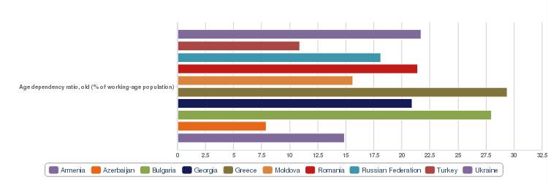Figure 3. Age dependency ratio, old : >65 years old as a % of working age population (15-64 years old), 2012

SWOT - DEMOGRAPHY
STRENGTHS | WEAKNESSES
- Young population Turkey and Azerbaijan | - Strong urbanisation process  - For Greece, Bulgaria, Ukraine, Romania and Georgia: ageing of their population leading to health and pension-financing issues  - For Azerbaijan and Turkey younger population: challenges of education and integration into the labour market
OPPORTUNITIES | THREATS
- Migration flows: potential for development of scientific, business and other types of networks with migrants from BSB region | - Labour emigration towards better economic opportunities outside BSB region

Economy
Overview of economic structure and performance
From 2000 to 2008, the Black Sea Basin countries enjoyed a steady growth based on foreign direct investment inflows, credit growth, increases in domestic demand, investment, and in particular export growth to Western European markets. After the short but severe recession that hit the Black Sea region economies following the global financial crisis in September 2008 most of them, except notably Greece, seem to be recovering (see figure 4 below).
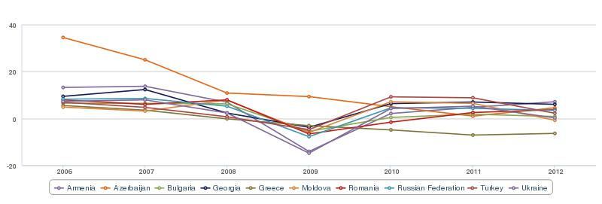
Figure 4. Overview of GDP growth trends per year over the period 2006-2012 (annual %) and impact of the 2008 crisis
Most Black Sea countries economic performance by far exceeded the EU’s average over the 2006-2012 period (see figure 5 below). Azerbaijan, Moldova, Georgia and Armenia registered particularly strong growth while on the other hand Greece’s economy contracted over the period.
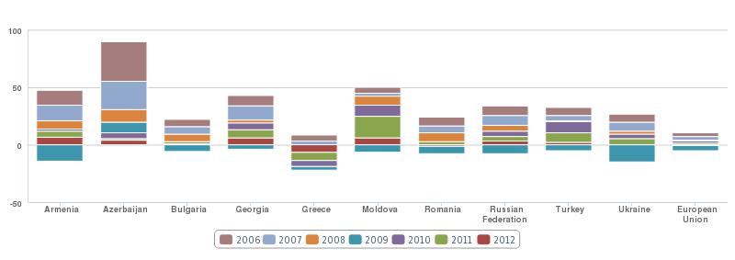
Figure 5. Stacked GDP growth per country over the period 2006-2012 (annual %)

Growth rates in 2012 still showed considerable variation among countries, with both Georgia and Armenia achieving high rates of growth (above 6%), while sub-national data reflects even greater disparities and persistant difficulties, in particular in eligible regions in Ukraine.
Though economic growth for the Black Sea Basin countries on average remained limited in 2012, it still outperformed the EU, which suffered a contraction of 0.3% overall. The EU recession and continuing problems emanating from the debt crisis limit further economic recovery in the Black Sea region. The EU, and more specifically the Eurozone area, is by far the most significant economic partner of the Black Sea region countries, EU Member States are key trade partners and the principal source of financing and foreign direct investment (FDI) for most Black Sea countries.
Other key indicators showed stable and sustainable trends in the Black Sea region, in particular the consumer price index that shows a continued trend of declining price pressures over the years. For the first time in 2012, all Black Sea region countries posted single digit rates of inflation, and inflation was below 5% in eight countries.
There has been overall a positive evolution of Black Sea Basin countries global competitiveness, as measured by the Global Competitiveness Index (CGI) of the World Economic Forum. Over the last five years, CGI scores for most countries have increased, meaning the countries improved the set of institutions, policies and factors determining the level of productivity and thus their potential for economic growth and their ability to sustain a high level of income. Between 2008 and 2012, Azerbaijan jumped from 69 to 39 (out of 148 countries) in CGI rankings, replacing Russia (downgraded from 64 to 51) as the most competitive economy of the Black Sea Basin. Armenia, Turkey, Georgia and Bulgaria are the other countries that have most improved their ranking and scoring over the period. Put in a worldwide context, Black Sea Basin countries main competitive assets are the availability of a healthy and educated workforce and a conducive macro-economic environment (save Greece), while the innovation factor is their weakest point (see table 2 below).

Country | GCI rank (out of 148) | CGI score (1-7) | 1 score (1-7) | 2 score (1-7) | 3 score (1-7) | 4 score (1-7) | 5 score (1-7) | 6 score (1-7) | 7 score (1-7) | 8 score (1-7) | 9 score (1-7) | 10 score (1-7) | 11 score (1-7) | 12 score (1-7)
Azerbaijan | 39 | 4.51 | 4.06 | 4.06 | 6.42 | 5.07 | 4.00 | 4.27 | 4.72 | 3.80 | 4.17 | 3.60 | 3.97 | 3.45
Turkey | 44 | 4.45 | 4.08 | 4.45 | 4.62 | 5.86 | 4.29 | 4.52 | 3.74 | 4.40 | 4.05 | 5.30 | 4.36 | 3.47
Bulgaria | 57 | 4.31 | 3.38 | 3.93 | 5.61 | 6.00 | 4.25 | 4.19 | 4.36 | 3.95 | 4.45 | 3.87 | 3.59 | 2.97
Russian Federation | 64 | 4.25 | 3.28 | 4.61 | 5.93 | 5.71 | 4.66 | 3.80 | 4.31 | 3.39 | 3.97 | 5.78 | 3.56 | 3.13
Georgia | 72 | 4.15 | 4.00 | 4.31 | 4.91 | 5.75 | 3.79 | 4.29 | 4.59 | 3.91 | 3.83 | 2.96 | 3.47 | 2.68
Romania | 76 | 4.13 | 3.34 | 3.33 | 5.14 | 5.47 | 4.41 | 3.89 | 3.96 | 3.95 | 4.14 | 4.44 | 3.62 | 3.01
Armenia | 79 | 4.10 | 3.98 | 3.81 | 4.88 | 5.46 | 4.18 | 4.34 | 4.49 | 3.91 | 3.74 | 2.73 | 3.82 | 2.99
Ukraine | 84 | 4.05 | 2.99 | 4.07 | 4.20 | 5.84 | 4.75 | 3.81 | 4.18 | 3.46 | 3.28 | 4.60 | 3.68 | 3.03
Moldova | 89 | 3.94 | 3.24 | 3.57 | 4.62 | 5.38 | 3.88 | 3.93 | 4.09 | 3.60 | 3.89 | 2.55 | 3.32 | 2.42
Greece | 91 | 3.93 | 3.49 | 4.79 | 2.82 | 6.10 | 4.81 | 3.93 | 3.77 | 2.86 | 4.62 | 4.37 | 3.84 | 3.08
The Global Competitiveness Index is based on 12 pillars : (1) Institutions, (2) Infrastructure, (3) Macroeconomic environment, (4) Health and primary education, (5) Higher education and training, (6) Goods market efficiency, (7) Labour market efficiency, (8) Financial market development, (9) Technological readiness, (10) Market size, (11) Business sophistication, (12) Innovation.
Table 2. Global Competitiveness Index (CGI) 2012-2013 ranking (out of 148 countries) and scoring (from lowest 1 to highest 7), overall and for each of the 12 pillars. Countries strongest features are highlighted in yellow.
In 2013, according to the World Economic Forum survey, corruption is perceived by business executives as the most problematic factor for doing business in Armenia, Azerbaijan, Bulgaria, Moldova and Russia, and as the second most problematic factor in Romania (after tax rates) and Ukraine (after access to financing). In Greece and Georgia, access to financing is considered the most problematic factor, while it is tax rates in Turkey.
In 2011 only three countries (Georgia, Azerbaijan and Armenia) attracted foreign direct investment (FDI) in excess of 5% of GDP against seven countries in 2007 (see figure 6 below). The FDI is a useful indicator of how the business environment in the eligible territories is perceived by investors, and it shows that the Black Sea region overall still suffers from a broader risk aversion following the 2008 crisis.
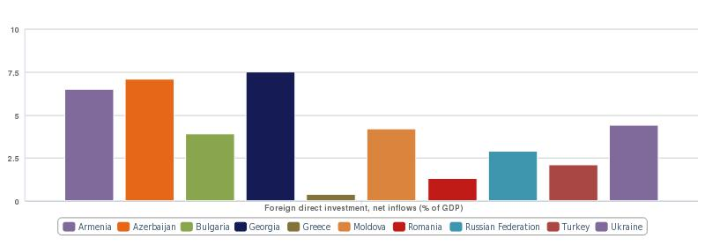Figure 6. Foreign Direct Investment, as a % of GDP, 2011
The significant emigration since the 1990s, mostly labour emigration, has generated considerable flows of remittances to the Black Sea region (see figure 7 below). Personnal remittances received represent a substantial part of Gross Domestic Product (GDP) for Moldova (23%), Armenia (20%) and Georgia (11%), and is at about the same level as foreign direct investment (FDI) overall for Ukraine. As migrant remittances tend to be more predictable and stable than FDI as a source of foreign exchange, they play an important role in offsetting the balance of trade deficit. Remittances also influence economic activity in the recipient country through the growth of consumer demand, savings and investments, and entrepreneurial activity, and as such represent an opportunity to take advantage of to get maximum benefit for the countries e.g. encouraging the productive investment of remittances.
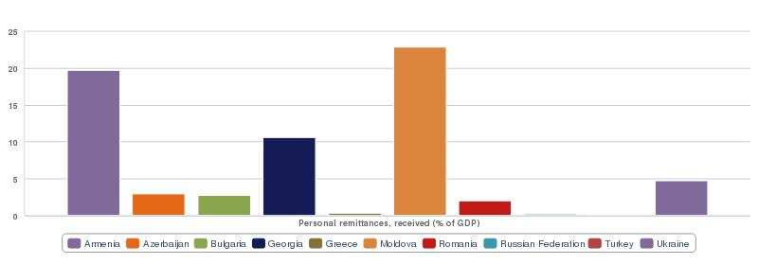Figure 7. Personnal remittances received, as a % of GDP, 2011
The Gross Domestic Product (GDP) per capita figures still reflect large wealth disparities among Black Sea region countries (see figure 8 below). GDP per capita in 2012 ranges from $2,038 in Moldova to $22,083 in Greece. The average for the region is $8,139, which corresponds to an upper middle income level.
This average is still four times lower than the EU overall figure in 2012 ($32,677), although, considering it was six times lower in 2006, there has been a convergence over the period, driven by stronger economic growth on average in the Black Sea region (see figure 5 above). When comparing Purchasing Power Parity (PPP), the GDP per capita gap is even smaller, as Black Sea region average figure is only 2.5 times lower than that for the EU.
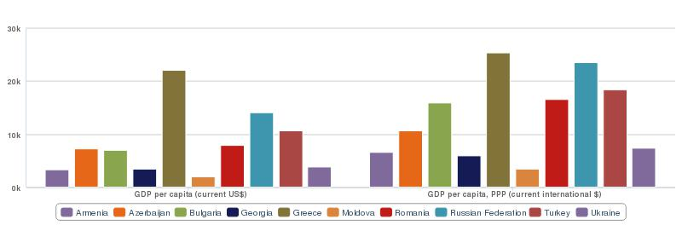
Figure 8. GDP per capita of Black Sea countries, 2012
Disparities among Black Sea countries have also reduced over the last few years, mostly due to the different countries growth rates but also to a lesser extent to their disparate demographic trends, notably affected by emigration. As a result the ratio in 2006 of 1 to 22 between the lowest (Moldova) and highest (Greece) GDP per capita figures, dropped to 1 to 11 in 2012 for nominal GDP, and 1 to 7 for PPP (see figure 8 above).
The economic structure in the Black Sea Basin eligible area still shows overall a larger share of agricultural and industrial sectors than the EU average. In terms of economic structure, the countries have in common a long-term decline of the agricultural sector, the rapid growth of the services sector, and the fact that on the expenditure side the private sector accounts for most of the incremental economic growth, led notably by consumer demand.
However the economies of the Black Sea region are very diverse in their structure, e.g. Armenia and Moldova rely on their agricultural sectors, while e.g. Ukraine is still dependent on low value added ‘heavy’ industry. Most countries are energy importers, but there are also two energy exporters (Russia and Azerbaijan), who rely on these exports to fuel their growth and face the challenge of diversifying their economies. Even service sector growth tends to take different forms. In some cases retail is more significant, though to varying degrees financial services, tourism, and transport and shipping also play important roles. This may generate complementarities within which regional cooperation may develop.
Small and Medium Enterprises
Small and medium enterprises (SMEs) in the ENI CBC Black Sea Basin eligible area represent 99% of all enterprises, which is similar to the EU overall. SMEs play an important role as key engines for economic growth, provide more than half of all employment and more than a third of gross value added. There is still potential for growth, in particular in the Eastern part of the Basin, considering these overall figures are below EU and OECD averages, where SMEs account for two-third of the employment and more than half the value added.
Access to financing continues to be one of the most significant challenges for the creation, survival and growth of SMEs, especially innovative ones, a problem that has been strongly exacerbated by the financial crisis. Business incubators, clusters of innovative SMEs, science and technology parks and development agencies may play an important role in facilitating appropriate access to financing for SMEs at local and regional levels. Cities and regions may underpin and strengthen this function through partnerships with private financial institutions and universities.
Other challenges to further development for SMEs in the Black Sea Basin include easing the administrative burden on small businesses, supporting entrepreneurship development and skills upgrading, supporting technology diffusion and SME access to international markets. This could provide opportunities in particular for the development of important regional sectors such as agribusiness, information and communication technologies (ICT), tourism and construction.
A comparison of business regulations for small and medium-size enterprises in Black Sea Basin countries reveals great discrepancies, an uneven path of reforms as well as a large potential for exchange of good practices among countries (see Table 3 below). Some countries (Georgia, Armenia) have achieved considerable success in improving the regulations that enhance business activity and now rank among the most business-friendly environments worldwide, while the business climate has got comparatively worse in Romania, Russia, Bulgaria and Ukraine since 2007. Georgia stands out as a top improver since 2005, both regionally and worldwide, focusing first on reducing the complexity and cost of regulatory processes (in such areas as business start-up, construction permits, property registration) then strengthening legal institutions relevant to business regulation (in such areas as getting credit and protecting investors). Aiming for economic recovery, Greece has recently considerably improved its regulatory framework, though it still ranks rather low.

Economy | EDB Rank 2007 | EDB Rank 2012 | Starting a Business | Dealing with Construction Permits | Getting Electricity | Registering Property | Getting Credit | Protecting Investors | Paying Taxes | Trading Across Borders | Enforcing Contracts | Resolving Insolvency
Georgia | 37 | 9 | 7 | 3 | 50 | 1 | 4 | 19 | 33 | 38 | 30 | 81
Armenia | 34 | 32 | 11 | 46 | 101 | 4 | 40 | 25 | 108 | 107 | 91 | 63
Bulgaria | 54 | 66 | 57 | 123 | 128 | 68 | 40 | 49 | 91 | 93 | 86 | 93
Azerbaijan | 99 | 67 | 18 | 177 | 175 | 9 | 53 | 25 | 76 | 169 | 25 | 95
Turkey | 91 | 71 | 72 | 142 | 68 | 42 | 83 | 70 | 80 | 78 | 40 | 124
Romania | 49 | 72 | 68 | 129 | 168 | 72 | 12 | 49 | 136 | 72 | 60 | 102
Greece | 109 | 78 | 146 | 31 | 59 | 150 | 83 | 117 | 56 | 62 | 87 | 50
Moldova | 103 | 83 | 92 | 168 | 161 | 16 | 40 | 82 | 109 | 142 | 26 | 91
Russian Federat. | 96 | 112 | 101 | 178 | 184 | 46 | 104 | 117 | 64 | 162 | 11 | 53
Ukraine | 128 | 137 | 50 | 183 | 166 | 149 | 23 | 117 | 165 | 145 | 42 | 157
Table 3. Ease of Doing Business (EDB) overall ranking 2007 (ranking out of 175 countries) and 2012 (out of 185 countries) and key indicator ranking for 2012. A good ranking on the EDB index means the regulatory environment is more conducive to starting and operating a local firm. Strong features of each country are highlighted in yellow.

International trade
With average exports representing 39% of GDP and imports 46% of GDP, the Black Sea countries show overall in 2012 a trade openness similar to that of the EU (with respectively 43% for exports and 41% for imports). These averages nonetheless mask great national discrepencies both in terms of the integration of these countries into international trade – with Bulgaria, Moldova and Ukraine being the most integrated and Romania and Russia the least – and in terms of trade balance, with the two oil-exporting contries achieving considerable trade surplus, while several others struggle with large trade deficits (see figure 9 below).
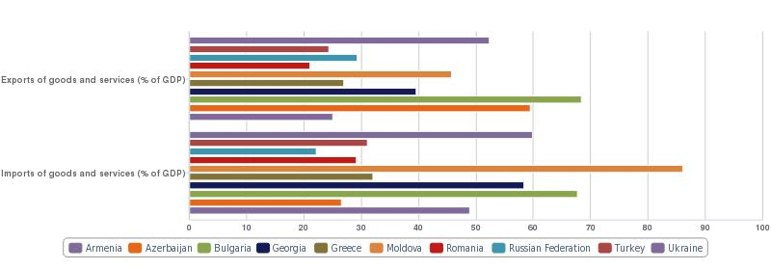
Figure 9. Exports and Imports of goods and services, as a % of GDP, 2012
Since 2004, the EU has become the main trading partner for each country in the Black Sea region. In 2009, trade with the EU amounted to 30% of overall trade for Armenia, 43 % for Azerbaijan and 29% for Georgia. Trade figures also reveal that intra-regional trade within the Black Sea region expanded more quickly than overall external trade, both in the growth years, from 2000–2008, and in the recovery year of 2010.
The breakdown of key exports for each country is presented in the figure below and shows the great disparities among Black Sea export profiles, with notably Moldova relying mostly on food products, Romania and Turkey on manufactured goods and Azerbaijan and Russia on fuel (see figure 10 below).
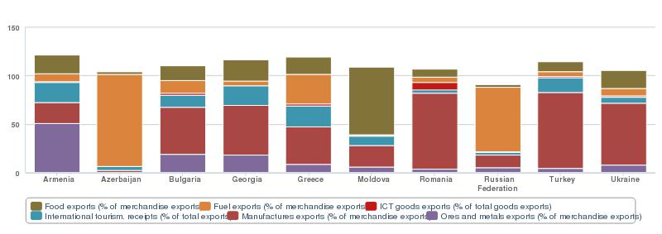
Figure 10. Main type of exports per country, 2011
High technology exports remain limited overall, ranging from 1.3% (Azerbaijan) to 10.2% (Romania) of manufactured goods exported in 2011 against 16% on average for the EU, with an uneven tendency over the last few years (see figure 11 below). These figures show that the stimulation of innovation and research in the Black Sea Basin area remains a challenge.
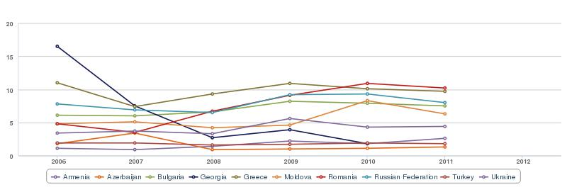
Figure 11. High technology exports (% of manufactured exports), 2006-2011
Tourism
The Black Sea Basin favourable climate and outstanding natural features - including mineral springs and beautiful beaches – have made the region an important destination for recreational and health tourism with the Crimea being the most important. Seaside resorts in Bulgaria, Romania, Ukraine, Russia and Georgia are very active but are less developed on Turkey's coasts (where tourism is focused mainly on the Mediterranean). Tourism potential in the Black Sea Basin area is rich and diversified, including in addition for spa and medical tourism, culture, nature, eco and agro-tourism, adventure, cave and mountain tourism, and tourism related to cuisine, rivers, hunting and diving as well as winter tourism (skiing).
Even though the lack of comprehensive regional data limits the possibility to draw a full regional picture, it appears clearly that the number of international visitors to the Black Sea Basin eligible area has expanded rapidly since 2004 thanks notably to enhanced tourist infrastructure. In 2012 only, Georgia registered 36% more international visitors than in 2011 reaching 4.4 million visitors (against 0.1 million in 2004). Tourism within the Black Sea region constitutes a substantial component, visitors from Black Sea Basin countries account for three quarters of total international arrivals to Azerbaijan, about half in Moldova and more than a third in Romania and Georgia. The countries of origin common to several Black Sea Basin tourist destinations include Germany, the United States, the UK and Italy, providing opportunities for joint tourism products around the Black Sea.
Continued expansion and diversification of tourism over the past six decades means it has become one of the largest and fastest-growing economic sectors in the world and it is still expected to increase considerably in the coming years. These international trends therefore could be an opportunity for cooperation for further tourism development based on the Black Sea Basin’s rich potential. Tourism has very positive impact on employment and income, although it also creates environmental challenges notably in the coastal areas.
Agriculture
Though the agricultural sector has generally declined in the Black Sea Basin countries, it is still a substantial or major component of most of their economies, in particular in terms of employment, e.g. providing over 45% of employment in Georgia and Armenia (see figure 13, employment distribution) or in terms of exports (see figure 10 above). Agricultural products such as fruits and nuts, vegetables, cereals, meat, dairy products, fish and alcohol are amongst the main goods traded between countries within the Black Sea Basin area and therefore there could be good potential complementarities.
Organic farming still appears to be little developped in the Black Sea Basin area, representing at best 1.6% of farmland in Romanian South-East region and 0.9% in Trabzon region (Turkey), despite a world tendency for a strong growth in organic farmland. Organically managed farmland grew by 57% in the EU in the period 2005 to 2011, representing 5.4% of EU agricultural land in 2011. Considering these dynamics and the more lalour-intensive nature of organic farming, it could present an opportunity for further development and cooperation in the Black Sea Basin.
The development of sustainable aquaculture in the Black Sea basin also seems to present good potential including in all the categories (fresh, brackish and marine water). The production from aquaculture has increased from 185,000 tons in 1999 to 320,000 tons in 2009 with an average annual growth rate of about 7.3 %. This increased production mainly came from freshwater aquaculture (74%), represented largely by carps and other ciprinidae, meanwhile mollusks and finfish (European sea bass, mussels, oysters, sea trout and turbot) characterise the production of brackish and marine aquaculture (26%). The actual development of brackish and marine aquaculture in the region is not homogenous and shows different patterns according to the technology applied and species reared (e.g. focusing on mussels in Bulgaria and on sea bass and sea trout in Turkey). Technology development during the last years (including cages and new rearing systems) represents new opportunities for marine aquaculture development as well as for regional cooperation and sharing of good practices.

SWOT - ECONOMY
STRENGTHS | WEAKNESSES
- Strong economic growth on average (2006-2012), especially Azerbaijan, Moldova, Georgia and Armenia  - Most of BSB countries seem to be recovering from recession  - Stable and sustainable single digit rates of inflation  - Improved set of institutions, policies and factors determining the level of productivity have raised competitiveness of most BSB countries  - Some countries (Georgia, Armenia) have achieved considerable success in improving the regulations that enhance business- friendly environments  - Disparities among BSB countries incomes have reduced over the last few years  - GDP per capita: there has been a convergence over the period (with EU overall)  - Economies of the BSB region are very diverse in their structure  - Diverse and possibly complementary service sector growth (retail vs financial services vs logistics)  - Intra-regional trade within the BSB region expanded more quickly than overall external trade  - Favourable climate for recreational tourism and outstanding natural features  - Tourism potential in BSB area is rich and diversified  - Agricultural products amongst the main goods traded between countries within the BSB area  - Potential for the development of sustainable aquaculture in BSB | - Growth rates considerable variation among countries (sub-national even greater disparities)  - Large wealth disparities among BSB countries  - GDP per capita in BSB four times lower than the EU overall figure  - Corruption is perceived by business executives as one of the most problematic factor for doing business in majority of BSB countries  - Business climate has got comparatively worse in Romania, Russia, Bulgaria and Ukraine since 2007  - Armenia and Moldova rely heavily on their agricultural sectors  - Low value added ‘heavy’ industry (especially Ukraine)  - Energy exporters (Russia and Azerbaijan) face the challenge of diversifying their economies  - Low access to financing, notably for SMEs  - Administrative burden on small businesses  - Great national discrepencies both in terms of the integration of BSB countries into international trade and in terms of trade balance  - Low capacity for innovation, high technology exports remain limited overall  - Organic farming is still little developed in BSB region
OPPORTUNITIES | THREATS
- Outmigration reducing pressure on unemployment  - Flows of remittances play an increasing role in regional economic development, and plays an important role in offsetting the balance of trade deficit  - Number of international visitors to the BSB area has expanded rapidly  - Continued expansion & diversification of tourism, fastest-growing economic sectors in the world  - High growth rate in organic agriculture worldwide | - EU recession and continuing problems emanating from the debt crisis limit further economic recovery in BSB region  - Foreign Direct Investments: BSB region still suffers from broader risk aversion following the crisis

Education and employment, R&D, research
Population level of education
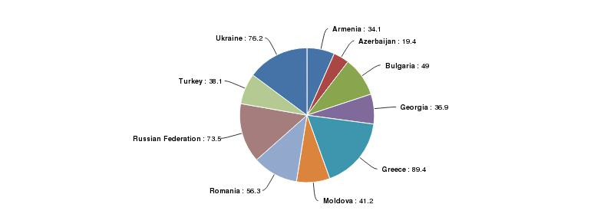
Figure 12. School enrollment in tertiary education (as a % of relevant age class), 2007
The Black Sea Basin is characterized by the high level of education of its workforce overall (although there are great regional disparities) and increasing youth enrolment in higher education on average, ranging from 19% in Azerbaijan to 89% in Greece (see figure 12 above).
Human capital therefore appears as a strong asset in the region, though education systems often face the challenge of adapting their training to match the changing needs of the economy in order to provide an appropriate skilled worforce. According to an EBRD/World Bank 2009 survey, for example, 43% of enterprises in Ukraine and Moldova consider the lack of skills as a problem for the performance and development of their enterprises. The percentages are lower, but still significant, for Georgia (27%) and Armenia (24%). Thus vocational education and training also has an important role to play, both to improve technology absorption and diffusion in the countries and to enhance individual employability.
Employment distribution and unemployment challenges
The strong structural hetereogeneity of Black Sea Basin economies (share of traditional industries, weight of the agricultural sector) and the pace of economic development and restructuring (growth of services, tourism and the oil industry in particular) is reflected in employment distribution and unemployment challenges (see figure 13 and table 4 below).
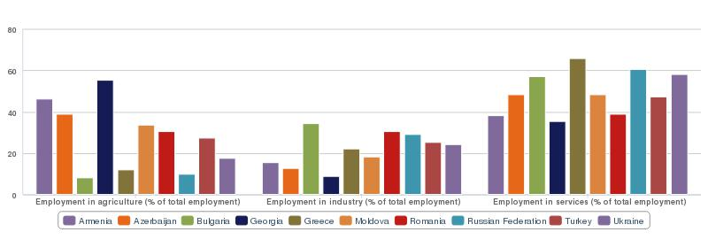Figure 13. Employment distribution, 2007
The gap in average wages among the Black Sea Basin areas has considerably reduced since 2006, going from a 1 to 10 ratio to a 1 to 4 ratio (between Moldova and Greece) in 2012. Following the harsh recession, since 2008 salaries in Greece have dropped while wages in all other regions/countries have considerably increased, multiplying by more than three in Azerbaijan and Georgia and by four in Bulgaria (see table 4 below). On average, wages within the Black Sea Basin remain four times lower than the EU average.
However, wage and salaried earners represent only around 40% of all workers in Georgia and Azerbaijan and about 65% in Romania, Turkey, Moldova and Greece – in sharp contrast to Bulgaria, Ukraine and Russia, or the EU average (>82%). The majority of workers in Georgia and Azerbaijan are self-employed, mostly in low-productive agriculture of a subsistence nature or small-scale informal activities. The challenge to integrate these workers into higher-productivity sectors, enhancing their skills and creating more jobs in the formal economy therefore remains high.

COUNTRY | ELIGIBLE REGIONS | WAGES  (€, monthly) | MALE UNEMPLOYMENT RATE (%) | FEMALE UNEMPLOYMENT RATE (%) | YOUTH UNEMPLOYMENT RATE (%)
ARMENIA | (whole country) | n.a. | 22.0% | 35.0% | 58.0%
AZERBAIJAN | (whole country) | 380 | 4.3% | 6.1% | 14.2%
BULGARIA | Severoiztochen | 678 | 19.1% | 17.2% | 36.1%
 | Yugoiztochen | 688 | 12.6% | 11.2% | 33.4%
GEORGIA | (whole country) | 350 | 16.1% | 13.8% | 33.3%
GREECE | Kentriki Makedonia | 885 | 25.5% | 27.5% | 62.0%
 | Anatoliki Makedonia – Thraki | 854 | 26.3% | 33.8% | 66.0%
MOLDOVA | (whole country) | 223 | 6.8% | 4.3% | 13.1%
ROMANIA | South-East | 413 | 7.1% | 6.1% | 31.3%
RUSSIA | Rostov Oblast | n.a. | 7.0% | 6.0% | 16.0%
 | Krasnodar Krai | n.a. | 7.0% | 6.0% | 16.0%
 | Adygea Republic | n.a. | 7.0% | 6.0% | 16.0%
TURKEY | İstanbul (TR10) | 760 | 10.1% | 14.4% | 20.0%
 | Tekirdağ, Edirne, Kırklareli (TR21) | 760 | 5.5% | 11.7% | 17.2%
 | Kocaeli, Sakarya, Düzce, Bolu, Yalova (TR42) | 760 | 8.9% | 14.0% | 20.1%
 | Zonguldak, Karabük, Bartın (TR81) | 760 | 6.5% | 8.6% | 17.9%
 | Kastamonu, Çankırı, Sinop (TR82) | 760 | 5.1% | 6.4% | 11.6%
 | Samsun, Tokat, Çorum, Amasya (TR83) | 760 | 5.2% | 6.8% | 10.5%
 | Trabzon, Ordu, Giresun, Rize, Artvin, Gümüşhane (TR90) | 760 | 7.8% | 4.0% | 22.0%
UKRAINE | Odeska | 338 | 8.0% | 3.1% | 10.7%
 | Mykolaiv | 353 | 9.2% | 6.5% | 19.6%
 | Kherson | 284 | 9.2% | 8.2% | 20.9%
 | Zaporosh'ye Oblast | 366 | 8.1% | 5.7% | 11.3%
 | Donetsk Oblast | 437 | 8.6% | 7.3% | 19.0%
 | Crimea Republic | 332 | 5.2% | 6.5% | 12.2%
 | Sevastopol | 362 | 7.1% | 4.8% | 18.0%
AVERAGE |  | 557 | 9.4% | 10.8% | 24.1%
Table 4. Overview of wages and unemployment rates in the Black Sea Basin eligible areas
Statistics reveal that the Black Sea Basin eligible areas have very different unemployment challenges. While Azerbaijan, Moldova, Romania, some Ukrainian regions (Crimea, Sevastopol, Odeska) and Turkish rural regions experience low or moderate levels of unemployment (< 7%), Armenia, Georgia, both Greek regions and the Bulgarian region of Zeveroiztochen have unemployment rates of above 15% (see table 4 above).
In regard to gender influence and unemployment rates, female unemployment tends to be higher in Armenia, Azerbaijan, Greece and most Turkish regions (save Trabzon) and lower in the other countries (see table 4 above).
Youth unemployment is a particularly acute issue, reaching 24% on average in the Black Sea Basin area in 2012, and was visibly most affected by the aftermath of the 2008 crisis (see figure 14 below). Common to all the Black Sea Basin regions, youth unemployment varies from 10.7% in the Odeska region (Ukraine) to 66% in Anatoli Makedonia Thraki (Greece).
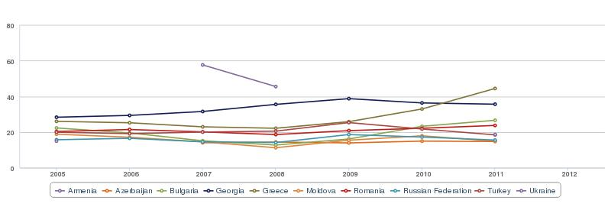
Figure 14. Unemployment, youth, 2005-2011 (national level as a % of total labor force ages 15-24) – impact of 2008 crisis
Research and development, research

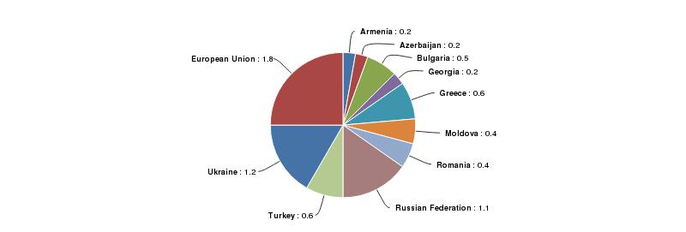
Figure 15. Research and Development expenditure (% of GDP), 2005
The Black Sea Basin area has a rich scientific potential, if considering the large numbers of universities and research centers in the area, although it faces difficulties in fostering research and innovation and keeping up with the pace of technological progress as is reflected in the structure of exports and in rather low research and development expenditures (see figure 15 above). Research and Innovation is therefore another potential area for cooperation.
Research and networking in science and technology in the Black Sea Basin region among some or all of the countries is supported and active under the EU 7th framework programme and Black Sea Basin ENPI CBC programme, as well as within a variety of other European and Black Sea initiatives and organisations, sometimes specialising on a specific field. Collaborative work on marine environment notably involves 43 research centres and universities in Black Sea riparian countries within a Black Sea Scientific Network (SCENE), and a strategic research agenda towards integrated marine research strategies and programme has been developed under the SEAS-ERA project. Considering the Black Sea Basin ENI CBC programme eligible area, it seems important to underline that key research centres for this collaborative work are sometimes located in capital cities.

SWOT – EDUCATION, EMPLOYMENT, RESEARCH
STRENGTHS | WEAKNESSES
- High level of education of BSB worforce overall  - Gap in average wages among the BSB areas has considerably reduced  - Large numbers of universities and research centers  - Collaborative work on marine environment notably involves 43 research centres and universities in Black Sea riparian countries | - Great regional disparities of levels of education  - Education systems challenge to adapt their training to match the changing needs of the economy  - Wage and salary earners only represent around 40% of all workers in Georgia and Azerbaijan (majority is self-employed, mostly in low-productive agriculture or small-scale informal activities)  - Armenia, Georgia, both Greek regions and the Bulgarian region of Zeveroiztochen have unemployment rates of above 15%  - Youth unemployment is a particularly acute issue, reaching 24% on average  - Female unemployment is higher in Armenia, Azerbaijan, Greece and most Turkish regions  - Rather low research and development expenditures
OPPORTUNITIES | THREATS
- Research and networking in science and technology variety of European and Black Sea initiatives and organisations (especially in maritime, environmental, energy and transport areas) | - Brain drain from the region (incl. brain waste - highly educated migrants working in low-skill jobs)

Environment
Overview of Black Sea Basin key environmental challenges
The Black Sea Basin environment is of paramount importance both in terms of regional development and of quality of life for its inhabitants. The Black Sea ecosystem is known to be rich and diverse but is also considered to be vulnerable as it experiences notably significant pressure from land-based pollution, through its large catchment area including the Azov Sea and three main river basins, the Danube, the Dnipro and the Don.
Inflows make the Black Sea very prone to eutrophication, a phenomenon made worse by the urban (sewage) and mostly agricultural discharges carried by the rivers and by direct discharges from numerable coastal ports, industrial zones and urban areas. A semi-closed sea, it connects with the oceans only through the Bosporus and The Dardanelles which explains its low renewal rate. In the coming years nutrient pollution is likely to continue to decrease in the Danube Basin due to the implementation of EU environmental policy, but the Don and Dnipro may continue to carry heavy nutrient loads into the southwestern part of the coast, leading to the whole Black Sea ecosystem being further endangered if necessary efforts and cooperation are not undertaken at the level of the Black Sea Basin overall (see figure 16 below).
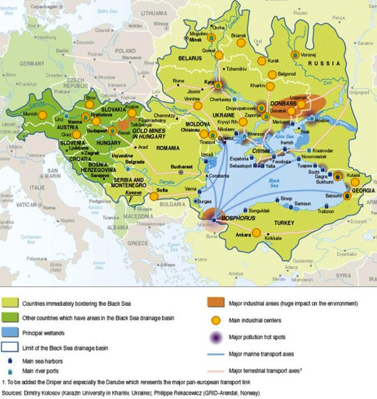
Figure 16. Overview of Black Sea drainage basin main sources of pollution 2005
In addition to eutrophication, other high priority transboundary ecological problems around the Black Sea include the decline in living resources (mostly fish stocks), chemical pollution, biodiversity change, habitat destruction, invasion by alien species, climate-change impacts, and mesoscale variability in the circulation system. Oil pollution enters the sea as a result of operational discharges by vessels and due to accidents as well as through land-based sources, and appears to be an ongoing concern in particular along major shipping routes and ports (see figure 17 below). Discharge of insufficiently treated sewage introduced microbiological contaminants into the Black Sea and posed a threat to human health, development of sustainable tourism and aquaculture. The Black Sea is also particularly vulnerable to solid wastes dumped into the sea from ships and coastal towns (eventually washed ashore) and some beaches have had a high accumulation of garbage presenting a risk to marine animals and humans.
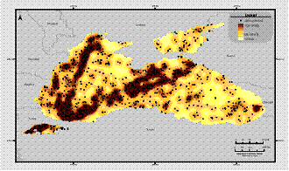
Figure 17. Composite map of oil spills anomalies (illicit vessel discharges) in the Black Sea during 2000-2004 : the darker areas signify the high anomaly regions
Policy coordination on a range of issues including the management of marine resources, integrated coastal zone management, accidental pollution, pollution from ships and from land, hazardous substances, waste dumping and atmospheric pollution is carried out by the Black Sea Commission (BSC). The BSC also carries out monitoring of oil pollution (with support from the EU) and international practical exercises for oil spill preparedness.
The importance of the environnement as a key challenge for the Black Sea Basin cooperation area is further emphasized by the Environnement Partnership of the Black Sea Synergy launched in March 2010.
Protected natural areas
There are more than twenty nature reserves in the Black Sea and eight in the Sea of Azov. These have different status at local, national and international levels (see figure 18 below). The four UNESCO biosphere reserves of international status protected by identical legislation are Kamchia (Bulgaria), Chernomorsky (Ukraine), Danube Delta (Romania) and Dunaisky (Ukraine). All Black Sea countries have ratified the Ramsar Convention on Wetlands of International Importance and the largest protected area of this kind in the coastal zone of the sea is in Ukraine.
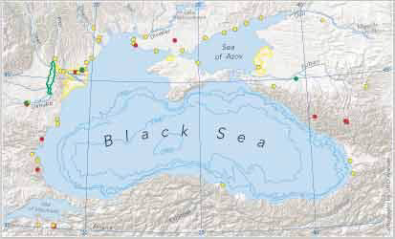 | 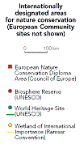
Figure 18. International nature protected areas in the Black Sea, compiled by European Environment Agency
The overarching international framework for cooperation on protected areas remains the Convention on Biological Diversity and notably the Convention’s Programme of Work on Protected Areas. The ‘Environment for Europe’ process within UNECE has been promoting integrated networks of protected areas towards the establishment of a Pan-European Ecological Network, which is being implemented in the EU via the ‘Natura 2000’ network and promoted in the other countries around the Black Sea through the ‘Emerald Network’. In addition to this global framework, the Black Sea Environment Programme organises conservation work in habitats that are critical for populations of priority species.
These efforts to recognize and protect the natural environment do, however, face serious limitations. Overall, the extent of terrestrial and marine protected areas varies (see figures 19 and 20 below), but still falls significantly short (less than 2% in Moldova and Turkey) in comparison to the EU, where protected areas cover 15.1% of the total territorial area. Many reserves also lack effective management plans and infrastructure, so that reinforced cooperation in those areas would seem to be of crucial importance, considering the rich and vulnerable environnement of the Black Sea region.
Figure 19. Terrestrial and marine protected areas (% of total territorial area of each country), 2010 | 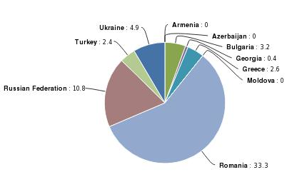  Figure 20. Marine protected areas (% of territorial waters of each country), 2010

Water and waste-water
The Black Sea region is generally well provided with freshwater resources, including those suitable for drinking water. However, pollution of rivers has led to a sharp decline in access to safe drinking water resources and necessitates the use of costly technologies for water treatment. Usage of groundwater for drinking purposes is not possible everywhere because of a lack of resources (this particularly applies to the southern part of the Black Sea region) while groundwater may itself be polluted. As a result, the current access to safe drinking water in the region could be characterised as problematic, particularly in rural areas.
The large cities of the Black Sea Basin catchment area outside the coastal zone mostly have full biological treatment of wastewater, which in general operates with sufficient efficiency. Nonetheless, wastewater treatment is often not sufficient in the rural areas and in coastal cities - all the more so given that the treatment plants get overloaded in the summer when the population in coastal cities increases substantially. Untreated or insufficiently-treated sewage (mostly due to worn-out equipment) is the main source of pollution from coastal cities and villages. Moreover usually no structures exist to remove effluent far from the shore (for instance, 3 miles), thus the coastal area of the sea is polluted. Municipal wastewater contributes significantly to the load of organic materials and nutrients in the Black Sea, as well as to the spread of diseases, though microbiological pollution is primarily a local problem.
Difficulties faced are also sometimes linked to institutional causes, in particular when central state control was replaced by governance structures based on decentralisation and greater levels of autonomy at the regional level before the development of sufficient institutional capacity at regional level. Public authorities in Moldova, Ukraine, Georgia and Russia assessed the lack of practical knowledge and skills in water resources management at the same level as the lack of adequate finance as the principal reasons for their inability to carry out the needed management reforms and infrastructure development.

Sustainable energy development
The need to promote sustainable energy development has been emphasised by the Ministers of Energy of BSEC Member States who have agreed to enhance cooperation and explore ways to promote Green Energy investments with an emphasis on energy efficiency, renewable energy sources and environmentally friendly energy technologies.
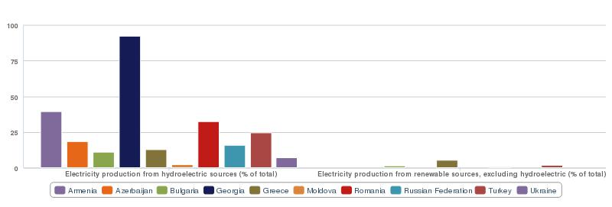
Figure 21. Electricity production from hydroelectric and renewable sources, 2010
Each country in the Black Sea Region is distinct in terms of its energy use and potential for renewable energy, nonetheless several trends appears. Hydropower is the most widespread source of energy, accounting for most of the electricity production in Georgia. Exploitation of renewables sources other than hydropower is still in its early stages, representing at best 5.3% in Greece against 9.1% on average in the EU (see figure 21 above), but has risen over the last few years. The massive growth in wind power seen globally is beginning to make itself felt in the region.
The Black Sea potential for marine renewable energy has not been fully investigated yet. In the Black Sea area tides are insignificant for energy extraction, but the offshore wind and wave power potential could be further assessed. Both Bulgaria and Romania recently began using, and exploring in detail, opportunities for marine renewable wind energy options.
Therefore, except maybe in Azerbaijan where the abundance of oil and gas complicates the economic argument for alternatives, there appears to be a broad scope for further sustainable energy development in the region.

SWOT – ENVIRONMENT
STRENGTHS | WEAKNESSES
- Black Sea ecosystem is known to be rich and diverse  - Four UNESCO biosphere reserves of international status protected by identical legislation  - BSB region is generally well provided with freshwater resources  - Large cities outside the coastal zone mostly have full and sufficiently efficient biological treatment of wastewater  - Hydropower is the most widespread source of renewable energy (strong in Georgia)  - Renewables sources other than hydropower have increased over the last few years | - Significant pressure from land-based pollution, through its large catchment area  - Black Sea low renewal rate and very prone to eutrophication  - Complex of transboundary ecological problems around the Black Sea (decline in living resources, chemical pollution, biodiversity change, habitat destruction, invasion by alien species, climate-change impacts, and mesoscale variability in the circulation system)  - Some beaches have had a high accumulation of garbage  - Extent of terrestrial and marine protected areas significantly less than that for the EU  - Many nature reserves lack effective management plans and infrastructure  - Current access to safe drinking water in the region could be characterised as problematic, particularly in rural areas. Usage of groundwater for drinking purposes is not possible everywhere  - Coastal area of the sea is polluted (wastewater treatment often not sufficient in rural areas and coastal cities: worn-out equipment, no structures exist to remove effluent far from the shore, and insufficient institutional capacity at regional level s  - Coastal wastewater treatment plants get overloaded in the summer  - Exploitation of renewables sources other than hydropower is still in its early stages
OPPORTUNITIES | THREATS
- Nutrient pollution from Danube is likely to continue to decrease due to the implementation of EU environmental policy  - Massive growth in wind power seen globally  - Calls for a more efficient EU energy policy towards the Black Sea; BSEC promotion of Green Energy investments | - Don and Dnipro may continue to carry heavy nutrient loadings into Black Sea northwestern part and Azov Sea  - Oil pollution enters the sea as a result of operational discharges by vessels and due to accidents  - Discharge of insufficiently treated sewage  - Pollution of rivers has led to a sharp decline in access to safe drinking water resources  - Around 50,000 ships sail through the Bosporus every year, including at least 10,000 oil tankers  - The transport of oil and gas across the Black Sea is a major activity

Health, safety and security
Overview of key health challenges
Though people in the Black Sea Basin countries still live on average seven years less than in the EU, the gap narrowed slightly from 2006 to 2010 as life expectancy has increased more quickly in the Black Sea Basin than in the EU, with a gain of 1.2 years (at 72.7) against a little less than 1 in the EU (at 79.6). Great inequalities remain between and within countries in the Black Sea Basin area (see figure 22 below). Life expectancy for men in 2012 ranged from 64.4 years in Donetsk oblast (Ukraine) to 78.2 in Greece, and for women from 75 years in Moldova and Odeska oblast (Ukraine) to 82.9 in Greece.
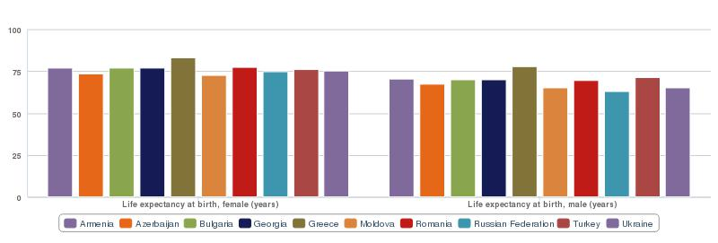
Figure 22. Life expectancy at birth, 2010
To sustain the average gains in life expectancy, continuous efforts are required to decrease mortality, particularly from diseases of the circulatory system, respiratory and infectious diseases, and external causes of injury and poisoning.
Circulatory system diseases remain by far the most important cause of premature death overall, with higher rates for men than women, followed by cancer. However, mortality rates linked to circulatory system diseases vary widely between countries in the region, from 245 deaths (per 100,000 population) in Greece to above 700 in Ukraine and Moldova. Evidence indicates that this challenge can be improved by countries addressing a combination of preventable factors, including high alcohol intake, obesity, high salt intake and physical inactivity. Promotion of healthy lifestyle appears thus as a priority for improving overall health and reducing premature mortality in the Black Sea Basin.
In regard to cancer, the mortality and incidence patterns vary according to the type of cancer with lung and colon neoplasms having the highest overall mortality. Men are also more affected than women by cancer with 172 against 96 deaths (per 100,000 population) on average in 2008. Discrepancies also appear within the Black Sea Basin region with Armenia and Romania being the most affected and Turkey and Georgia the least.

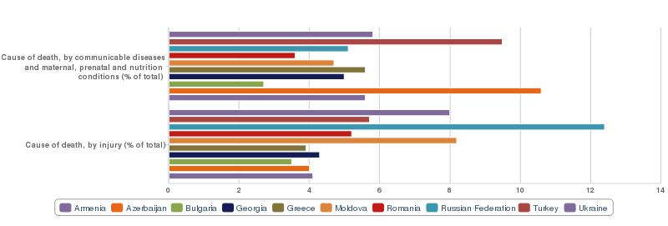
Figure 23. Cause of death (% of total deaths), 2008
External causes of injury and poisoning are also important causes of mortality in the region, again with higher rates among men then women, and comprise a constellation of causes, including transport and motor vehicle accidents, falls, suicides and homicides. With a three-fold disparity appearing at country level (see figure 23 above), best practices could be shared between countries to tackle deaths from these causes.
Within communicable diseases, tuberculosis remains a significant cause of mortality, however prevalence and mortality rates have both decreased over the last few years (see figure 24 below).
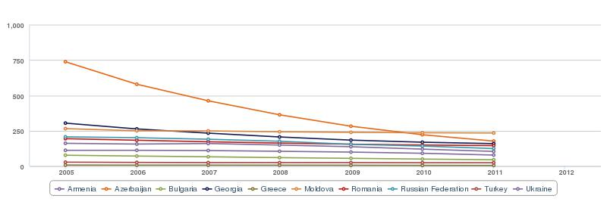
Figure 24. Tuberculosis prevalence rate (per 100.000 population), 2005-2011
In regard to HIV, the rates in Ukraine and Moldova are far beyond the EU average of 0.3% of the 15-49 age group infected, nonetheless HIV prevalence over the last few years appears to have decreased in Ukraine while only marginally increasing overall in the other countries (see figure 25 below).
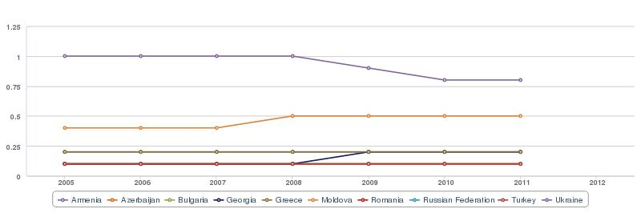
Figure 25. Prevalence of HIV (% of population ages 15-49), 2005-2011

The infant mortality rate, a useful indicator of both access to health care and overall living conditions, reveals great disparities among Black Sea countries, with only Greece in line with EU average (see figure 26 below). Particularly high in Azerbaijan – about 10 times higher than the EU level – it nonetheless decreased steadily, from 41 deaths before one year of age per 1,000 children in 2006, to 31 deaths in 2012. It also decreased, to a lesser extent, in all the other Black Sea countries over the period.

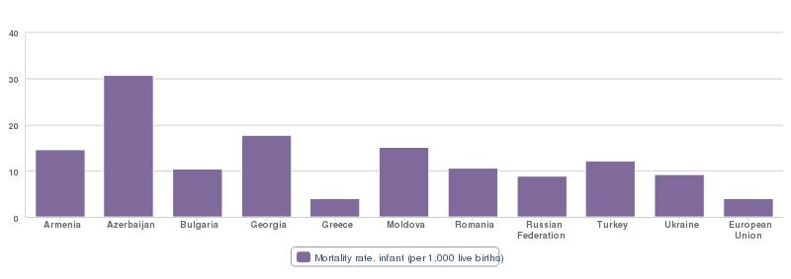
Figure 26. Number of infants dying before reaching one year of age, per 1,000 live births in 2012

With 35% of the population living below the national poverty line in Armenia in 2011 and 25% in Georgia in 2009, the countries’ health systems face serious challenges dealing with poverty and social exclusion. Armenian poverty figures have been stable since 2006, while poverty in Moldova dropped from 30% of the population in 2006 to 17% in 2011. Some Black Sea countries designed specific health systems responses to adress poverty and social exclusion. Notably, in 2006 Georgia launched a Medical Assistance Programme for People below the Poverty Line that provides a comprehensive package of services (including ambulatory treatment and urgent and planned hospital and specialized care) for the most vulnerable segment of the population. Romania carried out a programme focusing on its ethnic minority Roma population, disproportionately affected by many diseases including tuberculosis (TB). This involved notably the recruitment and training of peer health educators (representatives from the Roma community itself) that proved successful in improving the timely detection of TB cases and the completion of treatment in Roma communities. Such or similar initiatives, targeting poverty and social exclusion in the health sector, may provide a basis for exchange of experience and good practice among Black Sea countries.
Health challenges also include the impact of reproductive health on gender inequalities. Safe motherhood reflects the importance society attaches to women’s reproductive role. Early childbearing, as measured by the adolescent fertility rate, is associated with greater health risks for mothers and infants while adolescent mothers often are forced out of school and into low-skilled jobs. In this regard, Georgia’s high rates for both maternal mortality and fertility rates do not only reflect its health system deficiencies, but they also prevent gender equality (see figure 27 below). Furthermore, the trend is negative as female maternal mortality has considerably increased in Georgia over the last 10 years and in Moldova and Ukraine over the last five years. However, female mortality rates over this period have steadily decreased in all the other Black Sea Basin countries - particularly so in Azerbaijan and Turkey - and is relatively low in Greece.
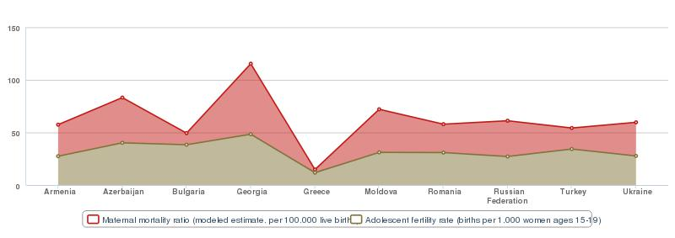
Figure 27. Maternal mortality rate and Adolescent fertility rate in 2010
Female reproductive health has a strong impact on the UNDP calculation of the gender inequality index (see figure 28 below), though Georgia’s high inequality score also reflects women’s poor representation in Parliament. Women’s relative disadvantage is smallest in Greece and Bulgaria, thanks to the countries efforts in reproductive health but also where women have a bigger share of parliamentary seats. In Turkey nonetheless, the main obstacles to gender equality are the unequal access by women to higher education and to the labour market.

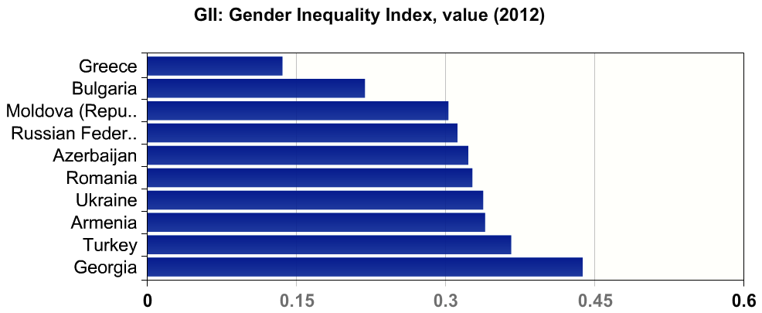
Figure 28. Gender Inequality Index (GII) in Black Sea Basin countries, UNDP, 2012. A high GII value indicates high inequalities.
Safety and security challenges
Irregular migration remains a reality in the Black Sea Basin region with one of the biggest challenges being human trafficking. Some of the countries in the region, such as Moldova and Ukraine, are the major countries of origin for victims of trafficking to the EU. The Black Sea region is also the meeting point for many irregular migration routes and illicit trafficking leading further west. The Eastern Mediterranean route, the Balkan and the Central and Eastern European routes all, at some point, cut through the Black Sea region.
Persistent conflicts and bilateral disputes often undermine endogenous regional cooperation, putting a strain on the potential effectiveness of regional organisations (notably BSEC). The Black Sea region continues to be affected by a number of conflicts, and the persistence of trade and economic blockades between several pairs of Black Sea states (Russia-Georgia, Turkey-Armenia, Azerbaijan-Armenia) has fragmented the regional economy and generated distortions undermining efforts toward economic cooperation.
In August 2008, the Black Sea region became the focal point of international attention as a result of the military confrontation between Georgia and Russia that put region-wide cooperation further on hold. Energy disputes between Russia and Ukraine in the winter of 2006 and 2009 raised concerns about the EU’s energy security and elicited calls for a more efficient EU energy policy towards the Black Sea.
Another major regional and international crisis unfolded after the Ukrainian revolution in February 2014, followed by illegal annexation of Crimea Republic and Sevastopol by the Russian Federation and armed conflicts in southeast of Ukraine.

SWOT – HEALTH, SAFETY AND SECURITY
STRENGTHS | WEAKNESSES
- Life expectancy has increased more quickly in BSB than in the EU  - Tuberculosis prevalence and mortality rates have both decreased over the last few years | - People in BSB countries live on average seven years less than in the EU  - Great inequalities remain between and within countries in the BSB area in terms of life expectancy  - Mortality, particularly from diseases of the circulatory system, and cancer remains high  - High (though decreasing) infant mortality rate  - Various preventable factors have high negative impact, including high alcohol intake, obesity, high salt intake and physical inactivity  - External causes of injury (incl. poisoning) disparities at country level  - HIV rates in Ukraine and Moldova are far above the EU average  - Health systems face serious challenges dealing with poverty and social exclusion  - High and in some countries increasing female maternal mortality  - Gender inequalities reflected in reproductive health and parliamentary representation  - Meeting point for many irregular migration routes  - Bilateral disputes and conflicts, including armed confrontations
OPPORTUNITIES | THREATS
- Emigration affects notably doctors and skilled medical workforce in Moldova and Bulgaria
- Human trafficking
- Larger-scale war

Energy, transport and communication networks
Overview of Black Sea Basin energy exchanges and networks
The transport of oil and gas across the Black Sea is a major activity, mainly via tankers that sail from the oil ports of Novorossiysk and Tuapse (Russia), Odessa (Ukraine) and Poti and Batumi (Georgia) – see figure 29 below. On the western shore, the European Union has only one major port, Constanta (Romania).
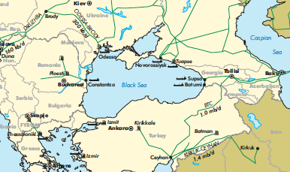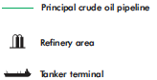
Figure 29. Regional oil infrastructure map, 2007
The oil ports of Ukraine, Russia and Georgia are all terminals for oil and gas pipelines from the Caspian Sea. In the south, an oil pipeline that originates in Baku (Azerbaijan) crosses Georgia and Anatolia before reaching the Turkish port of Ceyhan on the Mediterranean (see figure 29 above). The Blue Stream gas pipeline runs under the Black Sea to connect Tuapse (Russia) with Samsun (Turkey). This network of pipelines is expected to expand in the future via two projects: Nabucco (from Baku to the European Union, through Ceyhan) and South Stream (from Tuapse to Italy, via Constanta and Burgas).
Several projects are also underway for the integration of electricity grids around the Black Sea, potentially reducing vulnerability as well as consumer prices for electricity.
Overview of Black Sea Basin transport infrastructure
Economic development in the Black Sea countries, in particular rising foreign trade, gave a great push to the organization and development of a regional Black Sea transport system. The total cargo turnover for the ports of Bulgaria, Georgia, Russia, Romania and Ukraine between 2000 and 2007 increased more than twice and around 50,000 ships sail through the Bosporus every year including at least 10,000 oil tankers. The overall quality of port infrastructure around the Black Sea is still assessed as rather poor in Moldova and Romania (scoring less than 3 on a scale of 7) and as good in Greece, Turkey and Georgia.
The Trans-Black Sea inter-modal transport network is also gaining more importance in the region with sea ports playing an essential role in connecting land transport lines with maritime lines. The ports of the Black Sea region serve not only as transport gateways for the routes connecting the countries of the region but they also serve commodity turnover between the Asian-Pacific region and Europe. Even for Black Sea Basin land-locked countries, maritime transport provides access to the Mediterranean Sea and to ocean transport shipping routes i.e. for intercontinental trade links. The Danube river also plays a strategic role in the Black Sea region connecting the region with the North Sea and the rest of Europe and serving as a central artery for Bulgaria, Moldova, Romania, and Ukraine.
Motorways of the Sea (MoS) have been identified for transnational multimodal axis including the Black Sea region, as an extension of the Trans-European Transport Networks (TEN-T) to EU Neighbouring countries (see figure 30 below). The aim is to improve transport connections between the EU and its Eastern neighbours, as well as to improve intermodal freight operations, through the integration of short sea shipping into transport logistics, therefore improving port operations and making hinterland connections more efficient. The reference transport networks include different corridors in the Black Sea and Caspian Sea region, with EU countries being part of the EU TENs connecting with the Black Sea and the Transport Corridor Europe-Caucasus-Asia (TRACECA) linking Black Sea and Caspian Sea countries. Motorways of the Sea (MoS) imply a traffic concentration on sea-based routes and improving existing maritime links or establishing new viable, regular and frequent maritime links (see figures 32-33). Motorways of the Sea (MoS) may be operated by all types of regular shipping services including roll-on/roll off ships, roll-on/roll-off passenger ferries, rail ferries, container vessels and sea river ships. A list of MoS potential pilot projects for the Black Sea was identified in July 2010 and five were selected for further EU support.

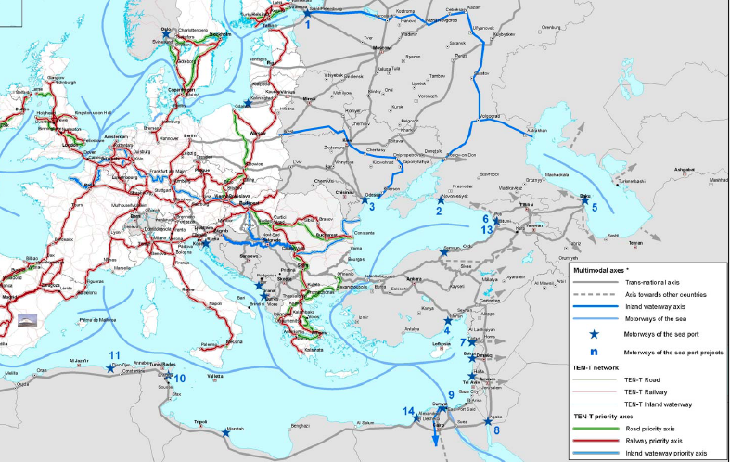
Figure 30. Multimodal axis within the Black Sea Basin and beyond, Ten-T network and priority axes, 2005
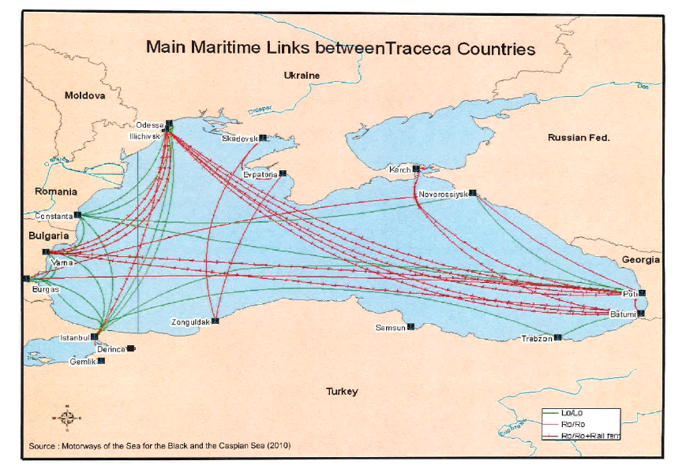
Figure 31. Main maritime routes in the Black Sea, 2010. Lo/Lo (lift-on/lift-off) vessels use a crane to load/unload cargo; Ro/Ro (roll-on/roll-off) vessels carry wheeled cargo (automobile, trucks, etc.) driven on and off the ship on their own wheels.
Cargoes movement and delivery against a background of increasing volumes of trade flows has become a priority for all countries of the region. However a complex of issues and requirements concerning maritime infrastructure, fleet renewal, quality of the services in the seaport, market access to the port services, adjustment to the international environmental standards and improvement of regulations and legislation related to the sea ports remain challenging.
Ferry lines cross the Black Sea in both north-south and east-west routes. Other routes also run parallel with the coast. The promotion of passenger, cruise and high speed ferry links could play an important role in the development of domestic and international tourism in the Black Sea region.
An overview of the Black Sea rail, road and and maritime transport framework, as well as planned TRACECA routes, is provided in the map below.
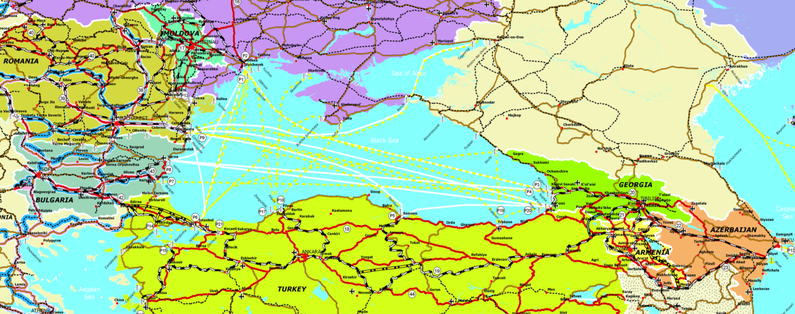
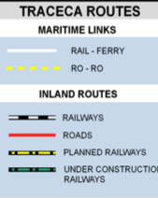
Figure 32. Overview of Black Sea Basin transport network (existing and planned), including main railways and roads
Telecommunications, Information and Communication Technologies (ICT)
Both mobile and internet access have increased by more than 200% since 2005 in all countries of the Black Sea region. Over the last few years, the number of internet users have also multiplied e.g. by more than seven in Armenia and Ukraine over the last six years, becoming a widespread tool. Thus the digital gap that existed among Black Sea Basin countries has considerably narrowed (see figure 33 below) though, overall, still lagging behind the EU average of 75 users per 100 people in 2012.
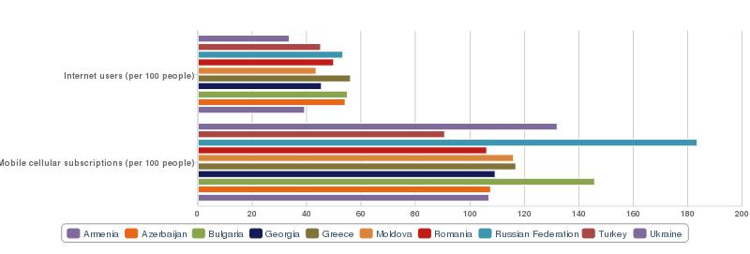
Figure 33. Internet and mobile phone use, 2012

SWOT – TRANSPORT AND ICT
STRENGTHS | WEAKNESSES
- The transport of oil and gas across the Black Sea is a major activity  - Total cargo turnover for the ports of Bulgaria, Georgia, Russia, Romania and Ukraine between 2000 and 2007 increased more than twice  - Overall quality of ports infrastructure around the Black Sea is good in Greece, Turkey and Georgia  - Both mobile and internet access have increased by more than 200% since 2005 in all countries of the Black Sea region  - The digital gap that existed among Black Sea Basin countries has considerably narrowed | - Quality of ports infrastructure around the Black Sea is still assessed as rather poor overall in Moldova and Romania. On the western shore, the EU has only one major port, Constanta  - A complex of issues and requirements concerning maritime infrastructure, fleet renewal, quality of the services in the seaport, market access to the port services, adjustment to the international environmental standards and improvement of regulations and legislation related to the sea ports remain challenging  - Internet use overall still lagging behind the EU average
OPPORTUNITIES | THREATS
- The ports of the Black Sea region serve commodity turnover between the Asian-Pacific region and Europe
- Motorways of the Sea (MoS) have been identified for transnational multimodal axis including the BSB region, as an extension of the Trans-European Transport Networks (TEN-T) to EU Neighbouring countries

Culture, civil society and self-government
Culture
Crossroad of civilisations, the Black Sea Basin has a rich and diverse cultural heritage that needs to be preserved and it retains strong cultural assets in architecture, archeology, arts, music, literature, theatre, and cinematography. Outstanding universal value has been recognised by UNESCO for 18 cultural places in the Black Sea Basin area including historical cities, religious architecture and archeological sites. Several regional intangible cultural assets have additionally been listed as the heritage of humanity such as polyphonic songs (Georgia), musical instruments (Armenia, Azerbaijan), poems and storytellers (Armenia, Romania, Turkey), craftsmanship and arts (Armenia, Azerbaijan), traditional ceremonies and festivities (Azerbaijan, Bulgaria, Turkey) and diet (Greece). This wealth of cultural variety offers considerable opportunities for cooperation.
Civil society and local self-government
In the last decade, civil society and civic movements, mostly informal, have been particularly active in the Black Sea region, notably in Georgia, Ukraine and Moldova. The number of NGOs increased throughout the region; nonetheless they often remain poorly anchored in society, with low membership and volunteering levels and even lower levels of individual donations, relying mostly on foreign or public funds (e.g. individual donations to NGOs in Moldova is ten times lower than to Churches). With strong competition for funding, local NGOs often remain organization-centered rather than joining forces in coalitions and networks around issues. However, there are also positive initiatives of collective action, e.g. recently in Ukraine where an anti-tobacco coalition (gathering notably 40 NGOs) united so the Parliament passed a law banning smoking in public places. Even so, fostering a collaborative spirit among NGOs and connecting them to the wider society remains a challenge in large parts of the Black Sea Basin area.
At the level of the Black Sea Basin, NGO cooperation has developped within the Black Sea NGO Forum, which met regularly since its launch in Bucharest in 2008. The Eastern Partnership Civil Society Forum also provides a medium for cooperation among NGOs, from both sides of the EU external borders, on reforms in Black Sea Partner Countries.
All the countries in the Black Sea Basin region are members of the Council of Europe and signatories of the European Charter on local self-government, which was supplemented in 2009 by an additional protocol on citizen participation. They all take part in the Council of Europe Congress of the Local and Regional Authorities that promotes the principles of local democracy.
The Assembly of European Regions (AER) provides also an active forum for interregional cooperation at a wider Europe level, and membership at regional level from all the Black Sea Basin countries is widespread. In 2011, the EU Committee of the Regions established a Conference of the Regional and Local Authorities for the Eastern Partnership (CORLEAP) that provides a platform for dialogue between local and regional authorities from the EU and the Partner Countries. At Black Sea Basin level, cooperation between local and regional authorities was promoted through the creation in 2008 of the Black Sea Euroregion, though it still has a limited membership.
The Black Sea Forum for Dialogue and Partnership, created in 2006 and designed as a regional platform for international and regional organisations as well as state structures, appears to be affected by regional tensions.

SWOT – CULTURE AND CIVIL SOCIETY
STRENGTHS | WEAKNESSES
- BSB rich cultural heritage and strong cultural assets in architecture, archeology, arts, music, literature, theatre and cinematography  - Outstanding universal value recognised by UNESCO for 18 cultural places in BSB area (historical cities, religious architecture and archeological sites)  - Wealth of cultural variety, with numerous traditional craftmanship and other intangible cultural assets listed as heritage of humanity  - Civil society and civic movements, mostly informal, have been particularly active - the number of NGOs increased throughout the region  - Creation in 2008 of the Black Sea Euroregion  - Black Sea NGO forum meets regularly | - NGOs often remain poorly anchored in society, with low membership and volunteering levels  - NGOs often remain organization-centered rather than joining forces in coalitions and networks around issues  - Black Sea Euroregion still gathers limited membership  - Black Sea Forum for Dialogue and Partnership affected by regional tensions
OPPORTUNITIES | THREATS
- Council of Europe Congress of the Local and Regional Authorities, Assembly of European Regions (AER), as well as more recently EU Committee of the Regions Conference of the Regional and Local Authorities for the Eastern Partnership (CORLEAP) provide platforms for dialogue and cooperation

Black Sea Basin strategic analysis and consultations

After identifying the key strengths, weaknesses, opportunities and threats within the cooperation area, analysis for the programme strategy development further focused on past experience and lessons learnt. Broad stakeholders consultations were organised in the programme area in order to validate the SWOT and reflect on possible priorities. A review of other EU financial instruments was also carried out to ensure the strategy would not include elements that could more suitably be funded under other EU programmes.

Past experience analysis
A review of lessons learned from Black Sea Basin 2007-13 programme monitoring reports (2012, 2013) and EC mid-term evaluation provided the following information for the strategy development:
- The strong relevance of the programme and its current priorities for all participating countries; programme priorities are in line with the needs of the programme area with the greatest alignment being with Objective 1 (Promote economic and social development in regions on both sides of common borders);
- Recognition of the programme as an instrument for facilitating cross-border cooperation;
- Over-ambitious, unrealistic indicators at programme level;
- Some performance difficulties for projects under the first priority (some projects focused on promoting economic cooperation and establishing complicated systems, such as multi-country information databases on companies and products, without having sufficient experience in the area). Some internal, administrative impediments in the second priority for the ENPI East countries (complexity of official mutual recognition of study programmes/diplomas/materials). Some projects implied improvement of national policies, amendments in legislation (beyond the scope of the project);
- Often problematic financial sustainability/lack of exit strategies at project level;
- Result oriented monitoring system must be developed in order to assess the success of implementation at project level;
- 24-month intervention is too short for some actions;
- Visibility requirements are fulfilled but attention must be paid to the dissemination of project results;
- No correlation between projects under the same priority (the projects tend to be implemented on a ‘individual basis’, without having the bigger programme picture);
- Excellent cooperation among partner countries leading to stable partnerships (among universities and research centers, local administrations, NGOs…).
A mapping of projects awarded under the Black Sea Basin 2007-13 two calls for proposals according to key themes allowed the identification of the main areas of interest for project beneficiaries and partners within the programme priorities and action already taken in particular fields. It also provided information on the fields of competence among regional stakeholders, as only successful applications were analysed.
A survey on current priorities and future needs, carried out via a questionnaire forwarded in June 2013 to the National Info Points, Joint Monitoring Committee members, current beneficiaries and partners and potential applicants provided information on the relevance of the current programme strategy and of further fields of interest for cross-border cooperation.
The outcomes of past experience analysis were combined with the results of the SWOT analysis and compared with the list of ENI CBC thematic objectives and indicative priorities - see table below. Indicative priorities justified by at least two analyses, including strongly by one are highlighted in light green. When strongly justified by at least two analyses, priorities are highlighted in dark green.

Thematic Objectives | Indicative priorities
1. Business and SME development | Fostering cooperation between public and private sector
 | Strenghtening economic clusters
 | Enhancement of competitiveness
 | Promotion of and support to entrepreneurship
 | Support to the development and modernisation of businesses in specific sectors (eg tourism, agriculture)
2. Support to education, research, technological development and innovation | Fostering cooperation between businesses and training institutions for innovation and R&D, joint educational planning
 | Promotion of skills development and lifelong learning
 | Supporting local cooperation in education
 | Promotion of and support to research and innovation
3. Promotion of local culture and preservation of historical heritage | Promoting local culture and history
 | Supporting traditional skills for local economic development
4. Promotion of social inclusion and fight against poverty | Support to the development of social services
 | Enhancing the access to social services
 | Promoting gender equality and equal opportunities
 | Support to the integration of immigrants and vulnerable groups
 | Promoting employment and supporting labour mobility
 | Stimulate employment for youth
5. Support to local and regional good governance | Increasing capacity of local and regional authorities and communities
 | Coordination of planning activities
 | Support to regional integration
 | Promoting legal and administrative cooperation
6. Environmental protection and climate change adaptation | Joint actions for environmental protection
 | Preservation and sustainable use of natural resources
 | Support to energy efficiency and to the use of renewable energy
 | Promotion of a low carbon economy
 | Support to sustainable waste and waste water management systems
7. Improvement of accessibility to the regions, development of transport and communication networks and systems | Improving the mobility of persons and goods
 | Developing transport services and infrastructures
 | Developping ICT infrastructure
8. Common challenges in the field of safety and security | Support to the development of health
 | Enhancing the access to health
 | Prevention and fight against organised crime
 | Police cooperation (exchange of intelligence information, etc.)
 | Support to the joint activities for the prevention of natural and man-made disasters as well as joint action during emergency situations
9. Promotion of energy cooperation | Energy cooperation
 | Energy transmission
 | Energy distribution
10. Promotion of border management, and border security | Support to border efficiency and security
 | Improvement of the border-crossing infrastructure and equipment at the border crossing points
 | Improvement of border management operations, customs and visa procedures
Table 1. Combined outcomes of SWOT and past experience analyses (stakeholder survey and mapping of project)

The combined analyses show that Thematic Objectives 4, 6 and 7 were broadly supported overall, while some indicative priorities under Thematic Objectives 1, 2, 3 and 8 were also strongly supported (see the summary in the table above). On the other hand, Thematic Objectives 5 and especially 9 and 10 were very hard to justify on the basis of the SWOT and past experience analyses.
The SWOT and past experience analyses led to the elimination of Thematic Objectives 9 and 10 from further consultations and the targeting of relevant indicative priorities under the remaining objectives as presenting the most interesting potential for cooperation within the Black Sea Basin.

Stakeholder consultations
The SWOT analysis and the eight remaining Thematic Objectives, focused on a limited number of priorities, were further consulted with a wide range of stakeholders:
- During the Black Sea Basin ENPI CBC programme 2007-2013 annual conference held in Istanbul, Turkey on 5th December 2013. The conference participants included representatives of national, regional and local authorities, NGO, researchers and academics, as well as other stakeholders active in the Black Sea Basin area. All countries participating in the Black Sea Basin 2007-13 were represented, along with Azerbaijan as a potential participant in the Black Sea Basin ENI CBC programme 2014-2020. A specific session was devoted to the review of the SWOT analysis and the thematic objectives.
- Via open online public consultation via the website of the current programme and some national websites. The Assembly of European Regions, the Conference of Peripheral Maritime Regions and the International Center for Migration Policy Development contributed notably to the consultation process.
- Through stakeholder consultations (events and/or written consultations) in participating countries from November 2013 to March 2014. Consultations were held at both national and regional levels in most participating countries to allow consistency with national/regional strategies as well as to include the views of the actors on the ground. Consultations included: Comments at national level by Bulgaria in December 2013; consultation events with wide stakeholders participation held by the National Authorities of Armenia, Georgia, Republic of Moldova and Ukraine, in co-operation with EU Technical Assistance project ENI CBC - Support to the preparation of programmes (SPP), in January 2014 and a similar consultation of mostly national bodies in Azerbaijan in May 2014; comments from national authorities in Greece (in December 2013) and input from wider stakeholders after the relevant documents were put on the website of the National Authority (www.interreg.gr) and circulated to stakeholders by email early in 2014; public consultations atnational, regional and local level in Romania in the first quarter of 2014.
The consultation process allowed for the checking and validation of the SWOT analysis by regional stakeholders. Other consultations held during the development of the programme included regional level consultations on the ENI CBC Thematic Objectives in Turkey from May 2013 and extensive regional consultations on the Thematic Objectives in Republic of Moldova in September-October 2013 with conclusions at national level in the first quarter of 2014. Contributions (additional elements, specifications) were integrated in an updated version of the socio-economic analysis and the SWOT as relevant.

Thematic objectives and priorities considered most relevant during the consultation process, or which attracted most interest from the stakeholders consulted, are highlighted below.

Consultation | TO1 | TO2 | TO3 | TO4 | TO5 | TO6 | TO7 | TO8
Armenia
Azerbaijan
Bulgaria
Georgia
Greece*
Moldova*
Romania
Russian Federation
Turkey
Ukraine
Assembly of European Regions (AER)
Conference of Peripheral Maritime Regions (CPMR)
International Center for Migration Policy Development (ICMPD)
* Compilation of consultation results: Greece (31.12.2013, 20.02.2014); Moldova (autumn 2013, 27.01.2014)
Table 2. Outcome of stakeholder consultation on thematic objectives and priorities. Support or interest from stakeholders is highlighted in green, strong support or interest is highlighted in dark green.

Thematic Objective 6 was unanimously supported as the most relevant by participating countries, while there was also a wide consensus on Thematic Objective 1 during the consultations. There was some interest and support for Thematic Objectives 2, 3, 4 and 7.
There was limited support for Thematic Objective 5 during the national consultations (already poorly supported by the SWOT and past experience analyses). The importance of increasing the capacity of local and regional authorities and communities for the success of the programme was nonetheless emphasised, in particular by international organisations. Good governance and local/regional capacity building is very much a transversal issue, important for the success of CBC projects, and could be included in the programme at horizontal level rather than as a separate Themative Objective. Comments from the consultations also suggest that to be effective, local and regional capacity building should not be an aim in itself but oriented towards the achievement of thematic results and specific targets (learning by doing).
There was very little support during the consultations for Thematic Objective 8 therefore this objective was not included or analysed further.

Consistency with other EU programmes
The ENI CBC programming document states that CBC programmes must deliver real cross-border added value and “not cover elements which are already funded or could more suitably be funded from other ENI or EU programmes”. A gap analysis is therefore provided below to identify what is (or is not) covered by other EU programmes and compared with the orientations of the remaining six Thematic Objectives.
The following table presents an overview of main EU cooperation programmes and support to regional development in the Black Sea Basin countries.

Other Cross-Border Cooperation or Transnational/  Interregional programmes | Romania- Republic of Moldova (ENI CBC)
 | Republic of Moldova-Ukraine (Eastern Partnership Territorial Cooperation)
 | Romania-Ukraine (ENI CBC)
 | Romania-Bulgaria (European Territorial Cooperation)
 | Bulgaria-Turkey (IPA CBC)
 | Greece-Bulgaria (European Territorial Cooperation)
 | Armenia-Georgia (Eastern Partnership Territorial Cooperation)
 | Azerbaijan-Georgia (Eastern Partnership Territorial Cooperation)
 | Danube transnational programme (2014-20) includes notably Bulgaria, Romania, Moldova and some regions in Ukraine. It will contribute to the Danube Strategy thematic goals.
 | Interreg Europe interregional programme (2014-20) includes notably Bulgaria, Greece and Romania.
 | Balkan-Mediterranean transnational programme (2014-20) includes notably Bulgaria and Greece.
Other programmes including EU/non EU partnerships | Erasmus+ (2014-20) programme: to boost skills and employability, as well as modernising education, training, and youth work (supports mobility of students and teaching staff, joint degrees, capacity building projects, strategic partnerships).
 | Horizon 2020 – EU framework programme for research and innovation. It includes targets for cross-thematic marine and maritime research. Its first work programme (2014-15) includes a specific call for proposals for the Black Sea Region.
 | Twinning, TAIEX (Technical Assistance and Information Exchange): cooperation tools between a public administration in a partner country and the equivalent institution in an EU Member State to promote reforms
Thematic Cooperation programmes | INOGATE: international energy co-operation programme between the EU, the littoral states of the Black and Caspian Seas and their neighbouring countries. The co-operation framework covers the areas of oil and gas, electricity, renewable energy and energy efficiency.
 | TRACECA (Transport Corridor Europe-Caucasus-Asia): an international transport cooperation programme between the EU and Partner countries in Eastern Europe, South Caucasus and Central Asia. The cooperation framework covers the areas of maritime transport, aviation, road and rail, transport security and transport infrastructure. Strategy for the development of the international transport Europe-Caucasus-Asia corridor up to 2015 and aims to create a sustainable infrastructure chain ensuring multi-modal transport with step-by-step integration of the corridor into the Trans-European Transport Networks. It encourages regional cooperation and attracts the support of IFIs and private investors.
 | Environment and the Sustainable Management of Natural Resources including Energy (ENRTP): focuses on sustainable energy.
 | Nuclear Safety and Cooperation Instrument (NSCI): finances actions to improve nuclear safety (including safe transport, remediation and emergency preparedness).
 | LIFE (2014-20): promotes implementation and integration of environment and climate objectives in other policies and EU Member States practice; emphasis on better governance; priorities: resource efficiency, biodiversity loss and climate adaptation and mitigation. Limited possibilities for partner countries participation.
ENPI (until 2013), ENI (from 2014)  Partner countries | Bilateral country programmes for each partner country (the main EU cooperation tool), includes a Comprehensive Institution Building (CIB) component
East Regional Programmes, including :
- Eastern Partnership Integrated Border Management (IBM): supports the implementation of the concept of integrated border management, with the dual objective to secure the borders and to facilitate the legal passing of persons and goods.
- Eastern Partnership SMEs development support: supports partner country institutions to put in place and implement policy and legislative reforms in support of SMEs ; supports Business Support organisations and promotes trade opportunities between European and partner country companies (East-Invest) ; strengthens auditing and reporting capacity of SMEs to improve their access to financing.
- Eastern Partnership SME Finance Facility: combines EBRD, EIB and KfW loans with EU grant resources, to support SME lending
- Small Business Support Programmes in the Eastern Partnership: Business Advisory Services and Enterprise Growth Programmes provide individual and customised technical assistance to help micro, small and medium-sized enterprises adapt to the demands of a liberal market economy, and develop the capacities of local SMEs as well as local business advisory services.
- Eastern Partnership Youth Window: support in responding to the needs of youth in societies through cooperation among young people and youth worker
- ClimaEast: supporting climate change mitigation and adaptation to foster improved climate change policies, strategies and market mechanisms
- Greening economies in the Eastern Neighbourhood : supports the move towards a green economy by decoupling economic growth from environmental degradation and resource depletion and by promoting sustainable consumption and production strategies
- Eastern Parnership Culture programme: strengthens regional cultural links and dialogue within the Eastern Partnership region, and between the EU and ENP Eastern countries' cultural networks and actors
 | The Eastern Partnership Integration and Cooperation (EaPIC) programme: additional funding based on reforms achieved to support democratic transformation and institution building, sustainable and inclusive growth and economic development
 | Neighbourhood Investment Facility (NIF): finances key infrastructure projects in partner countries as well as supports their private sectors (mix of grants and loans)
 | Neighbourhood Civil Society Facility: financial support to projects, capacity building, involvement in sector policy dialogues for civil society actors
 | SIGMA (Support for Improvement in Governance and Management): joint initiative of the EU and OECD provides technical support at national level
Cohesion Policy under European Structural and Investment Funds  EU Member States | European Regional Development Fund (ERDF): investments in 2014-20 will be concentrated on 4 key priorities: innovation and research, ICT, support for SMEs and shift towards a low-carbon economy
 | Cohesion Fund: focused on priority Trans-European transport links and key environmental infrastructure projects
 | European Social Fund (ESF): employment, education and social inclusion
 | European Agricultural Fund for Rural Development: finances rural development programmes
 | European Maritime and Fisheries Fund (EMFF): priorities for 2014-20 are to help fishermen in the transition to sustainable fishing, to support coastal communities in diversifying their economies, to finance projects that create new jobs and improve quality of life along European coasts and to make it easier to access financing
Instrument for pre-accession (IPA)  Turkey | For the 2014-2020 period, financing under IPA is provided through the following policy areas: 1) Reforms in preparation for Union membership and related institution and capacity-building, 2) Socio-economic and regional development, 3) Employment, social policies, education, promotion of gender equality and human resources development, 4) Agriculture and rural development; 5) Regional and territorial cooperation
Table 3. Overview of other EU financial instruments for cooperation and regional development in Black Sea Basin countries
Thematic Objective 1. EU cooperation programmes focus mostly on SME development and technical assistance, leaving a broad scope for the development of non-overlapping cooperation opportunities within the Black Sea Basin priorities, as identified in the analyses and during the consultations (notably tourism, etc.).
Thematic Objective 2. Several partnership programmes (Horizon 2020, Erasmus+) provide suitable funding for cooperation in the field of research and innovation within the Black Sea Basin, including exchange of students and searchers and establishment of partnerships between education and research centres. The inclusion of Thematic Objective 2 therefore does not appear fully justified.
Nonetheless, some specific research activities could be included in CBC projects as relevant, without being the main aim of the projects. Likewise, universities, education institutions and research/tehnological centers may remain among the target groups for the valuable input they may provide under other thematic objectives.
Thematic Objective 3. The Eastern Partnership culture programme targets support to partner countries. In the future it will focus on technical assistance and will not provide further opportunities for direct partnerships between cultural actors so there are now few opportunities for cooperation in the cultural sector. Some cultural aspects may nonetheless be reflected also under economic (e.g. tourism) and environmental (e.g. archeological sites) issues so that cultural actors and some specific cultural activities could also be included under those priorities as relevant.
Thematic Objective 4. EU support to social issues is mostly funded under country-specific programmes so there are few opportunities for cooperation and exchange of experience between countries within the Black Sea Basin area under current EU programmes.
Thematic Objective 6. EU cooperation programmes in the environmental sector target energy efficiency measures, sustainable use of natural resources, promotion of a low carbon economy and adaptation to climate change. This leaves considerable scope for further joint actions for environmental protection, as identified in the analyses and during the consultations (notably monitoring, etc).
Thematic Objective 7. The TRACECA programme provides a highly suitable, comprehensive and long-lasting cooperation framework to enhance transport networks and infrastructure within the Black Sea Basin. Transport infrastructure development is otherwise supported notably under country-specific programmes, via cohesion funds and the NIF. Therefore, despite the large remaining need to upgrade transport facilities within the region, the inclusion of transport in the Black Sea Basin strategy does not appear justified. Some specific transport-related issues could still be considered for their economic or environmental dimensions and included in CBC projects when relevant but not constitute the main aim of the project.
In regard to the development of information and communication technologies (ICT), these are most notably supported under Horizon 2020. Considering that ICT is also a transversal tool that underpins innovation and competitiveness across a broad range of sectors, the inclusion of ICT components may still be considered in CBC projects under any priority whenever relevant to enhance CBC project effectiveness.

Summary of strategy identification

Table 4. Summary of strategy development. At each step, TOs strongly supported are shown in bold, TOs with less supprt are shown in normal font, TOs with low support are not shown.
Considering the need for the Black Sea Basin strategy to concentrate on a limited number of themes in which concrete results can be obtained, and the stronger relevance of some priorities under TO1 and TO6 indicated throughout the analytical and consultation process, these two objectives have been selected for the strategy definition.

Black Sea Basin ENI CBC programme strategy

Wider objective
The Black Sea Basin ENI CBC programme will contribute to the ENI CBC overall aim to “promote co-operation across the borders between EU Member States and the countries on the European Neighbourhood and Russian Federation”.
More specifically, the programme will contribute to two of the ENI CBC overarching strategic objectives:
- Promote economic and social development in regions on both sides of common borders
- Address common challenges in environment, public health, safety and security
The wider Black Sea Basin ENI CBC programme objective can be defined as:
Improve the welfare of the people in the Black Sea Basin regions through sustainable growth and joint environmental protection

Horizontal issues and modalities
A number of important elements for successful, sustained and inclusive cross-border cooperation will be supported as horizontal issues or modalities to be deployed across any of the priorities selected, rather than as separate thematic priorities. They include:
  - So-called ‘people-to-people’ actions i.e. enhanced cooperation among local and regional authorities, NGOs and other civil society groups, universities and schools, chambers of commerce etc.
  - Promotion of local and regional good governance, capacity-building components for local/regional authorities and agencies and NGOs.
  - Promotion of regional integration/coordination through regional platforms and long-lasting partnerships at organisation levels (among institutes, universities, scientific community, public institutions, local/regional administrations and agencies, NGOs, etc.).
  - The use and development of relevant information and communication technologies to enhance project effectiveness, regional integration/coordination and synergies on results.
  - Promotion of gender equality, and opportunities for youth.

Thematic objectives and priorities
The completed analytical and consultation process for the Black Sea Basin strongly supports the selection of specific priorities under two thematic objectives among those proposed in the ENI CBC strategy document:
- Thematic Objective 1. Business and SME development
- Thematic Objective 6. Environmental protection, and climate change mitigation and adaptation

- The Black Sea Basin programme will contribute to the achievement of ENI CBC Thematic Objective 1. ‘Business and SME development’ via the programme objective:
Objective 1. Promote business and entrepreneurship within the Black Sea Basin

The programme objective will be addressed through two priorities, 1.1 and 1.2 defined for the Black Sea Basin and described below.
Priority 1.1 – Jointly promote business and entrepreneurship in the tourism and cultural sectors
Justification for the definition of Priority 1.1:
- Tourism sector development is strongly supported by the socio-economic and the SWOT analyses. It has a very positive impact on employment and income, it is one of the fastest-growing sectors and still has strong growth prospects. The Black Sea Basin also has a rich cultural heritage and valuable cultural assets.
- Both the questionnaire and the results of the calls analyses show there is a clear interest in tourism projects. Previous calls also show an interest in cultural projects, often linked to tourism development.
- Tourism relevance to CBC was clearly confirmed during the consultation process while several countries underlined the importance of the cultural sector.
Expected result under Priority 1.1:
Stronger cross-border business opportunities in the tourism and cultural sectors in the Black Sea Basin
Indicative activities/orientations under Priority 1.1:
- Promote the development and joint marketing of cross-border tourism products and transnational thematic itineraries (e.g. cultural, religious, ancient trade routes, agricultural); promote diversification and integration of coastal and inland tourism.
- Promote historical heritage and support its preservation through sustainable tourism development (e.g. small-scale investments, marketing).
- Encourage synergies, networking and connectivity among tourism and culture stakeholders and tour operators within the Black Sea Basin (e.g. specific network for maritime tourism, etc.); promote electronic marketing tools and cross-border logistics information on e.g. cultural events.
- Share experience and/or develop jointly targeted tourism packages for specific markets (e.g. the elderly); share experience to promote higher quality, and more innovative, tourism products (e.g. underwater archaeological parks, eco-tourism, cultural tourism, medical tourism).
- Jointly promote cultural products (handicrafts, artworks, etc) and events (festivals, fairs).
- Jointly enhance the openness of the Black Sea Region to international and non-European tourism (e.g. joint marketing, communication and promotion campaigns, development of Black Sea Basin brands).
- Encourage networking, share good experience in strenghtening cultural and creative industries (music, multimedia, etc.).
- Exchange best practices on the development of environmentally friendly tourism strategies (e.g. improve resource efficiency, waste and pollution prevention/management in tourist areas, guidelines on minimising impacts on biodiversity and enhancing benefits of tourism in protected areas).
- Improve tourism services and promote the upgrade of skills e.g. through exchange programmes between educational institutions (e.g. for young professionals), or through the joint creation of open online courses based on best experience.
Target groups for Priority 1.1:
Tourism and regional development agencies, tourism industry associations, cultural and archeological associations/institutions, local/regional authorities, universities and educational institutions, nature parks and protected areas management bodies, local business associations, farmer associations and NGOs.

Priority 1.2 – Increase cross-border trade opportunities and modernisation in the agricultural and connected sectors
Justification for the definition of priority 1.2:
- Support to the development and modernisation of businesses in specific sectors was strongly supported during the consultation process.
- Modernisation of the agricultural sector and food industry is strongly supported by the socio-economic and SWOT analyses. Agriculture is still a substantial or major component of the Black Sea Basin national economies, in particular in terms of employment or in terms of exports. Agricultural products are among the main goods traded between countries within the Black Sea Basin area suggesting potential complementarities. Organic farming presents potential opportunities as well as the development of sustainable aquaculture.
- It is beyond the scope of this programme in itself to modernise specific sectors, but the Black Sea Basin programme can provide good cross-border added value to the support provided by country-specific programmes and national authorities (through the exchange of experience, promotion of trade links, networking, etc.).
Expected result under Priority 1.2:
Increased cross-border links for trade and modernisation in the agricultural and connected sectors in the Black Sea Basin
Indicative activities/orientations under Priority 1.2:
- Promotion of international trade links, sectoral and cross-sectoral networks and partnerships (e.g. business forums) within the Black Sea Basin and support to internationalisation of exchanges (e.g. capacity building).
- Strengthen internet connectivity, cross-border business information exchange systems, market and logistics information with greater use of information and communication technologies (ICT).
- Exchange good practice in modern and innovative marketing and trade strategies, electronic marketing tools and develop joint marketing strategies (e.g. regional branding).
- Support innovation, research and cooperation, including for the development of logistics, in the agricultural industry, jointly developing and implementing best practices in producing quality agricultural products.
- Introduction of innovative technologies for sectoral development (organic/bio products, sustainable aquaculture), including exchange of experience and small-scale investments in pilot projects.
- Support entrepreneurial culture through teaching and training for young people working in agricultural and connected sectors; share good practices in this field.
- Exchange of best practice experience on the practical introduction of standards (e.g. food safety).
- Joint actions to support productive use of migrant remittances in the modernisation of the agriculture/aquaculture/food industry.
Target groups for Priority 1.2:
Chambers of commerce, business support and regional development agencies, farmer associations and agro-industry associations, SME associations, business associations, aquaculture and fisheries associations, migrant associations, regional/local authorities and agencies and research institutes.

- The Black Sea Basin programme will contribute to the achievement of ENI CBC Thematic Objective 6. ‘Environmental protection, and climate change mitigation and adaptation’ via the programme objective:
Objective 2. Promote coordination of environmental protection and joint reduction of marine litter in the Black Sea Basin

This programme objective will be addressed through two priorities, 2.1 and 2.2 defined for the Black Sea Basin and described below.
Priority 2.1 – Improve joint environmental monitoring
Justification for the definition of Priority 2.1:
- Cooperation for solving common environmental issues is strongly supported by the socio-economic and the SWOT analyses. A sound and common knowledge base, regularly updated, is necessary for consistent and coordinated actions by stakeholders around the Black Sea and to assess trends and quickly and effectively react to threats.
- Measure 2.1 (strengthen joint knowledge and information base to address common environmental challenges) was by far the most popular area of cooperation in the 2007-2014 programme, both in terms of number of projects and partners (1/4 of all projects awarded and >1/4 of all project partners) and in terms of funds allocated (1/3 of funds). The new ENI CBC programme should build upon and extend, but not repeat, the joint work already carried out. Actions supported should be consistent with, but not duplicate, existing information systems and monitoring activities carried out most notably by the Black Sea Commission.
- Both the questionnaire results and the consultations confirm there is a clear interest in environmental issues, in particular in monitoring and risk assessment.
Expected result under Priority 2.1:
Improved availability of cross-border compatible environmental monitoring data and information within the Black Sea Basin
Indicative activities/orientations under Priority 2.1:
- Reinforce joint and compatible cross-border monitoring, evaluation and information systems, tools and capacity to prevent and control transboundary pollution (including through small-scale investments).
- Improve long-term cross-border collaboration, information and research capacity (including innovative technologies) for addressing ecosystem transformation, biodiversity monitoring and migration of species.
- Jointly strengthen collaboration between science, industry, relevant stakeholders and decision-makers to address integrated coastal management issues and to harmonise monitoring, marine environment assessment and data provision.
- Improve the availability and cross-border interoperability of updated online public access data and data products (e.g. maps) for the Black Sea so industry, public authorities, NGOs and researchers may make more effective use of them.
- Promote cross-border cooperation among maritime authorities responsible for activities such as safe navigation or fisheries control so to share information on risks and threats (integrated maritime surveillance).
- Improve cooperation on environmental monitoring between stakeholders involved in disaster prevention and management.
- Enhance contact among countries and exchange good practice on early warning systems that allow the population exposed to hazards to take appropriate actions to avoid/reduce risk and to prepare effective responses; improve availability of environmental information for the population regarding notably the risk of earthquakes, floods and forest fires.
Target groups for Priority 2.1:
Scientific (oceanographic, hydrographic, meteorologic, seismic) agencies and institutes/research centers/universities, coastal, maritime and port authorities, local/regional authorities and agencies, fisheries associations, environmental NGOs, nature parks and protected areas (including marine) management bodies and schools and educational institutions.

Priority 2.2 - Promote common awareness-raising and joint actions to reduce river and marine litter
Justification for the definition of Priority 2.2:
- Cooperation in solving common environmental issues is strongly supported by the socio-economic and the SWOT analyses. Litter originating from shipping, land or rivers within the Black Sea drainage basin results in a ‘visible’ pollution problem along the rivers and coasts, in the sea itself and on the seabed. It is a joint transboundary problem, as the sea basin dynamic current system results in the transportation of any matter from a given location in the Black sea to almost any coastal area. It has an impact on people’s welfare and economic activities such as tourism development; it often harms or kills marine life, and might threaten the biodiversity of the Black Sea. Direct mobilisation of local/regional stakeholders and enhancement of responsible citizenship could have a strong effect on reducing this kind of pollution.
- Both raising environmental awareness and tackling solid waste issues were raised in responses to the questionnaire and in consultations.
Expected result under Priority 2.2:
Increased awareness of environmental challenges and good waste management practices related to river and marine litter within the Black Sea Basin
Indicative activities/orientations under Priority 2.2:
- Jointly raise public awareness and education regarding river and marine litter problems, the value of biodiversity and environmental protection (mass-media campaigns, production of education tools and ‘responsible-citizenship’ guidelines for different sectors for target audiences such as children and students, tourists, municipal authorities, shipping companies and shipping crews).
- Share and promote good environmental management practices and technologies (including through small-scale investments) related to the treatment and disposal of waste, the reduction of illegal dumping and landfill sites on riverbanks and seashores and the prevention of their adverse effects.
- Jointly promote the practice of the ‘3 Rs’ (reduce, reuse, recycle) for waste as well as the use of waste for energy production.
- Strenghten community action, promote and organise cross-border Black Sea Basin coastal and river clean-up campaigns (involving schools, students and volunteers) and share good experiences in this field.
- Encourage the involvement of, and partnerships between, NGOs and civil society, the private sector (e.g. in the tourism, shipping and fisheries sectors) and local/regional authorities and waste services to combat river and marine litter.
- Share experience to improve port reception facilities and services for garbage collection from vessels (e.g. prepare guidelines/manuals for development of the port waste management plan in line with International Maritime Organisation/EU requirements and promote its implementation in Black Sea ports).
Target groups for Priority 2.2:
Local/regional authorities and waste management and control services, environmental NGOs and civil society organisations, schools and educational institutions, tourism industry associations, fisheries associations and port authorities.

Objectively verifiable indicators
Achievement of the BSB programme will be measured by way of objectively verifiable indicators.
ENI CBC implementing regulation stipulates that the ENI CBC programmes shall include a description of objectively verifiable indicators, in particular:
- The expected results for each priority, and the corresponding result indicators, with a baseline value and a target value;
- The output indicators for each priority, including the quantified target values, which are expected to contribute to the results.
ENI CBC programming document further specifies that:
- All programmes should adopt at least some of ENI CBC ‘Common Output Indicators’ developed in order to increase accountability and facilitate reporting progress at instrument level.
- Programmes shall monitor their progress by means of outcome indicators that shall quantitatively or qualitatively measure the wider societal impact of a particular goal that spans beyond the direct beneficiaries of the programme and cover a wider group of society.
Therefore, as reflected in the table below, the BSB programme includes two levels of indicators:
- At result level: 4 indicators (one per priority)
- At activity level: the use of 6 Common Output Indicators (COI) and of 3 programme-specific output indicators (PSOI).

Definition of programme indicators
Type | Prio. | Indicator | Definition and Source of verification
RI | 1.1 | R1.1 Strength of cross-border business opportunities in the tourism and cultural sectors | Based on survey. Assessment of the cross-border business opportunities by a reference group.
RI | 1.2 | R1.2 Strength of cross-border links for trade and modernisation in the agricultural and connected sectors | Based on survey. Assessment of strength of cross-border links for trade and modernisation in the agricultural and connected sectors in BSB by a reference group
RI | 2.1 | R2.1 Level of availability of cross-border compatible environmental monitoring data and information | Based on survey. Assessment of availability of cross-border compatible environmental monitoring data and information by a reference group.
RI | 2.2 | R2.2 Level of awareness of environmental challenges and good waste management practices related to river and marine litter | Based on survey. Assessment of the awareness of inhabitants, companies and relevant public service providers on environmental challenges and good waste management practices related to river and marine litter by a reference group.
PSOI | 1.1 | 1.1.1 Number of strategies and products developed jointly to promote tourism | Based on data taken from the project databases. Products to be interpreted as any deliverable (e.g. new tourism route) of the projects that can be offered to tourists directly or indirectly.
PSOI | 1.1 | 1.1.2 Number of crossborder tourism and cultural events organised using ENI support | Based on data taken from the project databases. Number of crossborder cultural events, festivals, congresses, etc. promoting tourism or culture. Event involving participants from at least two ENI CBC participating countries.
COI | 1.1 | 1.1.3 Number of small scale improvements to cultural and historical sites as a direct consequence of programme support (COI 7) | Based on project reports. Number of cultural and historical sites being improved as a direct consequence of programme support. Valid for site improvements of e.g. buildings, landscapes, sites or structures of local, regional, or national significance, works of monumental sculpture or paintings, new acquisitions to collections or museums, etc. The improvements must be of a permanent nature.
COI | 1.2 | 1.2.1 Number of enterprises participating in crossborder agricultural or agro-industrial business events (COI 3) | Based on data taken from the project databases, number of enterprises participating in cross-border business events organised with support from the programme, e.g. trade shows, business fairs, business fora etc. involving participants from at least two ENI CBC participating countries. The event must be a direct consequence of the support. Indicator made more specific to target the agricultural and agro-industry sectors.
COI | 1.2 | 1.2.2. Number of additional ICT based tools developed supporting cross-border cooperation (COI29) increasing cross-border trade opportunities for agricultural and agro-industrial products | Based on project reports, additional Information and Communication Technologies (ICT) based tools developed supporting cross-border cooperation. May include new joint databases, information exchange portals, other joint logistics or decision-support systems, etc. Indicator made more specific to target the agricultural and agro-industry sectors.
COI | 1.2 | 1.2.3 Number of business development organisations receiving support (COI1) to promote modernisation in the agricultural or connected sectors | Based on data taken from the programme database, number of business development organisations receiving support in any form from the programme. Business development organisation may include chambers of commerce, business incubators, regional  or local development agencies and other organisations with the primary aim to develop local business. Indicator made more specific to target the agricultural and connected sectors.
COI | 2.1 | 2.1.1 Number of additional ICT based tools developed supporting cross-border cooperation (COI29) improving joint environmental monitoring and public availability of environmental information | Based on project reports, additional ICT based tools developed supporting cross-border cooperation. May include new joint databases, information exchange portals, other joint logistics or decision-support systems, etc. Indicator made more specific to target environmental monitoring.
COI | 2.1 | 2.1.2 Number of institutions using programme support for cooperation in education, R&D and innovation (COI4) to improve data sharing and cross-border information exchange systems on the environment within BSB | Based on data taken from the programme database, number of institutions (universities, research institutes, etc.) receiving support in any form from the programme and using it for cooperation in education, R&D and innovation. Indicator made more specific to target environmental monitoring.
COI | 2.2 | 2.2.1 Number of persons actively participating in environmental actions and awareness raising activities (COI17) | Based on project reports, number of citizens/students/pupils etc. actively participating in environmental actions (e.g. clean-up campaigns) and awareness raising activities as well as with regard to the promotion of energy efficiency.
PSOI | 2.2 | 2.2.2 Number of organisations using programme support to develop or improve waste management tools or small scale facilities along river banks and sea shores (including ports) | Based on data taken from the programme database, number of organisations of any kind (NGOs, ports, municipal waste services, etc.) using programme support to develop or improve waste management tools or waste management facilities along river banks and sea shores.
Output indicators will be measured annually and included in the annual reporting to the EC. Their measurement at programme level will be based on an aggregation of the relevant data from project reports and/or from the programme database, as relevant (information included in the programme management and information system). The target values presented in the table below have been defined based on an indicative budget allocation per priority, an estimation of number of projects per priority and of number of relevant output(s) per project.
Result indicators will be measured before the programme is submitted to the EC (to set the baselines), and after programme completion (by 2023, in order to draft the final report to the EC). Result indicators have been formulated at the level of priorities and their measurement is based on specific surveys among the relevant reference groups in each of the participating Black Sea countries.
Type | Indicator | Unit of measurement | Baseline | Target
RI | R1.1 | 1-5 Likert-scale
RI | R1.2 | 1-5 Likert-scale
RI | R2.1 | 1-5 Likert-scale
RI | R2.2 | 1-5 Likert-scale
PSOI | 1.1.1 | Number of strategies/products | 0 | 38
PSOI | 1.1.2 | Number of events | 0 | 100
COI | 1.1.3 | Number of sites | 0 | 5
COI | 1.2.1 | Number of enterprises | 0 | 600
COI | 1.2.2 | Number of ICT tools | 0 | 4
COI | 1.2.3 | Number of organisations | 0 | 15
COI | 2.1.1 | Number of ICT tools | 0 | 13
COI | 2.1.2 | Number of institutions | 0 | 10
COI | 2.2.1 | Number of persons | 0 | 3 600
PSOI | 2.2.2 | Number of organisations | 0 | 40
Definition of the indicators and ways to measure them is further described in the Monitoring and Evaluation system and plan (see in Annex 3).

Risk analysis and mitigating measures
The achievement of the programme objectives is subject to external influences that are beyond the direct control of the programme management bodies and may impact negatively on the programme.
Two main types of risks on programme achievement may be identified:
- Contextual risks that cover the range of potential adverse outcomes that may arise in the BSB context (e.g. regional conflicts…)
- Programmatic and institutional risks that include the potential for the programme to fail to achieve its objectives, the potential for the programme to cause harm in the external environment and ‘internal risks’ from the perspective of the EU/MA (e.g financial loss…)
In case of contextual risks, the programme management bodies have limited control over the risk but still need to assess the adverse effect on the programme, monitor the relevant situation and have a management plan put in place as possible. In case of programmatic and institutional risks relevant mitigation measures and a management plan may be put in place.
The risk management matrix presented below highlights main identified risks and the programme plans to manage or mitigate these. Risks have been identified notably based on the SWOT analysis and lessons learned from the previous (ENPI CBC) programming period and are also linked to the programme intervention logic summed up in the logical framework.
As risk levels may evolve and new risks may emerge during programme implementation, the external environment will be monitored so to take action to manage or mitigate these risks when necessary and to the extent possible. The programme risk management matrix will therefore be subject to regular review and updating by the MA during programme implementation.

Risk | H: high  M: medium  L: low | Likelihood | Impact on BSB progr. | Management/mitigation measure if applicable | Responsibility if applicable
Contextual Risks
Lack of political commitment by some eligible countries to participate in the BSB programme |  | H | M | The programme is still presented for adoption by the EC and will only be implemented in those countries which have made the necessary formal commitment | MA, JPC, EC
Cross-border cooperation is hampered by an unstable political situation in some regions and/or by regional conflicts |  | H | M | Eligibility of some regions may be suspended, transfer of funds to some regions may be suspended | EC, MA, NA
EU sluggish growth and continuing problems emanating from the debt crisis limit further economic recovery in BSB and development of business and entrepreneurship |  | M | L
Programmatic and Institutional Risks
ENI CBC new management and implementation modalities result in delays in programme start-up and implementation |  | H | M | Identify potential bottlenecks, then enhance capacity, ensure sufficient resources and/or support adaptation of procedures as needed to speed up programme implementation | AA, JMC, MA, JTS, NA, EC
Decreasing interest from applicants in ENI CBC because of lengthy procedures for selection/contracting and grant payment |  | L | L | More efficient and timely procedures are put in place | MA, JTS, JMC
Difficulties in finding partners limits countries balanced participation in the programme |  | M | L | Provide improved partner search tools and opportunities | MA, JTS, NA
Limited capacity (including financial) of project partners hampers project implementation |  | M | L | Communication is strengthened and additional trainings are provided to enhance project management capacity of partners, project co-financing and adequate pre-financing issues are addressed if necessary | MA, JTS, NA, JMC
Projects partners face implementation difficulties because of slow grant payment procedures |  | M | M | Procedures are revised and improved | MA, JTS, NA, CCP
Financial losses at programme level resulting from fraud or financial mismanagement |  | M | L | Monitor and ensure that anti-fraud mechanisms put in place and programme audit and control measures function effectively, improve them as necessary | MA, AA, JTS, NA, EC

Programme logical framework
The BSB programme logical framework presented in the following pages provides an overview of the strategy defisnition, including programme intervention logic, indicators of achievement and risks.

Logical Framework for the Black Sea Basin ENI CBC Programme 2014-2020

 | Intervention logic | Objectively verifiable indicators of achievement | Sources of verification | Risks
Overall Objective | Improve the welfare of the people in the Black Sea basin regions through sustainable growth and joint environmental protection
Specific Objectives | - Promote business and entrepreneurship within the Black Sea basin  - Promote coordination of environmental protection and joint reduction of marine litter in the Black Sea basin
Expected results | - Stronger cross-border business opportunities in the tourism and cultural sectors in BSB | R1.1 Strength of cross-border business opportunities in the tourism and cultural sectors | Survey | - EU sluggish growth and continuing problems emanating from the debt crisis limit further economic recovery in BSB and development of business and entrepreneurship
 | - Increased cross-border links for trade and modernisation in the agricultural and connected sectors in BSB | R1.2 Strength of cross-border links for trade and modernisation in the agricultural and connected sectors | Survey
 | - Improved availability of cross-border compatible environmental monitoring data and information within BSB | R2.1 Level of availability of cross-border compatible environmental monitoring data and information | Survey
 | - Increased awareness on environmental challenges and good waste management practices related to river and marine litter within BSB | R2.2 Level of awareness on environmental challenges and good waste management practices related to river and marine litter | Survey
Indicative activities | 1.1.a Develop cross-border tourism products and transnational thematic itineraries.  1.1.b Promote networking and connectivity among tourism and cultural actors within BSB.  1.1.c Develop jointly targeted tourism packages for specific markets and more innovative tourism products.  1.1.d Jointly enhance the openness of the Black Sea Region to international and non-European tourism.  1.1.e Encourage networking and share good experience in strengthening cultural and creative industries.  1.1.f Exchange best practices on the development of environmentally friendly tourism strategies.  1.1.g Promote historical heritage and support its preservation for tourism development.  1.1.h. Jointly promote cultural products and events.  1.1.i. Improve tourism services and promote the upgrade of skills (e.g. through exchange programmes between educational institutions or the joint creation of open online courses). | O1.1.1 – Number of strategies and products developed jointly to promote tourism | Project reports | - Lack of political commitment by some eligible countries to participate in the BSB programme  - Cross-border cooperation is hampered by an unstable political situation in some regions and/or by regional conflicts  - ENI CBC new management and implementation modalities result in delays in programme start-up and implementation  - Decreasing interest from applicants in ENI CBC because of lengthy procedures for selection/contracting and grant payment  - Difficulties in finding partners limits countries balanced participation in the programme  - Limited capacity (including financial) of project partners hampers project implementation  - Projects partners face implementation difficulties because of slow grant payment procedures  - Financial losses at programme level resulting from fraud or financial mismanagement
 |  | O1.1.2 - Number of crossborder tourism and cultural events organised using ENI CBC support | Project reports
 |  | O1.1.3 - Number of improved cultural and historical sites as a direct consequence of programme support (COI 7) | Project reports
 | 1.2.a Promote international trade links, sectoral and cross-sectoral networks and partnerships within BSB, support internationalisation of exchanges.  1.2.b. Strengthen internet connectivity, cross-border business information exchange systems, market and logistics information with greater use of ICT.  1.2.c. Exchange good practice in modern and innovative marketing and trade strategies, electronic marketing tools, develop joint strategies.  1.2.d. Support innovation, logistic and joint development of good practices in producing quality agricultural products.  1.2.e. Introduction of innovative technologies for sectoral development, including exchange of experience and small-scale investments in pilot projects.  1.2.f. Exchange of good practice on the practical introduction of standards (e.g. food safety).  1.2.g. Joint actions to support productive use of migrant remittances in the modernisation of agriculture, aquaculture and food industry.  1.2.h. Support entrepreneurial culture through teaching and training for young people working in agricultural and connected sectors; share good practices in this field. | O1.2.1 - Number of enterprises participating in crossborder agricultural or agro-industrial business events (COI3) | Project reports
 |  | O1.2.2 - Number of additional ICT based tools developed supporting cross-border cooperation (COI29) increasing cross-border trade opportunities for agricultural and agro-industrial products | Project reports
 |  | O1.2.3 - Number of business development organisations receiving support (COI1) to promote modernisation in the agricultural or connected sectors | Programme Management and Information System (MIS)
 | 2.1.a. Reinforce compatible cross-border monitoring and information systems to prevent and control transboundary pollution.  2.1.b. Improve long-term cross-border collaboration, information and research capacity for addressing ecosystem transformation, biodiversity monitoring and migration of species.  2.1.c. Jointly strengthen collaboration between science, industry, relevant stakeholders and decision-makers to address integrated coastal management issues and to harmonise marine environment assessment.  2.1.d. Promote cross-border cooperation among maritime authorities (safe navigation, fisheries control…).  2.1.e. Improve cooperation between stakeholders involved in disaster prevention and management. | O2.1.1 - Number of additional ICT based tools developed supporting cross-border cooperation (COI29) improving joint environmental monitoring and public availability of environmental information | Project reports
 |  | O2.1.2 - Number of institutions using programme support for cooperation in education, R&D and innovation (COI4) to improve data sharing and cross-border information exchange systems on the environment within BSB | MIS
 | 2.2.a. Jointly raise public awareness and education regarding river and marine litter problems, the value of biodiversity and environmental protection.  2.2.b. Jointly promote the practice of the ‘3 Rs’ (reduce, reuse, recycle) for waste and the use of waste for energy production.  2.2.c. Strengthen community action, promote and organise cross-border Black Sea Basin coastal and river clean-up campaigns.  2.2.d. Jointly promote good environmental management practices and technologies related to waste management on riverbanks and seashores.  2.2.e. Share experience to improve port reception facilities and services for garbage collection from vessels.  2.2.f. Encourage partnerships between NGOs and civil society, the private sector, local/regional authorities and waste services to combat river and marine litter. | O2.2.1 - Number of persons actively participating in environmental actions and awareness raising activities (COI17) | Project reports
 |  | O2.2.2 - Number of organisations using programme support to develop or improve waste management tools or facilities along river banks and sea shores (including ports) | MIS

Nature of projects and types of support
Projects are expected to establish long-lasting cross-border links within the Black Sea Basin while resulting in a clearly improved situation for the issues they address. Projects shall achieve a set of results that will allow the programme to reach its objectives. Project partners shall mention in their application how they will contribute to some of the programme expected results and provide relevant outputs both at the level of programme priorities and of horizontal issues.

Each project shall aim at establishing:
- Enhanced cross-border contacts within the Black Sea Basin including e.g. networking, forums and the establishment of lasting partnerships;
- Enhanced knowledge and skills including e.g. the exchange of experience and good practice, innovation, capacity-building and joint research;
- Concrete and visible outputs including e.g. small-scale investments, pilot projects, information and communication technologies shared tools, online open-access resources.
When designing and implementing their action, project partners shall also pay particular attention to ensure:
- The sustainability of their action;
- Communication on and dissemination of results;
- Synergies and complementarities with other actions in the same field.

Projects shall be submitted jointly by partners from at least one of the participating EU Member States and one of the participating partner countries or the Russian Federation. Participation of Turkish partners is only possible in projects with at least one partner from a participating EU Member State and one partner from a participating partner country or the Russian Federation. The project lead partner may be from any of the participating countries.

In line with ENI CBC Programming document, the partners implementing projects will primarily represent the regional and sub-national administrative levels, as well as civil society organisations based within the eligible programme area. Eligibility of project partners is based on the ENI regulation, but priority will be given to local and regional authorities, civil society, chambers of commerce, and the academic and educational community; as well as other eligible actors based within the geographical eligibility of the programme and important for the realisation of the objectives of the programme. National authorities may be involved in project implementation when necessary.

Project partners shall be effectively established in the programme area or, in case of international organisations, have a base of operations in the programme area. A European grouping of territorial cooperation may be a project partner, regardless of its place of establishment, provided its geographic coverage is within the programme area.

The conditions for involvement of other organisations shall be defined in the Guidelines for Applicants prepared for each call for proposals.

Project activities shall be implemented in the programme area. Projects may be partially implemented outside the programme area only if:
- It is necessary for achieving the programme objective and it benefits the programme area, and
- Costs of activities outside the programme area are limited to 20% of the EU contribution at project level.

Projects shall always deliver clear cross-border cooperation impact and benefits. Projects may take the form of:
- Integrated projects where each beneficiary implements a part of the activities of the project on its own territory;
- Symmetrical projects where similar activities are implemented in parallel in the participating countries;
- Single-country projects where projects are implemented mainly or entirely in one of the participating countries but for the benefit of all or some of the participating countries and where cross-border impacts and benefits are identified.

The recommended financial size and the number of partners involved in each project partnership will be further defined in the Calls for Proposals.

Support to projects will be provided in the form of grants awarded to projects selected through calls for proposals. Two calls for proposals are provisionally expected to be launched during the programme lifetime, according with the time-frame for programme implementation (presented in the chapter on programme implementation). The procedures to launch the calls for proposals, select and implement projects will be detailed in the Guidelines for Applicants. This document will also include the specific requirements concerning the deliverables under the project, the financial plan, and the time-limit for execution.

Mainstreaming of cross-cutting issues
ENI CBC regulations require a description of the ways the following cross-cutting issues will be mainstreamed during programme implementation, where relevant: democracy and human rights, environmental sustainability, gender equality and HIV/AIDS.
Within the BSB programme, environmental sustainability is strongly mainstreamed at the level of thematic Objective 2., while democracy and human rights and gender equality are integrated as horizontal issues. Considering the programme strategic orientations and BSB socio-economic analysis, the mainstreaming of HIV/AIDS appears less relevant.
Integration at project level of the relevant cross-cutting issues described below will be:
- Assessed during the selection process and included into the criteria for project evaluation
- Checked in project reports and during project monitoring visits.
Further guidance on requirements for project selection and reporting will be provided in the programme’s Guidelines for Applicants and Implementation Manual or similar documents issued at programme level.
Environmental sustainability
Considering the great environmental challenges faced by the Black Sea basin as described in the socio-economic analysis, the issue of environmental sustainability has been clearly mainstreamed within BSB programme strategy design. Objective 2 focuses on enhancing environmental protection, while 38.33% of the programme budget is allocated to this Objective.
Moreover, environmental constraints and opportunities are also considered under Objective 1 priorities, notably within indicative activities such as the development of environmentally friendly tourism strategies (under 1.1) or the introduction of innovative technologies for organic/bio products and sustainable aquaculture (under 1.2).

Beyond these thematic priorities, all projects funded in the frame of the BSB programme will have to integrate environmental considerations. This notably includes following good environmental practices during implementation, in particular in relation to energy efficiency as well as in relation to the use of water, extraction from surface or ground water reserves and the production of waste, etc. Where necessary, the likely environmental effects should be assessed via an Environmental Impact Assessment. Projects with a direct negative impact on the environment will not be selected for financing.

Democracy and human rights
In regard to democracy and human rights, several aspects are embedded in BSB strategy as horizontal issues or modalities to be deployed in projects across any of the priorities selected, in particular:
- So-called ‘people-to-people’ actions, including enhanced cooperation among NGOs and other civil society groups as well as capacity-building components for NGOs will enhance the role of non-state actors and build their capacity as partners in public policy making;
- Enhanced cooperation among local and regional authorities, promotion of local and regional good governance and capacity-building components for local/regional authorities and agencies will support public administration reform and decentralization and local government;
- Support for the use and development of information and communication technologies will enhance access to information for citizens.
In addition, the programme thematic objectives and priorities are expected to positively contribute to the following aspects of human rights:
- The right of citizens to employment and to economic initiatives through promotion of business and entrepreneurship under Objective 1 priorities;
- Better access to education and improved opportunities for cultural exchange through upgrading skills, training young people and the promotion of cultural cooperation (supported under Objective 1 priorities and indicative activities);
- Higher ecological standard of living through promotion of coordination of environmental protection and joint reduction of marine litter under Objective 2 priorities.
The projects shall seek to integrate considerations related to democracy, good governance and human rights. This may also include exchange of good practices, as well as regular and transparent project financial reporting, widely circulated and understandable project results, ensuring there is no discrimination against particular target groups (e.g. ethnic minorities), whether the project helps to ensure respect for any relevant human rights, etc.
Gender equality
Promotion of gender equality is meanstreamed within BSB programme design as a horizontal issue to be deployed in projects across any of the priorities selected. Both men and women shall have equal access to the opportunities and benefits of the programme.
All projects will have to adequately consider gender related issues – such as equality of opportunity, rights, distribution of benefits, responsabilities for men and women. This may include the integration of a gender perspective when planning e.g. training activities, considering the likeliness of increased gender equality beyond the project ends, etc.

Complementarities and synergies
The BSB programme strategy has been designed further to a review of EU relevant strategies and policies (including Blue Growth strategy, etc.) to ensure coherence of the programme support with existing EU strategic frameworks. A consistency analysis with relevant EU programmes has been carried out so that the defined BSB objectives and priorities deliver real cross-border added value and do not cover elements that are already funded or could more suitably be funded from other ENI or EU programmes.
Coherence of the programme strategy with national and regional strategies has been ensured through extensive stakeholders consultations at national and regional levels. The socio-eonomic analysis has pointed out for key sectors the existing regional cooperation frameworks, where relevant.
Complementarity of support is essential to ensure the best use of resources and the greatest results for the eligible regions and stakeholders. Beyond ensuring further consistency with other initiatives supported by the EU or at regional/national level during programme implementation, the BSB programme will also look for complementarities with other key cooperation frameworks within the BSB region and by other donors, most notably:
- The Organization of the Black Sea Economic Cooperation (BSEC), created in 1992, which has a larger regional scope than the BSB programme as it brings together the BSB programme participating countries, as well as Albania and Serbia. BSEC has a permanent Secretariat in Istanbul, a Parliamentary Assembly adopting recommendations, and a Business Council. The main financial pillar of BSEC is the Black Sea Trade and Development Bank based in Thessaloniki, which supports economic development and regional cooperation. The International Centre for Black Sea Studies (ICBSS), based in Athens, is a regional think-tank associated with BSEC, which has notably developed a Black Sea Research Network that aims to exchange views and practices among research institutes. Countries cooperate within BSEC in various fields including, most relevant for complementarities and synergies with BSB programme, the areas of tourism, agriculture and environmental protection.
- The Commission for the Protection of the Black Sea against Pollution (BSC), with a permanent Secretariat in Istanbul, acts as the coordinating mechanism for the implementation of the Convention on the Protection of the Black Sea against pollution and was adopted in 1992 by six countries: Bulgaria, Georgia, Romania, Russian Federation, Turkey and Ukraine. BSC implements the Black Sea Strategic Action Plan for the environmental protection and rehabilitation of the Black Sea (updated in 2009). The BSB programme will build upon the experience accumulated within BSC and look for synergies with its ongoing activities, in particular under Priority 2.1 Improve joint environmental monitoring, but also under Priority 2.2 Promote common awareness-raising and joint actions to reduce river and marine litter.
- Other international donors, active motsly in partner countries and supporting issues included under Objectives 1 and 2 of the BSB programme, notably United Nations Development Programme (UNDP), German Federal Enterprise for International Cooperation (GIZ), United States Agency for International Development (USAID) and the Global Environment Facility (GEF).
The BSB programme has a specific scope and focus which adds value to existing cooperation frameworks and initiatives, due to the following:
- Eligibility of project partners is based on the ENI regulation, but priority will be given to local and regional authorities, civil society, chambers of commerce, and the academic and educational community;
- Project definition is in the hands of these local and regional actors on the basis of the programme priorities;
- Projects are prepared and implemented in a partnership spirit, with similar organisations sharing experience with their partners across the borders, working together to address common challenges or to develop a joint potential;
- Projects will have a cross-border impact;
- The programme priorities concentrate on the common needs of the eligible regions, and were jointly identified by 9 participating countries;
- The area of cooperation defined by the programme for the Black Sea Basin is broad, regionally coherent and unique.
The ENI CBC programme will seek to build upon, complement and achieve synergies with the various initiatives (at regional, national, cross-border and international levels) that support projects with similar objectives in part or the whole of the eligible area. It shall in any case seek to avoid double funding and overlapping of activities, for which the main risk lies within the other CBC and transnational/interregional programmes supported by the EU. During the implementation of the BSB programme, coherence of support with other initiatives and projects may be ensured in the following way:
- The BSB programme MA/JTS may exchange information with:
  - The MAs of the other CBC and transnational/interregional programmes supported by the EU within parts of the BSB to ensure a good complementarity of support,
  - The EU Delegations in partner countries and in Turkey to ensure a good overview and synergies within EU support at country level,
  - The relevant international organizations and key cooperation frameworks active in the eligible area.
- In their project proposals, the applicants will be requested to:
  - Describe how their cooperation project builds upon or complements other projects and initiatives, implemented by themselves or by other partners, and how they are consistent with relevant regional/national strategies, if relevant.
  - Stipulate whether they are applying to other funds for support for all or some of the activities proposed. This should not have the effect of discriminating against their proposal during evaluation stage, but it will still be taken into account during the contracting stage. It will draw the attention of JMC and MA, ensuring appropriate consultation with other donors and programmes before the grant contract is signed, in order to avoid double funding of activities should the project be supported.
Given the limited budget of the BSB programme, in order to achieve an impact in the eligible regions, it is important that the programme also promotes springboard or multiplier effects. In their application, project partners will be invited to describe, if relevant, how their proposal may have such springboard or multiplier effects, for instance by the dissemination or replication of results in other regions, or because the project can be considered as a pilot that may be replicated on a larger scale under other funding initiatives.
Throughout the programme implementation period, the MA/JTS and the programme partners will promote initiatives for the coordination and exchange of information on the BSB programme strategy with the organisations active in the area. This should allow the programme to use, and build on, the experience and the results of other programmes working toward similar priorities in the eligible regions.
Through an active policy of information and dissemination, the MA/JTS will ensure that the projects results and lessons learned are made widely available to other programmes and initiatives.

Programme structures and national bodies

The Black Sea Basin ENI-CBC Programme management and control system will be organised with the following authorities, structures and bodies:
- Joint Monitoring Committee (JMC): supervises and monitors programme implementation and is responsible for the approval of project proposals;
- Managing Authority (MA): responsible for the management and implementation of the programme;
- Audit Authority (AA): carries out audits on the programme management and control systems, on an appropriate sample of projects and on the annual accounts of the programme;
- National Authorities (NAs): national counterpart institution to the Managing Authority in each participating country and overall responsible for supporting the MA in the implementation of the programme in their own countries;
- Group of Auditors (GoA): assists the Audit Authority in carrying out its tasks;
- Control Contact Points (CCPs): support the Managing Authority in its control functions;
- Joint Technical Secretariat (JTS): assists the MA, JMC, AA and the SC in carrying out their respective duties;
- Selection Committee (SC): supervises the evaluation and selection of the project proposals received during calls and issues recommendations for award decisions to JMC.

Joint Monitoring Committee (JMC)
The countries participating in the programme will establish a Joint Monitoring Committee (JMC) within three months of the date of the adoption of the programme by the European Commission. The JMC will be the joint decision-making structure for the programme.
Composition
Each participating country shall appoint its representatives to the JMC before it is set up. The appointment is functional and not personal. The JMC will include:
- A delegation from each country participating in the programme, with one voting right per delegation
- A Chairperson, the role will be fulfilled by the Head of the MA or any other person appointed to replace him/her, without voting rights;
- A Secretary appointed by the MA, without voting rights;
- A representative/representatives of the European Commission as observer/s;
- Other observers, at the proposal of any delegation, the MA or the EC.
Participating countries shall ensure, whenever possible and appropriate, the adequate participation of all actors concerned and, in particular, local stakeholders including civil society organisations and local authorities in order to ensure their participation in the implementation of the programme.
Functions
The main functions of the JMC will be:
- Approve the MA work programme and financial plan, including the use of technical assistance;
- Monitor the implementation by the MA of the work programme and financial plan;
- Approve the criteria for selecting projects to be financed;
- Be responsible for the evaluation and selection procedure of projects to be financed;
- Approve any proposal to revise the programme or the description of management and control systems;
- Examine all reports submitted by MA and, if necessary, take appropriate measures;
- Examine all contentious cases brought to its attention by MA, including the recovery of funds;
- Examine and approve annual reports;
- Examine and approve the annual monitoring and evaluation plan;
- Examine and approve the annual information and communication plan.
Notwithstanding point 4, JMC may set up a Selection Committee acting under its responsibility.
Functioning
The procedures of the JMC will be defined in the Rules of Procedure (RoP), including the following items:
- The JMC shall seek to take decisions by consensus. However, a voting procedure may be followed, particularly when making decisions on the selection of projects and on the grant amounts allocated to them. The decisions to be voted upon will be adopted by a qualified majority which will be defined in the Rules of Procedure of the JMC.
- JMC may make decisions using a written procedure at the initiative of its chairperson, the Managing Authority or any participating country in conformity with its Rules of Procedure. Each country will have a single vote, which will be cast by the Head of each National Delegation in accordance with internal agreements within each delegation.
- The JMC is convened by its chairperson or following a duly justified request from one Head of Delegation or from the European Commission. The JMC will meet as often as necessary but at least once per year.
- The MA is assisted by the JTS which acts as the secretariat and organises the JMC meetings.
- The Chairperson shall act as the moderator and lead the discussions.
- Minutes shall be drawn up after each meeting of the JMC for signature by the Chairperson and the Secretary. A copy of these minutes shall be shared with the representatives of participating countries, the Commission and any other observer. The minutes of each meeting will have to be approved by the JMC itself either through a written decision or at its next meeting at the latest.

Managing Authority (MA)
The Managing Authority (MA) is responsible for managing the implementation of the programme, in accordance with the principle of sound financial management and for ensuring that the decisions of the Joint Monitoring Committee comply with the applicable laws and requirements.
By agreement of the countries participating in the programme, the appointed Managing Authority is the Ministry of Regional Development and Public Administration and it will have its operational base in Bucharest (Romania). Its functions will be fulfilled mainly by the Directorate of MAs for European Territorial Cooperation Programmes, the Monitoring Directorate, the Directorate for Programme Authorisation and the Directorate for Payments and Accounting, assisted by support departments within the Ministry.
Designation process
The Romanian government will proceed with the designation of the Managing Authority after the Joint Operational Programme (JOP) is adopted by the European Commission, in accordance with article 25 of the ENI CBC Implementing Rules (IR).
The designation body will be the Ministry of European Funds of Romania.
The assessment of the compliance of the management and control systems shall be carried out by the Audit Authority.
The designation process includes the following phases:
- The receipt of the management and control system description and the gathering other relevant documents by the Audit Authority.
- Analysis of data gathered, examination of documents and performance of the audit work required including, where considered appropriate, interviews with staff.
- Preparation of the report and opinion and a contradictory procedure, including validation of findings and conclusions. Adequate time should be allocated to this procedure to allow the authorities assessed to respond to observations and provide additional information.
- Formal decision by the designating body
Functions
In accordance with article 26 of the ENI CBC Implementing Regulation, the main functions of the MA will be:
- In regard to programme management:
  - Support the work of JMC and provide it with the information it requires to carry out its tasks, in particular data relating to the progress of the programme in achieving its expected results and targets;
  - Draw up and, after approval by the JMC, submit to the European Commission the annual and the final reports;
  - Share information with other management bodies and beneficiaries relevant to the execution of their tasks or project implementation;
  - Establish and maintain a computerised system to record and store data on each project necessary for monitoring, evaluation, financial management, control and audit, including data on individual participants in projects, where applicable. In particular, it shall record and store technical and financial reports for each project. The system shall provide all data required for drawing up payment requests and annual accounts, including records of amounts recoverable, amounts recovered and amounts reduced following cancellation of all or part of a project grant;
  - Implement information and communication plans in accordance with article 79 of the ENI-CBC Implementing Rules;
  - Implement monitoring and evaluation plans in accordance with article 78 of the ENI-CBC Implementing Rules;
  - Ensure capitalization and put in place coordination mechanisms to foster complementarities and synergies with other programmes or financial instruments in the Black Sea area.
- In regard to the selection and management of projects:
  - Draw up and launch the selection procedures;
  - Ensure adequate awareness raising and capacity building for potential beneficiaries in collaboration with the NAs and with the support of the JTS
  - Manage the project selection procedures;
  - Provide the lead beneficiary with a document setting out the conditions for support for each project including the financing plan and execution deadline
  - Take any necessary precautionary measure in order prevent duplication of activities among the projects funded by the EU (e.g. through consultations with NAs and EC and other relevant MAs)
  - Sign contracts with lead beneficiaries;
  - Manage projects.
- In regard to technical assistance:
  - Manage the contract award procedures;
  - Sign contracts with contractors;
  - Manage contracts.
- In regard to the financial management and control of the programme:
  - Ensure adequate training for project beneficiaries with the support of the JTS and the NAs;
  - Ensure adequate training of controllers, with the support of the CCPs;
  - Verify that services, supplies or works have been performed, delivered and/or installed or carried out and whether expenditure declared by the beneficiaries has been paid by them and it complies with applicable law, programme rules and conditions for programme financing;
  - Ensure that beneficiaries involved in project implementation maintain either a separate accounting system or a suitable accounting code for all transactions;
  - Keep track of the systemic and most common errors by beneficiaries and inform CCPs and NAs about them;
  - Put in place adequate correction measures concerning project irregularities and inform the relevant bodies about them;
  - Put in place effective and proportionate anti-fraud measures taking into account the risks identified;
  - Set up procedures to ensure all documents related to expenditure and audits that are required to ensure a suitable audit trail are held in accordance with the requirements of article 10 of the ENI-CBC Implementing Rules;
  - Draw up the management declaration and annual summary referred to in article 68 of the ENI-CBC Implementing Rules;
  - Draw up and submit payment requests to EC in accordance with article 60 of the ENI-CBC Implementing Rules;
  - Draw up the annual accounts;
  - Take account of the results of all audits carried out by, or under the responsibility of the Audit Authority, when drawing up and submitting payment requests;
  - Maintain computerised accounting records for expenditure declared to the Commission and for payments made to beneficiaries;
  - Keep an account of amounts recoverable, amounts recovered and of amounts reduced following cancellation of all or part of the grant.
- In regard to verifications:
  - Carry out administrative verifications for each payment request by beneficiaries;
  - Carry out on-the-spot project verifications.

Audit Authority (AA) and Group of Auditors (GoAs)
Upon a proposal by Romania, and by agreement of the participating countries, the appointed Audit Authority is the Romanian Court of Accounts.
The Audit Authority shall ensure that audits are carried out on the programme management and control systems, on an appropriate sample of projects and on the annual accounts of the programme.
The Audit Authority for the programme will be assisted by a Group of Auditors comprising a representative from each country participating in the programme.
The Audit Authority shall ensure that the audit work complies with internationally accepted audit standards.
Functions
In accordance with article 28 of the ENI CBC Implementing Regulation, the main functions of the AA will be to:
- Prepare an audit strategy setting out the methodology and sampling methods;
- Ensure that audits are carried out on the management and control systems, on an appropriate sample of projects and on the annual accounts of the programme;
- Draw up an audit opinion on the annual accounts of the preceding accounting year, in conformity with article 68 of the ENI-CBC Implementing Rules;
- Draw up an annual audit report, in conformity with article 68 of the ENI-CBC Implementing Rules.
The Audit Authority shall, within nine months of the signature of the first financing agreement between a Partner Country and the European Commission, submit to the Commission an audit strategy for the performance of audits. The audit strategy shall set out the audit methodology on the annual accounts and on projects, the sampling method for audits on projects and the planning of audits in relation to the current accounting year and the two subsequent accounting years. The audit strategy shall be updated annually from 2017 until and including 2024. The updated audit strategy shall be submitted with the programme annual report to the Commission.
The Audit Authority will coordinate its audit plans and methods with the European Commission and share with the EC the results of the audits carried out on management and control systems.
Group of Auditors
The group of auditors shall be set up within three months of the designation of the Managing Authority. It shall draw up its own rules of procedures. It will meet at least once per year and shall be chaired by the Audit Authority.
The members of GoAs will be appointed by each country and will be independent from the other national bodies participating in the programme.
The members of the GoA shall contribute to the following:
- The audit strategy, and further annual updates, that shall set out the audit methodology on the annual accounts and on projects, the sampling method for audits on projects and the planning of audits for the current accounting year and the two subsequent accounting years;
- The audit opinion on the annual accounts. This opinion shall establish whether the accounts give a true and fair view, the related transactions are legal and regular and the control systems are properly put in place and function. The opinion shall also state whether the audit work casts doubt on the assertions made in the management declaration referred to in the article 71 of the ENI-CBC Implementing Regulation;
- The annual audit report providing a summary of controls carried out, including an analysis of the nature and extent of errors and weaknesses identified, both at system level and for projects, as well as the corrective actions taken or planned.

The institutions acting as members of the Group of Auditors in each country are:

Country | Institution | Department
Armenia | Chamber of Control of RA | Methodology and International Affairs Department
Azerbaijan
Bulgaria | Audit of European Union Funds, Executive Agency to the Minister of Finance of the Republic of Bulgaria
Georgia | State Audit Office of Georgia | Quality Assurance Department
Greece | Greek Audit Authority: Edel (Financial Audit Committee) –Ministry Of Finance | Planning and Evaluation Directorate (D52)-Unit C  Planning and Audits Directorate (D56)-Unit C
Republic of Moldova | Court of Accounts of the Republic of Moldova | Division Methodology, Analysis and Planning
Romania | Romanian Court of Accounts - Audit Authority | Audit Directorate for ERDF
Turkey | Republic of Turkey Prime Ministry, Undersecretariat of Treasury | Board of Treasury Controllers
Ukraine | Accounting Chamber of Ukraine

National Authorities (NAs)
In accordance with article 2 of the Implementing Rules, the National Authority is the entity appointed by each participating country bearing the ultimate responsibility for supporting the Management Authority in the implementation of the programme in its own territory.
In accordance with article 31 of the Implementing Rules, each National Authority shall, inter allia:
- be responsible for the set up and effective functioning of management and control systems at national level;
- ensure the overall coordination of the institutions involved at national level in the programme implementation;
- represent the country in the Joint Monitoring Committee.

Its main functions shall be:
- support the MA in the preparation of the annual report by providing, reviewing and/or commenting the information concerning the implementation of the programme on their territory;
- support the MA for preparing the annual monitoring and evaluation of the programme ;
- support the MA/JTS in the implementation of the information and communication plan and in the organisation of communication and information events on their territory;
- support the MA/JTS in relation to the elaboration of the application pack and ensuring its compliance with the national legislation specificities;
- support the MA/JTS in the preparation of grant contract template and annexes;
- support in disseminating information about the call for proposals on their territory;
- propose members in the Selection Committee and check that the proposed members are not subject to a conflict of interest;
- support the MA/JTS in carrying out the administrative check and ensure the eligibility check for the entities on their territory;
- support the MA/JTS in the contracting phase, including the prevention of the duplication of activities among projects funded by EU;
- support the MA/JTS in conducting project monitoring and follow-up on their territory;
- support the MA/JTS for on the spot visits and requests related to the results-oriented monitoring, on their territory;
- provide information to MA/JTS/beneficiaries located on their territory on national procedures/requirements (e.g. labour law provisions, VAT exemption, eligibility issues, procurement);
- contribute to capitalisation of results at national level;
- ensure dissemination of results and good practice;
- inform the MA about the detection or suspecting of operational and management problems that were/may be encountered by any project implemented on their territory as soon as such information becomes available;
- notify irregularities to the MA without delay;
- support in identifying risks on their territory;
- define together with the MA effective and proportionate anti-fraud measures to be put in place on their territory.

For ENI CBC Partner Countries, the National Authority is the body ultimately responsible for the implementation the provisions set out in the Financing Agreement signed with the European Commission.
National Authorities shall ensure support to Managing Authority from the relevant national institutions in its obligations referred to in article 30(2) of the ENI CBC Implementing Rules.
Moreover, in collaboration with the MA, each National Authority ensures either directly or through a national competent body(ies), that appropriate mechanisms are in place in their countries in order to prevent, detect and correct irregularities on their territories.
Finally, the National Authority ensures, either directly or through a national competent body, assistance to the Managing Authority in the recovery process for orders concerning beneficiaries located on its territory, in accordance with the provisions of article 74 of the ENI CBC Implementing Regulation.
The details of the coordination and of the measures set to fulfil with the above-mentioned obligations deriving from the ENI CBC Implementing Regulation, are given in the document describing the programme management and control system.
Pursuant to point (a) of article 20(6) of the ENI CBC Implementing Regulation, the following institutions are appointed as National Authority for each participating country:
Country | Institution | Department
Armenia | Ministry of Economy | EU Relations Department. EU Programmes Division (PAO)
Azerbaijan | Ministry of Economy and Industry
Bulgaria | Ministry of Regional Development | European Territorial Cooperation and Neighbourhood Programmes Department, Directorate General Territorial Cooperation Management
Georgia | Office of the State Minister of Georgia on European and Euro-Atlantic Integration | Deputy Minister  EU Assistance Coordination
Greece | Managing Authority of European Territorial Cooperation Programmes, Ministry for Development and Competitiveness | Management & Monitoring of Balkan Peninsula & Black Sea Basin Programmes – Unit B1
Republic of Moldova | State Chancellery of the Republic of Moldova | Office for Coordination of Cross Border and Transnational Cooperation Programmes
Romania | Ministry of Regional Development and Public Administration | National Authorities Unit for European Programmes
Turkey | Ministry for EU Affairs, Turkey | Financial Cooperation Directorate  Financial Cooperation Directorate, Cross Border Cooperation Unit
Ukraine | Ministry of Economic Development and Trade | Directorate for Co-operation with International Financial Institutions and Coordination of International Technical Assistance

Control Contact Points (CCPs)
Each participating country shall appoint one CCP which will support the MA in the control tasks linked to project expenditure verification.
The common functions to be fulfilled by each participating country through its CCPs will be to support the Managing Authority by:
- assisting the Managing Authority when required to carry out administrative verifications in respect of each payment request by beneficiaries (such as providing information to the Managing Authority on specific national rules, procedures etc.);
- accompanying the Managing Authority for the on-the-spot verifications of projects (to participate in the verification missions and facilitate checks of the organization subject to the verification);
- ensuring that the expenditure declared by the beneficiaries in support of a request for payment is examined by a controller meeting the criteria set out in the ENI CBC Implementing Rules. Specific procedures for the organization of expenditure verification will be put in place in each country, (such as the validation of compliance with the ENI CBC Implementing Rules criteria, performing the expenditure verification with its own controllers or setting up a long list or a short list of external independent auditors if the case). These procedures will be included in the description of the programme management and control systems;
- supporting the Managing Authority in training the controllers.

The institutions hosting the CCPs in each participating country are:

Country | Institution | Department
Armenia | Ministry of Finance | Inspectorate of Finance and Budgeting Control
Azerbaijan
Bulgaria | Ministry of Regional Development of the Republic of Bulgaria | Financial Management and Control Department, Legislation and Irregularities Department, Directorate General Territorial Cooperation Management
Georgia | Office of the State Minister of Georgia on European and Euro-Atlantic Integration | Chief of Staff  Administration Department, Chief of Staff
Greece | Single Paying Authority, Ministry of Development And Competitiveness | Unit D, First Level Control Unit
Republic of Moldova | Ministry of Finance | International Cooperation Directorate
Romania | Ministry of Regional Development and Public Administration | Directorate First Level Control
Turkey | Ministry for EU Affairs, Turkey | Financial Cooperation Directorate, Monitoring and Evaluation Unit
Ukraine

Joint Technical Secretariat (JTS)
In accordance with article 20 of the ENI CBC Implementing Rules, the participating countries have appointed the South East Regional Development Agency (SERDA) to fulfil the role of Joint Technical Secretariat (JTS) described in article 27 of the same Regulation. It will be located in Constanta in the South East region of Romania.
Functions
The JTS shall assist the MA, the JMC and, where relevant, the AA in carrying out their respective functions. The main tasks will be the following:
In regard to programme management:
- Act as secretariat of the SC and JMC, i.e. organise the meetings, draft the minutes, prepare, implement and follow up decisions;
- Contribute to the elaboration of annual implementation reports and the final report;
- Support the MA in the implementation of the annual communication plan;
- Support the MA in the implementation of the monitoring and evaluation plan;
- Ensure dissemination of project results and cooperation good practice (programme newsletter, beneficiary meetings, etc.), as well as support the MA in capitalisation activities;
- Establish close links and maintain regular information flows with the NAs;
In regard to the call for proposals:
- Support the MA in the preparation of the application pack and relevant templates;
- Support the MA in the preparation of grant contract template and annexes;
- Carry out information and publicity activities to support project generation (update the web-site, provide a help-desk, organise workshops and seminars for partners search, awareness raising and capacity building for potential beneficiaries, etc.);
- Support the MA in launching the calls for project proposals as needed;
In regard to the selection and management of projects:
- Prepare documentation for SC and JMC meetings;
- Carry out administrative checks of project applications, a quality check of the work carried out by the external assessors during technical and financial evaluations, prepare requests for clarification and draft reports for all the evaluation steps;
- Support the MA in the signing of grant contracts (e.g. review the project proposal and project budget with the lead beneficiary, contribute to the preparation of grant contracts, etc.)
- Monitor progress, including financial progress, made by funded projects by checking financial and technical reports and requests for payments, visiting project events, carrying out on-the-spot checks and supporting the MA in Results Oriented Monitoring (ROM);
- Support the MA in training for project beneficiaries;
- Follow-up project implementation and update the monitoring system;
- Assist the MA in the financial management of the projects, including on the spot-checks and in updating the risk analysis;
- Maintain updated Questions and Answers sections in the web-site both for beneficiaries and for controllers.
Staff and recruiting procedures
The JTS will be composed of international staff recruited by an evaluation committee made up of representatives of the MA and the participating countries.
The structure will be gradually set up and staff recruited on the basis of the needs and the workload in each phase of the programme cycle. To ensure transparency and to guarantee balanced representation of the participating countries, while respecting the principles of equality and non-discrimination, the JTS staff will be selected through an international open procedure.

Other structures supporting national authorities
The National Authorities may be supported by relevant competent bodies, other than the CCP and the member of GoA, for fulfilling their role and tasks.

Selection Committee (SC)
Pursuant article 20(4) of the ENI-CBC Implementing Rules, the Joint Monitoring Committee may set up a project selection committee acting under its responsibility for each call for proposals.
The SC is nominated by the JMC and composed as follows:
- Chairperson (non-voting member): This function shall be assigned to the MA or JTS. The Chairperson is responsible for supervising and monitoring the work of the assessors (internal and external) and it is the only one that, when needed, can contact the applicants.
- Secretary (non-voting member): This function shall be assigned to the JTS. The JTS representative performing this function shall be responsible for carrying out all logistic and administrative tasks connected with the evaluation procedures.
- Voting members: one member proposed by each participating country, they endorse the conclusions of the work of the internal assessors during Step 1, of the external assessors during Step 2 (see section 3.1 a);
- Observers: A representative of the European Commission shall be invited to the meetings of the SC as an observer and may attend SC meetings without decision-making power.
In addition to the above, the following actors are also involved in the evaluation process of the Black Sea Basin Programme:
- External assessors: independent external experts shall be recruited in accordance with the Terms of Reference approved by the JMC. They will work under the supervision of the Chairperson for the Technical and Financial Evaluation.
- Internal assessors: they are appointed among the staff of JTS and MA in order to carry out the administrative check, as well as the quality check of the grids done by external assessors during the Technical and Financial Evaluation.

Project evaluation and selection procedures

This procedure is addressed to all actors involved in the preparation, management and execution of the evaluation and selection of projects in the framework of the Joint Operational Programme “Black Sea Basin 2014-2020”.

Actors involved, roles and responsibilities
Projects are evaluated and selected through an articulated process consisting of several steps and involving different actors. The actors are the following:
- Joint Monitoring Committee (hereinafter referred to as JMC): in the context of the evaluation process, the main task of the JMC shall be to decide on the selection criteria for the projects and to take the final decision on projects to be approved and the amount granted to them; it also decides on the selection criteria for the external assessors; in addition, if the case may be, it appoints by name the voting and non-voting members of the Selection Committee: the Chairperson, the Secretary, the internal assessors and the observers; The JMC approves the Evaluation Reports submitted by the SC after each step.
- Managing Authority (hereinafter referred to as MA): in the context of the evaluation process, the tasks of the MA shall be to nominate the Chairperson of the SC (non-voting member) from the MA/JTS staff, the Secretary of the SC (non-voting member) from the JTS staff, the internal assessors and to endorse the Evaluation Reports.
- Joint Technical Secretariat (hereinafter referred to as JTS): in the context of the evaluation process, the functions of the Secretary of the SC shall be performed by a person nominated by the MA from the staff of the Joint Technical Secretariat and appointed by the JMC. Additionally, JTS staff may be appointed as internal assessors.
- National Authorities (hereinafter referred to as NA): in the context of the evaluation process, the tasks of the NA shall be to carry out the eligibility checks.
- Selection Committee (hereinafter referred to as SC): its main task will be to validate the results of the work of the assessors (internal and external), in particular revising and complementing the comments for the recommended projects, which will be the basis for negotiations by MA in the contracting phase. It shall also supervise the administrative check the technical and financial evaluation and the eligibility check

Description of the evaluation and selection process
All persons involved in the different steps of the evaluation process have to strictly adhere to the following principles:
- Confidentiality: information made available to persons involved in the evaluation process is to be treated as strictly confidential;
- Objectivity, impartiality and equality of treatment: Projects have to be assessed alike and treated impartially on their merits, following a review strictly based upon the information they contain and the published selection criteria. Any case of possible conflict of interest has to be reported to the SC Chairperson, and the respective person should withdraw immediately from the selection process. All SC members (voting and non-voting members) as well as all internal and external assessors must sign a Declaration of Impartiality and Confidentiality;
- Transparency and clarity.

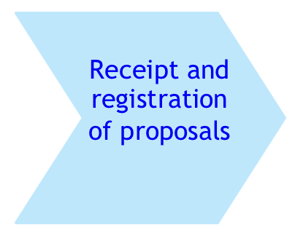
The different steps of the assessment process in the framework of the Black Sea Basin Programme can be summarized as follows:
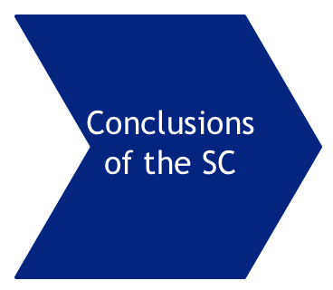
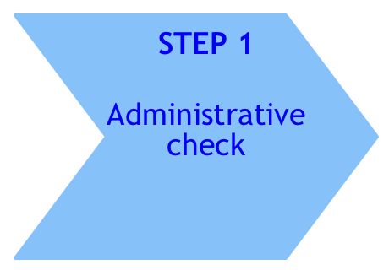

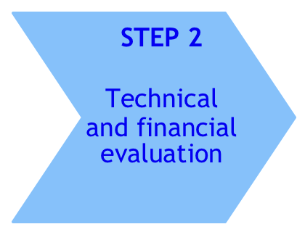

Administrative check (step 1)
The administrative check will be carried out by internal assessors nominated from the MA and JTS staff under the supervision of the SC Chairperson and Secretary. Each project proposal will be examined by 2 internal assessors: both assessors shall fill in the administrative check grids.
Once the administrative check is complete, the Chairperson, with the support of the Secretary, will establish a list of all the proposals satisfying the criteria and a list of proposals not satisfying the criteria.
These lists and the administrative grids for all the applications submitted will be presented to the SC voting members for endorsement.
Once the voting members of the SC have agreed on the outcome of Step 1, the report and the minutes of the SC meeting will be signed by all members of the Committee (voting and non-voting) and the Administrative Check Report is submitted to the MA for endorsement of the evaluation procedure. The MA will verify whether the evaluation process took place according to the regulations and provisions in force, identify any possible irregularities in the procedure and inform the JMC accordingly.
The endorsed Administrative Check Report will be submitted to the JMC for approval.
Technical and financial evaluation (step 2)
The technical and financial evaluation will be carried out by external assessors.
The assessors shall work under the supervision of the Chairperson of the SC. Two external assessors must be appointed to evaluate each project proposal.
An additional assessment done by another independent assessor, may be carried out when:
- the total scores given by the initial two assessors diverge by more than 20 points and
- only one of the total initial scores is above the threshold for overall admissibility of the proposals.
The decision on the need of a third assessment will be taken by the SC members.
Quality check by the SC Chairperson
To ensure the quality of the work carried out by the assessors, the SC Chairperson – with the help of the Secretary and internal assessors – shall preliminarily review all completed evaluation grids before the SC meeting.
The outcome of this step will be:
          - a list of applications proposed for selection, ranked in descending order per Thematic Objective according with their average scores, until the maximum amount available for each Thematic Objective under this call for proposals is reached;
          - reserve list of applications that cannot be funded for budgetary reasons;
          - a list of rejected applications.

During its deliberation, the SC members are not allowed to change the external assessors' scores and/or to alter the evaluation grids completed by the external assessors and/or the list of the applications provisionally selected. The SC will revise the conclusions made for the projects recommended for funding and will endorse or complement the recommendations made by the assessors.
Once the voting members of the SC have agreed on the outcome of Step 2, the report and the minutes of the SC meeting are duly signed by all members of the Committee (voting and non-voting) and the Technical and Financial Report is submitted to the MA for endorsement. The MA will verify whether the evaluation process took place according to the regulations and provisions in force, identifying any possible irregularities in the procedure and informing JMC accordingly.
The endorsed Technical and Financial Report will be submitted to the JMC for approval.
Verification of eligibility
The verification of eligibility will only be performed for the applications that have been proposed for selection according to their score and within the available financial envelope. However, the JMC may approve the extension of the verification of eligibility to projects on the reserve list.
The verification of eligibility will be carried out by the National Authority in each participating country. The chairperson shall send the list of the applicants/partners from each country to the respective NA. The NA will provide opinions in relation to the eligibility of the applicants/partners in their country based on the eligibility documents provided by the applicants/partners. Each NA will make a list of eligible entities and a list of entities which fail to meet the eligibility criteria.
These lists shall be sent to the Chairperson who will prepare the Verification of Eligibility Report, which shall be submitted to the SC and MA for endorsement. The MA will verify whether the evaluation process took place according to the regulations and provisions in force, identifying any possible irregularities in the procedure and informing JMC accordingly.
The endorsed Verification of Eligibility Report will be submitted to the JMC for approval.
Appeals
Applicants believing that they have been harmed by an error or irregularity during one of the steps (administrative, technical and financial or verification of eligibility) of the evaluation and selection process may file an appeal directly to the MA. The applicant should substantiate its appeal by arguing why the decision of the Selection Committee/Joint Monitoring Committee infringes the provisions of the Guidelines for Grant Applicants or other applicable rules.

Programme implementation

Description of the management and control systems
A summary description of the management and control systems (DMCS) will be inserted after approval of the DMCS

Time-frame for programme implementation
Provisional indicative time-frame for programme implementation
 | 2015 |  | 2016 |  | 2017 |  | 2018 |  | 2019 |  | 2020 |  | 2021 |  | 2022 |  | 2023 |  | 2024
 | I | II | I | II | I | II | I | II | I | II | I | II | I | II | I | II | I | II | I | II
Submission to EC
Adoption by EC
Period of execution
Signature of Fin. Agreements.
JMC meetings
Launching of the calls
Evaluation/selection of projects
Contracting phase
Implementation of projects
Programme closure

Technical assistance (TA)

According with art. 34 of Regulation (EU) No.897/2014, a maximum of 10 % of the Union's total contribution may be allocated to technical assistance
Although the vastness of the eligible territory and the large number of partners expected to be involved in the projects makes programme implementation very demanding in terms of financial resources, in order to give priority to projects, initially, a 10 % of the Union's total contribution shall be allocated to technical assistance of the programme.
Nevertheless, during the implementation stage, based on the budget execution at projects level and also taking into account the final deadline for contracting, upon a needs analysis, the amount may be modified, according with art. 6 of Regulation (EU) No.897/2014.
On the other hand, the EC has indicated that there will be an EU Techical Assistance project for the 2014-2020 programmes, therefore it is anticipated that support will be provided also by this project, especially for communication and training activities.
In accordance with art.35(1) of the Regulation (EU) No.897/2014, the TA budget shall support the preparation, management, monitoring, evaluation, information, communication, networking, complaint resolution, control and audit activities related to the implementation of the programme and activities to strengthen the administrative capacity for implementing the programme.
Technical assistance shall be used for the needs of both programme structures and beneficiaries.
The main indicative activities planned to be implemented from the technical assistance budget are described below:
- Support to the programme’s bodies (JMC, MA, NAs, AA&GoA, CCP and SC) for fulfilling their tasks related to the management, implementation, monitoring, evaluation, audit and control of the programme,
- Establishment and functioning of the Joint Technical Secretariat;
- Supporting partner search initiatives and the enhancement of the potential applicants’ capacity to submit relevant project applications, contributing to the programme objectives and expected results;
- Strengthening beneficiaries’ capacity for an efficient and effective management of the projects;
- Supporting the activities related to information and promotion of the programme and capitalization of its results, as they are presented in the Communication Strategy.
The TA activities will be implemented by the MA, JTS and AA and the related contracts shall be awarded according with the national public procurement legislation of Romania, the country hosting the MA, JTS and AA, which is in line with EU public procurement requirements.
However, if during the programme implementation, the circumstances will require the implementation of TA activities by other programme bodies, the procurement procedures applicable shall be those described in art. 37(1) of the Regulation (EU) No.897/2014.
Eligibility requirements set out in Article 48 of the Regulation (EU) No.897/2014 apply mutatis mutandis to technical assistance costs.
Costs referred to in Article 49 of the Regulation (EU) No.897/2014 shall not be considered eligible as technical assistance costs.
Costs for preparatory actions shall be eligible upon submission of the programme to the Commission, provided the programme is approved by the Commission.
The overall indicative TA budget is inserted below.
2014-2020 Indicative Technical Assistance budget
Budget categories |  | 2015-2024 (€) | %
Total |  | 4,903,860 | 100%
1 | Staff costs | 2,223,048 | 45.3%
2 | Travel costs | 860,502 | 17.5%
3 | Equipment & supplies | 166,850 | 3.4%
4 | Administrative costs | 296,500 | 6.0%
5 | Subcontracted services | 1,330,350 | 27.1%
6 | Other costs (bank fees,etc.) | 17,443 | 0.4%
7 | Contingent Expenses | 9,168 | 0.2%
All the prices include VAT. The VAT represents 24% from all the prices
The value of the daily allowance may vary according to the Romanian legislation

Monitoring and Evaluation
Description of the Monitoring and Evaluation System
The monitoring and evaluation (M&E) activities will play an important role in the programme implementation cycle. The objective is to put in place a proper risk management by project partners, programme bodies and the EC. In addition, the M&E system will enable learning to take place during project and programme implementation as well as safeguarding accountability. In order to meet these objectives, the following activities will be carried out: monitoring at project level, monitoring at programme level and evaluation. See full details in Annex 3.
Monitoring activities at project level shall be carried out both internally (by the project partners) and externally (by the programme bodies). The aim of the project-level monitoring activities shall be to track progress in project implementation, to take remedial action where necessary as soon as possible, as well as to update action plans. Day-to-day monitoring activities by the MA and JTS will consist of a review of progress reports, regular contact with the lead beneficiaries by e-mail and telephone, and where possible attending key project events. Also, specific on-the-spot visits may be carried out to the lead beneficiaries or to beneficiaries’ premises by MA or JTS staff. The MA or JTS staff will visit each project at least once during its implementation.
Project beneficiaries (lead partners) will be responsible for project-level monitoring. In case of substantial risks, the lead beneficiary should inform the MA immediately. In all other cases, it will report to the MA every four months in the form of progress reports. In addition, it will be compulsory for project applications to include the measurement of at least one of the programme output indicators, alongside project-specific output indicators.
The programme will also carry out an internal Result-Oriented Monitoring (ROM) plan, in the framework of which it will review the performance of projects funded with a focus on the likelihood that results will be achieved and the need for remedial action. ROM reports will also make recommendations to lead beneficiaries and beneficiaries in order to improve project implementation.
As regards monitoring at programme level, day-to-day activities will focus primarily on progress in implementation of the programme in terms of financial and output indicators, as well as in terms of risks and assumptions. The basis for data collection will be mainly project reports. Aggregation will be carried out in the framework of the Management and Information System (MIS), where data on progress in terms of launching calls, applications received, the assessment of their quality, contracts signed and project-level on-the-spot visits and audits is also available.
In addition, there will be a need for additional data collection in order to measure programme level result indicators. This will include surveys among reference groups, consisting of a sample of organisations from among the target groups for each priority in the programme strategy, possibly also including expert organisations in certain areas. These reference groups will be asked for their assessment of the situation in relation to the objective of the corresponding priority, the average of which will constitute the value of the result indicator (see full methodology for measuring the result indicators in Annex 3).
The MA shall submit an annual report approved by the JMC to the EC by 15 February each year. That annual report shall include one technical and one financial part covering the preceding accounting year. The programme will also provide input to the KEEP database on, amongst others, common output indicators, projects contracted, status of beneficiaries and budget allocations per (type of) partner.
In terms of evaluation, by the end of 2017 the EC will commission a mid-term evaluation at instrument-level, which will generate conclusions and recommendations that are relevant for the programme as well. The MA will inform the JMC about the mid-term evaluation findings to the extent they are relevant for the programme. In addition, the programme may commission a programme-specific evaluation (which is likely to take place in 2020), building on the EU-level mid-term evaluation and used as a basis for future programming, or possibly serving as a basis for reallocation of funds and/or revision of indicators target values.
Indicative Monitoring and Evaluation Plan
The M&E plan (attached in Annex 3) is used to systematically plan the collection of data to assess and demonstrate progress made in achieving expected results. It highlights mechanisms or modalities for monitoring the achievement of outputs and contribution towards achievement of expected results. The M&E plan incorporates the programme indicators, baselines targets and their means of verification. It contains detailed definitions for the programme indicators, rationale for their selection, sources of information and verification, baselines and targets, methods and tools to collect data, where necessary calculation formulas for result indicators, and milestones to measure and report on progress in terms of output indicators. The plan also presents the frequency of data collection. An indicative list of evaluations to be undertaken, together with their subject and rationale is also included.

Communication
Communication is a key component in the successful implementation of the Black Sea Basin ENI CBC programme 2014-2020. It is important for ensuring those involved, including other interested parties and the wider public, are kept informed of the support being provided by the EU and the results and impacts of this support. It is important also for keeping both external and internal actors informed and for liaison with EU and other bodies supporting initiatives in the BSB area. It is also an important component in capitalisation of results.
The ENI CBC Implementing Regulation stipulates that information on the communication strategy for the whole programme period, and an indicative information and communication plan for the first year should be included in the programme.
The strategy addresses information and communication needs for internal actors involved in programme implementation as well as for external actors benefiting from programme implementation.
The overall objective of the BSB Communication Strategy is to facilitate the achievement of the programme objectives through effective communication to improve participation, assist successful implementation, ensure transparency and increase awareness of the programme, EU and national support.
The guiding principles, the responsible bodies, the visibility rules for information and communication are specified in other components of the legal framework governing the development and implementation of the ENI CBC, in particular that communication is targeted, adequate and non-discriminatory. These requirements and principles have been taken into account in the preparation of the communication strategy.
See annex 4 for the communication strategy and the Annual Information and Communication Plan for 2016.

Strategic Environmental Assessment
According to ENI CBC implementing regulation, BSB joint operational programme should include “information on fulfilment of regulatory requirements laid down in Directive 2001/42/EC of the European Parliament and of the Council”, i.e. the directive on the assessment of the effects of plans and programmes on the environment, the so called Strategic Environmental Assessment (SEA) Directive.
The purpose of the SEA Directive is to provide for a higher level of protection of the environment and to contribute to the integration of environmental considerations into the preparation and adoption of plans and programmes with a view to promoting sustainable development. According to the directive, a full environmental assessment should be carried out for a particular programme as follows:
- It is required automatically when the relevant programme sets the framework for consent for projects with work components listed in annex l or ll of the EIA Directive (87/337/EEC), or which in view of the likely effect on sites, have been determined to require an assessment pursuant to art. 6/7 of the Habitat Directive (92/43/EEC).
OR
- The need for a full environmental assessment is determined following a ‘screening’ process to determine whether the programme sets the framework for future consent of projects likely to have a significant effect on the environment.
As the SEA Directive does not specifically address cross-border cooperation programmes with Partner Countries, the EC issued a Guidance Note on Strategic Environmental Assessment (SEA) in the context of ENI CBC (June 2014). According to the guidance, it is the responsibility of the Member State hosting the Managing Authority (MA) for the programme to determine, according to its national legislation, how to conduct the SEA process.
SEA process
According to current practice in Romania, the procedure for the assessment of such programmes is adapted by the Ministry of Environment, Water and Forests (MoE), on a case by case basis, according to the SEA Directive and the Romanian Government Decision on the environmental assessment of plans and programmes.
In the case of the BSB programme, the MoE and the MA decided to conduct a screening process on whether the programme activities are likely to have significant environmental effects in the eligible regions in Romania on one hand and to consult the environmental authorities in the participating countries on the other hand. The EU project ENI CBC Support to the Preparation of Programmes (SPP) assisted the MA and MoE to fulfil the requirement of the SEA directive. The process included:
- July-November 2014: Representatives of the relevant environmental authorities in each participating country were nominated by the National Authorities. The relevant authorities are:
Country | Nominated Environmental Authority
Armenia | Ministry of Nature Protection
Azerbaijan | Ministry of Ecology and Natural Recourses
Bulgaria | Ministry of Environment and Water
Georgia | Ministry of Environment and Natural Resources
Greece | Ministry of Environment, Energy & Climate Change
Moldova | Ministry of Environment
Turkey | Ministry of Environment and Urbanisation
Ukraine | Ministry of Environment
- October 2014: The conduct of a screening process of the proposed programme strategy Thematic Objectives, priorities, indicative activities and expected results by the SPP SEA expert (according to Annex ll of the SEA Directive) to determine whether future projects are likely to have significant environmental effects.
- November 2014: Environmental authorities were asked for their expert opinion on whether the programme is likely to have a significant effect on the environment in the eligible regions in their countries and whether there are national requirements to be followed in this particular instance. Documents sent to the environmental authorities included:
  - EC Guidance Note on SEA in the context of ENI CBC (June 2014)
  - Draft of the BSB ENI CBC programme strategy as approved at BSB JPC meetings (July & Nov 2014)
  - Background information on ENI CBC and the BSB programme (Oct 2014)
  - Note for BSB participating countries on SEA process (October 2014)
  - The results of the screening process conducted by the SPP SEA expert
- December 2014-January 2015: Conduct of a screening process in Romania including:
  - Establishment of a Screening Committee made up of concerned public authorities: Ministry of Health, National Administration for Waters, Ministry of Internal Affairs (General Inspectorate for Emergency Situations), Ministry of European Funds, Ministry of Agriculture and Rural Development, Ministry of Transport, Department for SMEs, Business Environment and Tourism and public authorities from the eligible regions.
  - The start of the screening procedure was announced on the Ministry of Regional Development and Public Administration (MDRAP) and the programme websites (11&12 December 2014) and also via a notice in the România Liberă national newspaper (on 16&19 December 2014). In these announcements, the public was invited to comment on whether the programme was likely to have a significant impact on the environment in the eligible regions.. The draft programme strategy was made available on the MoE, MDRAP and programme websites.
  - The committee was given the documents listed above and met to conduct the screening process and make a conclusion on whether a full environmental assessment is required for the Romanian eligible territory. In addition, the committee was informed about the input received from the participating countries.
  - The draft decision of the Screening Committee was published on the MoE and MDRAP websites on 6 January 2015.
- January-February 2015: A SEA screening procedure was carried out by the Bulgarian Ministry of Environment and Water in regard to the eligible regions in Bulgaria to determine whether environmental assessment was needed.
Conclusions from participating countries
Participating Country | Conclusion
Armenia  Azerbaijan  Georgia  Greece  Moldova  Turkey | Based on internal consultations and own assessments according to their national procedures, the environmental authorities have concluded that the Black Sea CBC programme 2014-2020 is not likely to have a significant effect on the environment in the regions in their countries eligible for the programme and that no further action is required at national level. The environmental authorities have largely supported the initial assessment prepared by the SPP expert for the MA and the conclusions derived from it.
Romania | “As a consequence, according with the provisions of art. 3 par.(7) of the SEA Directive, the Ministry of Environment, Water and Forests decides that environmental assessment is not required pursuant to art.5 of the SEA Directive for the ENI CBC Black Sea Basin Programme 2014-2020.”
Bulgaria | The Ministry of Environment and Water has concluded that, “according to the relevant legal provisions, environmental assessment is not required for the Bulgarian NUTS II regions included in the eligible area of the Black Sea Basin ENI CBC Programme 2014-2020, the implementation of which is unlikely to have a significant negative impact on the environment and human health.” The decision was made based on two conditions related to environmental impact assessment where necessary and good water status and management of flood risk. These conditions have been included in the SEA report and reflected in the relevant part of the programme strategy.
Ukraine | Opinion pending
Overall conclusions
Based on the assessment of the BSB programme using criteria for determining the likely significance of environmental effects (according to Annex II of the SEA Directive), and taking into account the opinions received from the environmental authorities of the participating countries, it is concluded that the programme is not likely to have significant environmental effects in the regions eligible for the programme for the following reasons (full details can be found in the report on the SEA process in annex):
- The programme allocates financing and sets the framework for the projects and their operating conditions (‘soft’ type of projects with limited investments in equipment)
- The programme has no direct influence on the other plans or programmes
- Integration of environmental considerations is stipulated in the JOP; relevant project selection criteria will be applied
- No environmental problems relevant to the programme have been identified
- The programme is not directly relevant for the implementation of Community legislation on the environment
- No direct or cumulative effects on environment are expected, while some indirect positive impact is estimated in the whole programme area affecting the entire population
- ENI CBC is promoting cooperation across the borders, however, no direct trans-boundary environmental effects are expected
- No risks to human health or the environment have been identified
- In regard to the magnitude and spatial extent of effects, indirect positive impact is estimated in the whole programme area affecting the entire population
- No vulnerable areas will be directly affected. Intensification of the tourism related activities might potentially lead to an increased pressure on the vulnerable nature areas and cultural heritage objects. To eliminate this potential risk the project applicants will have to carry out the vulnerability assessment of their projects prior to applying for financing
- No direct effects on the landscape are expected
Therefore it can be concluded that the regulatory requirements of the SEA directive have been fulfilled in the case of the Black Sea Basin ENI CBC programme, in accordance with national legislation and the guidance on the subject provided by the EC. The nominated environmental authorities in the participating countries have been consulted and it is severally and jointly the opinion of the participating countries that the programme is not likely to have a significant effect on the environment of the regions eligible for the programme (to be updated following input from Ukraine).

Financial plan
An indicative financial plan (to be drafted by MA) containing two tables (without any division per participating country):
- a table specifying the yearly provisional financial appropriations for commitments and payments envisaged for the support from the Union for each thematic objective and technical assistance. The first year's appropriations shall include the costs for preparatory actions pursuant to Article 16

The table specifying the provisional amounts of the financial appropriations of the support from the European Union and co-financing for the whole programming period for each thematic objective and technical assistance is inserted below.

Provisional amounts of the financial appropriations for each thematic objective and technical assistance (EUR)
 | ENI EU Funding (a) | Percentage rate from total (a)  (b) | Co-financing (c) | ENI Co-financing rate (in %) (d) | Total funding (e) = (a)+(c)
Thematic Objective 1 | 25 337 752,20 | 51,67% | 2 815 305,80 | 90% | 28 153 058,00
Thematic Objective 2 | 18 796 985,10 | 38,33% | 2 088 553,90 | 90% | 20 885 539,00
Technical Assistance | 4 903 859,70 | 10,00% | 0,00 | 100% | 4 903 859,70
Total ENI | 49 038 597,00 | 100,00% | 4 903 859,70 |  | 53 942 456,70

Rules on eligibility of expenditure
No profit principle
Grants shall not have the purpose or effect of producing a profit within the framework of the project.
Where a profit is made, the Managing Authority shall be entitled to recover the percentage of the profit corresponding to the Union contribution to the eligible costs actually incurred by the beneficiary to carry out the project.
For this purpose, profit shall be defined as a surplus of the receipts over the eligible costs incurred by the beneficiaries (Lead Beneficiary and partners), when the request is made for payment of the balance.
Forms of grant will be defined in the guidelines for applicants, in accordance with article 47 of the ENI-CBC Implementing Regulation.

Eligibility of costs
The eligible costs will be defined in detail in the Guidelines for Applicants and in the Grant Contract, in line with articles 48, 49, 50 and 51 of ENI-CBC Implementing Regulation.

Apportionment of liabilities among participating countries
In accordance with article 74 of the ENI-CBC Implementing Regulation, the Managing Authority shall be responsible for pursuing the recovery of amounts unduly paid.
Where the recovery relates to a claim against a beneficiary established in a Member State and the Managing Authority is unable to recover the debt, the Member State in which the beneficiary is established shall pay the due amount to the Managing Authority and claim it back from the beneficiary.
Where the recovery relates to a claim against a beneficiary established in a CBC partner country and the Managing Authority is unable to recover the debt, the level of responsibility of the CBC partner country in which the beneficiary is established shall be such as it is laid down in the relevant financing agreement.
In accordance with article 72 of the ENI-CBC Implementing Regulation, “the Commission shall make financial corrections by cancelling all or part of the Union contribution to a programme and effecting recovery from the Managing Authority in order to exclude from Union financing expenditure which is in breach of applicable law or related to deficiencies in the programme management and control systems which have been detected by the Commission or the European Court of Auditors”.
In accordance with article 74, “where the recovery relates to systemic deficiencies in the programme management and control systems, the Managing Authority shall be responsible for reimbursing the amounts concerned to the Commission in accordance with the apportionment of liabilities among the participating countries as laid down in the programme”.
The criteria for apportionment shall be the following:
- If the systemic deficiency concerns one specific country, this country shall be responsible for reimbursing to the Programme accounts the amount identified as a result of the financial correction;
- If the systemic deficiency concerns the whole system, each country shall be responsible for reimbursing to the Programme accounts the amount representing the percentage of the financial correction applied to the expenditure incurred by the beneficiaries of the respective country and declared by the MA to the European Commission at the date of the decision to apply the financial correction.

Rules of transfer, use and monitoring of co-financing
Co-financing principle
Article 12 of ENI-CBC Implementing Rules states that co-financing shall amount to at least 10% of the Union contribution, that is 4.903.860 €. This minimum amount may come from the projects and from the contribution of the participating countries to the Technical Assistance.
Under the co-financing principle, as stated in article 183 of the Rules of Application (RAP) of the Financial Regulation (Commission Delegated Regulation (EU) No 1268/2012), the resources which are necessary to carry out the projects shall not be provided entirely by the Union contribution.
The percentage of Union contribution to projects shall be defined in the calls for proposals and the grant contracts.
The co-financing may take the following forms:
- Beneficiary’s own resources
- Income generated by the project
- Financial contributions by third parties, from sources other than the Union
Together with the Union contribution, these sources of co-financing shall constitute the project receipts, as defined by the article 125(5) of the Financial Regulation (EU, Euratom) No 966/2012.
Use and monitoring of co-financing
The Grant Contract shall include the sources of the co-financing by the project beneficiaries. The co-financing will be monitored and included in the programme accounting through the declaration on expenditure and receipts prepared by the beneficiaries, verified by a controller, which will be part of the requests for payment of the grant.

Reporting and exchange of computerised data between the Managing Authority and the EC
A description of the IT systems for the reporting and exchange of computerised data between the Managing Authority and the European Commission (unit C2, DG NEAR) is required under the ENI CBC Implementing Regulation (Art 4.5m). The European Commission has proposed that this be done via KEEP, a comprehensive online database of Territorial Cooperation projects, project partners and programmes (www.territorialcooperation.eu/keep/) which was operational during the 2007-2013 programme period. Although most statistics needed by the European Commission are already included in KEEP, a new KEEP template is being developed for the 2014-2020 programme period. It is anticipated that most data required by the European Commission will be kept in the KEEP database rather than being available only via programme reports. As well as being a tool for programmes to share data with the European Commission, KEEP will also allow for the sharing of data between programmes.

Programme language
As the programme is by definition multinational, in order to facilitate programme management and to shorten procedures and in accordance with Article 7 of the ENI CBC Implementing Regulation, the official language used in the programme is English.

ANNEXES

Annex 1 – Summary of mapping of projects awarded under the Black Sea Basin 2007-13 two calls for proposals and of the survey on current priorities and future needs

Annex 2 - Full SWOT and combined outcomes of SWOT and past experience analyses

Annex 2 - Outcomes from stakeholders consultations

Annex 3 – Monitoring and evaluation system and plan

Annex 4 – Communication strategy and annual information and communication plan 2016

Annex 5 – Report on strategic environmental assessment
Notes and Sources

Regulation (EU) No 232/2014 of the European Parliament and of the Council of 11 March 2014 establishing a European Neighbourhood Instrument
Commission Implementing Regulation (EU) No 897/2014 of 18 August 2014 laying down specific provisions for the implementation of cross-border cooperation programmes financed under Regulation (EU) No 232/2014 of the European Parliament and the Council
Programming document for European Union support to ENI Cross-Border Cooperation for the period 2014-2020, adopted by a Commission implementing decision on 08.10.2014
Russia did not participate in the consultations
See more details under the title ‘Nature of projects and types of support’ within the Programme Strategy Chapter. Note that specific provisions apply to international organisations and European Groupings.
As listed in Annex I of Regulation (EU) N° 232/2014 of the European Parliament and of the Council of 11 March 2014 establishing a European Neighbourhood Instrument
The Russian Federation has not been actively involved in the programme preparation and is unlikely to join the programme implementation
At the time of drafting this programme, and as provided in the ENI CBC programming document, the general EU restrictions on cooperation in regions that are illegally occupied by Russia are also applicable to CBC. Therefore, the regions of Sevastopol and the Crimea Republic are not currently eligible.
Please note though that at the time of drafting this programme, the general EU restrictions on cooperation in regions that are illegally occupied by Russia are also applicable to CBC, therefore the regions of Sevastopol and the Crimea Republic are not currently eligible. Note also that the Russian Federation has not been actively involved in the programme preparation and is unlikely to join the programme implementation.
IPA in the case of Turkey
Regulation (EU) No 232/2014 of the European Parliament and of the Council of 11 March 2014 establishing a European Neighbourhood Instrument
Commission Implementing Regulation (EU) No 897/2014 of 18 August 2014 laying down specific provisions for the implementation of cross-border cooperation programmes financed under Regulation (EU) No 232/2014 of the European Parliament and the Council
Programming document for European Union support to ENI Cross-Border Cooperation for the period 2014-2020, adopted by a Commission implementing decision on 08.10.2014
Full text of the statement available on http://eeas.europa.eu/blacksea/doc/joint_statement_blacksea_en.pdf
Full text of the resolution available on http://www.europarl.europa.eu
More information on the Eastern Partnership is available at http://eeas.europa.eu/eastern/index_en.htm
More information on the Danube Strategy and Action Plan is available on http://www.danube-region.eu
DG Maritime affairs and fisheries is carrying out two studies on the blue growth potential of the Black Sea and on the use of the so-called maritime clusters, networks of firms, training establishments, research centres, local and regional authorities. (from Commissioner Maria Damanaki’s speech 30 Jan 2014, Black Sea Stakeholders' conference Sustainable Development of the blue economy in the Black Sea Bucharest, 30 January 2014)
The part on ‘Safety and security challenges’ was nonetheless updated in February 2015 to reflect the situation in Ukraine and related major international crisis
Data for Ukraine as of 01.01.2013. Data for Russia 2005.
Note that data for Russia has not been updated (as not provided at regional level), therefore the trend could not be calculated for Russian regions
Between 2005 and 2012, the population of ENI CBC programme eligible areas of Armenia decreased by 8%, of Bulgaria by 5%, of Romania by 11%, of Ukraine by 5%.
Net migration = total number of immigrants less the annual number of emigrants (including both citizens and noncitizens)
Please note that figure 6 presents stacked GDP growth (both negative and positive) per year
According to World Bank classification
See figures 1,2 and 5 for more details
SMEs : <250 employees, < €50 m turnover or <€43m balance sheet total (as defined by the EC)
Based on data provided by participating countries ; data for Georgia < 100 employees
Value added = the value of output less the value of intermediate consumption. It is a measure of the contribution to GDP made by an individual producer, industry or sector.
Trade openness ratio = trade-to-GDP ratio = the average of total trade (i.e. the sum of exports and imports of goods and services) relative to GDP. It is used to measure the importance of international transactions relative to domestic transactions.
Regional data missing for Bulgaria and Ukraine; data missing for Armenia
Note that regional data is missing for several countries
Tertiary education includes academic education as well as advanced vocational or professional education.
Note: regional information received doesn’t allow to draw a comprehensive picture
National data for average monthly rate, 2010.
Data provided by participating countries, except provisionnal unemployment data for Armenia (2007) and Russia (2011) from World Bank, WDI.
Draft Note : Data provided by participating countries are not comparable (sometimes including higher education institutions, even if they do not carry out research activities) so more precise figures cannot be given
The Commission on the Protection of the Black Sea Against Pollution (the Black Sea Commission) via its Permanent Secretariat is the intergovernmental body established in implementation of the Convention on the Protection of the Black Sea Against Pollution (Bucharest Convention)
MONINFO project supported by the EU (DG ENV)
Established under the Convention on the Conservation of European Wildlife and Natural Habitats (the Bern convention) 1982
Under the Convention on the Protection of the Black Sea Against Pollution 1992
In their declaration of October 2010 in Nafplion (Greece). BSEC (Black Sea Economic Cooperation) members include Albania, Armenia, Azerbaijan, Bulgaria, Georgia, Greece, Moldova, Romania, Russia, Turkey and Ukraine.
Note that regional data for Russia is missing
In 2008, deaths per 100,000 population. Highest rates - Armenia: 182, Romania: 145; Lowest rates - Turkey: 118, Georgia: 97 (WHO)
Female maternal mortality in Turkey was divided by two between 2000 and 2010
Maternal mortality = ratio of the number of maternal deaths to the number of live births; Adolescent fertility = number of births to women ages 15–19 per 1,000 women ages 15–19
UNDP gender inequality index is based on reproductive health (maternal mortality, adolescent fertility), empowerment (educational attainment, parliamentary representation) and labour force representation data
Indicator on quality of port infrastructure included in the Global Competitiveness Index of the World Economic Forum, 2012-2013 report
In July 2010 report on ports and maritime links, produced by the ‘Motorways of the Sea for the Black Sea and Caspian Sea’ project financed by EU’s TRACECA programme
Black Sea Partner Countries include Armenia, Azerbaijan, Belarus, Georgia, Republic of Moldova and Ukraine
See a summary annexed to the programme
See a summary annexed to the programme
List of thematic objectives and priorities as available at the time in the draft version of the Programming document
See outcome of Black Sea Basin consultations in annex
Russia did not contribute to the consultations
See full outcomes of the consultation process provided in annex
Note, however, that health issues were sometimes included by stakeholders under Thematic Objective 4
Only relevant regional programmes > €10 million were included
Including aquaculture, food industry and agro-industry
Marine litter is any persistent, manufactured or processed solid material discarded, disposed of or abandoned in the marine and coastal environment. Marine litter consists of items that have been made or used by people and deliberately discarded into the sea or rivers or on beaches; brought indirectly to the sea with rivers, sewage, storm water or winds; accidentally lost, including material lost at sea in bad weather (fishing gear, cargo); or deliberately left by people on beaches and shores. Also known as marine debris.
See ‘Complementarities and synergies’ for more details on the Commission for the Protection of the Black Sea Against Pollution (Black Sea Commission),
See report from the Black Sea Commission on Marine Litter in the Black Sea Region, 2009
Art. 4c Regulations (EU) N° 897/2014
Note that COI 29 is used both for priorities 1.2 and 2.1
During indicators monitoring process, tourism events and cultural events will be counted separatly, as the latter might become input for COI 8
MA: Managing Authority; JTS: Joint Technical Secretariat ; EC: European Commission; NA: National Authorities of participating countries
Including for partner countries and Russia, countries having signed a Financing Agreement with the EU
Indicators provisionally developed, may still be revised
See further details under the section ‘BSB strategy definition’ of this document
Art. 45.1 of ENI CBC Regulation (EU) 897/2014. See section ‘Description of the Programme area’ of this document for more details on participating countries (however Russian Federation is unlikely to join the programme implementation).
5.33 and 6.7 Programming document 2014-20 ENI CBC
Ar. 6.3 of ENI Regulation (EU) 232/2014 refering to EU Regulation N°236/2014 laying down common rules and procedures for the implementation of the Union's instruments for financing external action (Art 8.1, 8.7 and 9.1)
See section ‘Description of the Programme area’ of the strategy part of the JOP for further details on the programme area.
Art. 45.3 (a) of ENI CBC Regulation (EU) 897/2014
Art. 39 of ENI CBC Regulation (EU) 897/2014 and further restrictions agreed within ENI CBC BSB programme
Art. 40 of ENI CBC Regulation (EU) 897/2014
Art. 4.3 Regulations (EU) N° 897/2014
See section ‘Horizontal issues and modalities’ of this chapter for more details
Following the screening processes in Romania and Bulgaria to determine whether the programme is likely to have an environmental effect, the following conditions were imposed: Romania: Projects which might have an environmental effect should be subject to an EIA. Bulgaria: The decision was made based on two conditions related to environmental impact assessment where necessary and good water status and management of flood risk.
For more details please refer to chapter ‘Overall strategic framework’
For more details please refer to ‘Consistency with other EU programmes’ under chapter ‘Black Sea Basin strategic analyses and consultations’
For more details please refer to ‘Stakeholders consultations’ under chapter ‘Black Sea Basin strategic analyses and consultations’
For more details please refer to ‘Socio-economic and SWOT analysis’ under chapter ‘Black Sea Basin strategic analyses and consultations’
In line with the Programming document 2014-20 ENI CBC (6.7). Further guidance on eligibility of project partners will be provided in the Guidelines for Applicants.
Russian Federation has not been actively involved in the programme preparation
See further details in the chapter ‘Communication strategy’ of this document
See Table 3 within ‘Consistency with other EU programmes’ under chapter ‘Black Sea Basin strategic analyses and consultations’ of this document
See further details in the chapter ‘Communication strategy’ of this document
A SC will be used for the first call for proposals but it was agreed during the development of the programme to keep open the option of not using a SC in subsequent calls
From the date of the adoption of the programme by the EC, art. 15 ENI CBC Regulation (EU) 897/2014
Signature of Financing Agreement by partner countries or the Russian Federation
Art. 4.5h Regulation (EU) N° 897/2014
Hotărârea Guvernului nr. 1076/2004
As indicated in the chapter above on Black Sea Basin ENI CBC programme strategy
Although public consultation is not required under the EU SEA Directive for the screening process, this was done in Romania as it is required under Romanian law. The public in the programme area had been consulted previously during the development of the strategy.
As stipulated in Article 85, pt. 4 and pt. 5 of the Law on Environmental Protection, Art. 4, pt. 1 and Art. 14, pt. 2 of the Ordinance on the conditions and procedures for environmental assessment of plans and programs, Art. 37, pt. 4 of the Ordinance on the conditions and procedures for assessing the compatibility of plans, programs, projects and investment proposals with the object and purpose of conserving protected areas
Source : EC, DG Regional Policy (map of the ENPI CBC BSB 2007-13 programme – same regions included in the ENI CBC programme)
Source: Data provided by participating countries, 2012 (except for Russia, 2005); World Bank, World Development Indicators (WDI) 2011 for Armenia
Source: Statistical data provided by participating countries in 2006 and 2013.
Source: Statistical data provided by participating countries in 2006 and 2013.
Source: World Bank, World Development Indicators (WDI)
Source: World Bank, World Development Indicators (WDI)
Source: World Bank, World Development Indicators (WDI)
Source: OECD, International migration outlook 2013
Source: World Bank WDI
Source: International Organisation for Migration (IMO) - Migration in the Black Sea Region, An overview 2008
Source: International Organisation for Migration (IMO) – Country migration profiles 2008 for Armenia, Azerbaijan, Bulgaria, Georgia, Greece, Moldova, Russia, Turkey, Ukraine; Extended migration profile 2012 for Moldova; OECD, International Migration outlook 2013
Source: International Organisation for Migration (IMO) – Country migration profiles 2008 for Armenia, Azerbaijan, Bulgaria, Georgia, Greece, Moldova, Russia, Turkey, Ukraine; Extended migration profile 2012 for Moldova
Source: International Organisation for Migration (IMO) – Country migration profile 2008, Turkey
Source: International Organisation for Migration (IMO) - Migration in the Black Sea Region, An overview 2008
Source: Data provided by participating countries ; WDI for EU and Armenia
Source: Data provided by participating countries
Source: Data provided by participating countries
Source: World Bank WDI
Source : Black Sea Trade and Development Bank – Black Sea Region : Sources of Sustainable Growth, Annual report 2012
Source: World Bank WDI
Source: World Bank WDI
Source: Data provided by participating countries
Source: Black Sea Trade and Development Bank – Black Sea Region : Sources of Sustainable Growth, Annual report 2012
Source: Black Sea Trade and Development Bank – Black Sea Region : Sources of Sustainable Growth, Annual report 2012, and WDI
Source: World Economic Forum, Global Competitiveness Report 2008-2009, Global Competitiveness report 2012-2013
Source: World Economic Forum, Global Competitiveness report 2012-2013
Source: World Bank WDI
Source: International Organisation for Migration (IMO) - Migration in the Black Sea Region, An overview 2008 ; European Training Foundation (ETF) – Black Sea labour market reviews
Source: World Bank WDI
Source: World Bank WDI
Source: Commission on the Black Sea - The Current State of Economic Development in the Black Sea Region, Policy Report, 2010
Source: Commission on the Black Sea - The Current State of Economic Development in the Black Sea Region, Policy Report, 2010
Source: OECD - SME Policy Index: Eastern Partner Countries 2012: Progress in the Implementation of the Small Business Act for Europe ; OECD - SME Policy Index : Western Balkans and Turkey 2012
Source: OECD SME Policy Index: Eastern Partner Countries 2012: Progress in the Implementation of the Small Business Act for Europe ; OECD - SME Policy Index : Western Balkans and Turkey 2012 ; OECD - The Impact of the Global Crisis on SME and Entrepreneurship Financing and Policy Response, 2009
Source : International Bank for Reconstruction and Development/World Bank, Doing Business 2013, Smarter Regulations for Small and Medium Size Enterprises
Source : International Bank for Reconstruction and Development/World Bank, Doing Business 2007, How to Reform ; Doing Business 2013, Smarter Regulations for Small and Medium Size Enterprises
Source: World Bank WDI
Source: European Parliament, DG for external policies of the Union – The EU’s Black Sea Synergy : Results and possible ways forward, Briefing 2010
Source: Black Sea Trade and Development Bank – Black Sea Region : Sources of Sustainable Growth, Annual report 2012
Source: World Bank WDI
Source: World Bank WDI
Source: Information provided by participating countries
Source: Data provided by participating countries in 2013 and 2006 (during the ENPI CBC programme drafting)
Source: World Tourism Organisation (UNWTO) – Tourism highlights 2013 ; Data provided by participating country in 2013 and 2006
Source: World Tourism Organisation (UNWTO) – Tourism highlights 2013
Source: Data provided by participating countries
Source: Data provided by participating countries
Source: FIBL-IFOAM - Organic Agriculture Worldwide: Key results from the FiBL-IFOAM survey on organic agriculture worldwide 2013
Source : Report of the First meeting of the ad hoc Working Group on the Black Sea (held in Constanta, Romania, 16-18 January 2012) at the General Fisheries Commission for the Mediteranean Committee on Aquaculture (held in Paris, France, 13-15 March 2013).
Source: World Bank WDI
Source: European Training Foundation (ETF) – Labour Markets and Employability trends and challenges in Armenia, Azerbaijan, Belarus, Georgia, Republic of Moldova and Ukraine, 2011
Source: Bank for Reconstruction and Development (EBRD) and World Bank - 2009 Business Environment and Enterprise Performance Survey (BEEPS)
Source: European Training Foundation (ETF) – Labour Markets and Employability trends and challenges in Armenia, Azerbaijan, Belarus, Georgia, Republic of Moldova and Ukraine, 2011
Source: World Bank WDI
Source: Data provided by participating countries in 2006 (for the Black Sea Basin ENPI CBC Programme drafting)
Source: Eurostat
Source: World Bank WDI
Source: European Training Foundation (ETF) – Labour Markets and Employability trends and challenges in Armenia, Azerbaijan, Belarus, Georgia, Republic of Moldova and Ukraine, 2011
Source: European Training Foundation (ETF) – Black Sea labour market reviews
Source: Data provided by participating countries
Source: Data provided by participating countries
Source: World Bank WDI
Source: World Bank WDI
Source: Black Sea Commission – State of the Environnement Report 2001-2007 ; UNEP/GIWA Eutrophication in the Black Sea Region, Impact assessment and causal chain analysis, 2005
Source: United Nations Environmental Programme (UNEP)/Global International Waters Assessment (GIWA) – Eutrophication in the Black Sea Region, Impact assessment and causal chain analysis, 2005
Source: Black Sea Commission – State of the Environnement Report 2001-2007
Source: Black Sea Commission - State of the Environment Report 2001-2007.
Source: European Environment Agency – Europe’s biodiversity – biogeographical regions and seas, the Black Sea 2012
Source: European Environment Agency – Europe’s biodiversity – biogeographical regions and seas, the Black Sea 2012
UNECE : United Nations Economic Commission for Europe
Source: European Environment Agency – Europe’s biodiversity – biogeographical regions and seas, the Black Sea 2012
Source: World Bank WDI
Source: World Bank WDI
Source: United Nations Environmental Programme (UNEP)/Global International Waters Assessment (GIWA) – Eutrophication in the Black Sea Region, Impact assessment and causal chain analysis, 2005
Source: United Nations Environmental Programme (UNEP)/Global International Waters Assessment (GIWA) – Eutrophication in the Black Sea Region, Impact assessment and causal chain analysis, 2005
Source: United Nations Environmental Programme (UNEP)/Global International Waters Assessment (GIWA) – Eutrophication in the Black Sea Region, Impact assessment and causal chain analysis, 2005
Source: World Bank WDI
Source: World Bank WDI
Source: WWF – Greening the Black Sea Synergy, 2008
Source: SEAS-ERA, Black Sea Strategic Research Agenda, April 2012
Source: World Bank WDI
Source: Data provided by participating countries
Source: World Bank Indicators
Source: World Health Organisation (WHO) – European Health Report 2012
Source: World Health Organisation (WHO) – European Health Report 2012
Source: World Health Organisation (WHO) statistics
Source : World Bank Health Nutrition and Population Statistics
Source: World Health Organisation (WHO) – European Health Report 2012
Source: World Health Organisation (WHO) – European Health Report 2012
Source: WHO statistics
Source: WB Health Nutrition and Population Statistics
Source: WB Health Nutrition and Population Statistics
Source: WB Poverty Statistics
Source: WHO, 2010 report - Poverty and social exclusion in the WHO European Region: health systems respond
Source: WB Gender Statistics
Source: United Nations Development Programme (UNDP)
Source: International Organisation for Migration (IMO) - Migration in the Black Sea Region, An overview 2008
Source: European Parliament, DG for external policies of the Union – The EU’s Black Sea Synergy : Results and possible ways forward, Briefing 2010
Source: European Parliament, DG for external policies of the Union – The EU’s Black Sea Synergy : Results and possible ways forward, Briefing 2010
Source: European Commission, Maritime affairs, European Atlas of the Seas
Source: International Energy Agency, Oil Supply Security 2007
Source: European Commission, Maritime affairs, European Atlas of the Seas
Source: BSEC report Development of the Sea Transport in the Black Sea Region: problems and prospects, 2009
Source : European Commission, Maritime affairs, European Atlas of the Seas
Source : DG TREN, High Level Group Motorways of the Sea axis
Source: Motorways of the Sea for the Black Sea and Caspian Sea project financed by EU’s TRACECA programme, Ports and Maritime Links, July 2010
Source: BSEC report Development of the Sea Transport in the Black Sea Region: problems and prospects, 2009
As emphasized in the 2011 Declaration of BSEC Transport Ministers on Transport in the Black Sea region
Source: TRACECA
Source: World Bank WDI
Source: Data provided by participating countries in 2006 and 2013 ; World Bank WDI
Source: Information provided by participating countries
Source:UNESCO website
Source: German Marshall Fund (GMF), Black Sea Trust for Regional Cooperation, On Wider Europe, March 2013
Source: Council of Europe website
Source: Assembly of European Regions website
Source: European Parliament resolution of 20 January 2011 on an EU Strategy for the Black Sea

